

HAND OUT DATE: WEEK 2 2024

HAND IN DATE: WEEK 12 2024

WEIGHTAGE:

|  |  |  |
| --- | --- | --- |
| **Module Code** | **:** | CT106-3-2-SNA |
| **Intake Code** | **:** | APD2F2406CS(CYB) |
| **Lecturer Name** | **:** | TS. DR. MANIMEGALAI A/P RAJENDERAN and MR. SHAHAB ALIZADEH |

|  |  |
| --- | --- |
| **Student ID** | **Student Name** |
| TP075316 | Abdullah Saleh Ahmed Qanaan |

Table of Contents

1.0 **Introduction** 4

**2.0 Abstract** 4

**3.0** **Install VirtualBox and Rocky Linux** 4

3.1 Installing Oracle VirtualBox 4

3.2 Install the Rokey Server 7

4.0 **Installation, updating & upgrading Ubuntu** 34

**5.0 Configuration network** 45

5.1 Manual configuration for Rocky IP address 47

6.**0 Install and configure DNS Server** 50

6.1 DNS server and what is a server? 50

6.2 Installation for BIND 50

6.3 DNS configuration 51

6.4 Modifying named.conf file 53

6.5 Setup DNS and the zone file 55

6.6 Allowing the firewall to pass the DNS ports 59

6.7 Testing our DNS by using nslookup method in Rocky Server 62

6.8 Testing DNS by using ping method 63

7.0 **Ubuntu DNS client testing** 64

7.2 Testing the DNS in Ubuntu 68

8.0 **Install and configure DHCP server on Rocky Linux** 69

8.1 DHCP server: 69

8.2 DHCP installation 71

8.3 DHCP configuration 72

8.4 Modification for the network 75

9.0 **BACK-UP steps** 80

9.1 Step 1 80

9.2 Step 2 81

9.3 Step 3 81

10.0 **Email Server** 82

10.1 What is an email server? 82

10.2 Installation of postfix 83

10.3 Postfix configuration 83

10.4 Dovecot Installation and Configuration 89

10.5 What is Dovecot? 90

10.6 Dovecot configuration 90

10.7 Testing the email server 96

10.8 Thunderbird mail 99

11.0 **Apache web Serer** 101

11.1 What is Apache? 101

11.2 Uses of Apache Web Server: 102

11.3 Installation of Apache Web Server 102

11.4 Testing Apache server: 109

11.5 Implementation SSL/TLS for Apache web server 110

11.6 Testing Apache Website 115

11.7 Testing Apache website on Ubuntu 117

12.0 **FTP** 118

12.1 FTP Server 118

12.2 FTP installation for Rocky Server 118

13.0 **FTP Ubuntu Configuration & Testing** 127

13.1 Testing FTP 129

13.3 FTP Server with SSL Installation 136

13.4 Installation FileZilla with SSL/TLS 142

14.0 **Troubleshooting** 153

14.1 DHCP troubleshooting 153

14.2 Apache web server troubleshooting 155

14.3 SSL/TLS for Apache web server troubleshooting 157

14.4 Email server troubleshooting 159

14.5 Thunderbird mail troubleshooting 160

References 166

# 1.0 **Introduction**

Network service integration is critical to the continuous operation of small and medium-sized businesses in the modern digital age. In order to combine essential services like DNS, DHCP, email, web, and SSL, this project involves building a virtualized infrastructure with Roky Server and Ubuntu Linux. This assignment will provide clear and comprehensive guide on building an accurate IT infrastructure by describing and detailing every step, from the scratch operating system setup to the final service functionality verification. a thorough method to give users and administrators all the information they need to operate safely and effectively in a virtualized environment.

# **2.0 Abstract**

This assignment describes how to build up and configure a whole IT infrastructure on an Oracle virtual machine Rocky Linux & Ubuntu. It involves the installation and configuration of DNS, DHCP, email, web, and LDAP servers. Also setting up SSL/TLS encryption, ACLs for management permission, and STUNNEL for secure tunneling. The method is explained in detail and a secure network environment is created with screenshots and step-by-step instructions.

# **Install VirtualBox and Rocky Linux**

## 3.1 Installing Oracle VirtualBox

We have a number of operating systems that we can use with our original system   
For my project, I used VirtualBox, a Linux operating system simulator that runs on the same hardware as the actual operating system.   
Adding any kind of operating system, like Ubuntu or Rock Linux, with independent commands that do not have any impact with the original system.

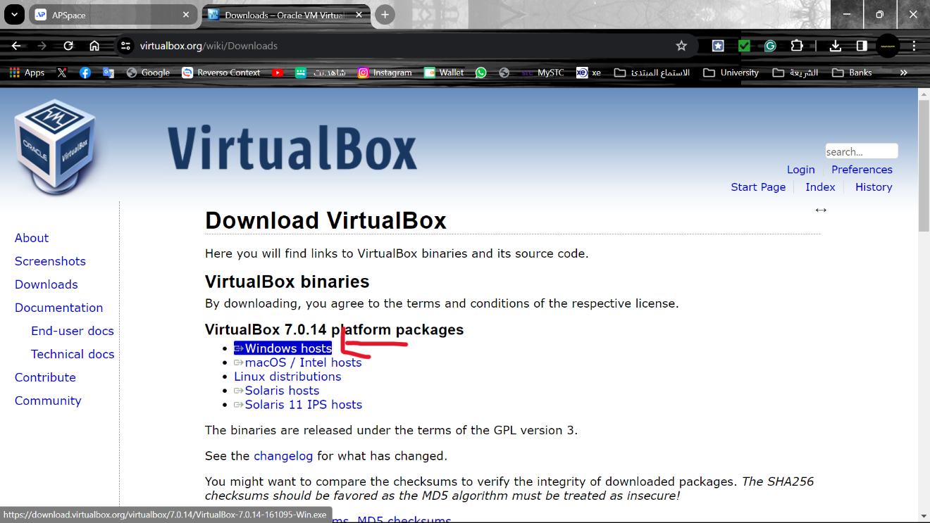

**Figure 1: Install VirtualBox.**

First, we enter the VirtualBox website <https://www.virtualbox.org/wiki/Downloads>, after press on Windows hosts to download for the Windows users.

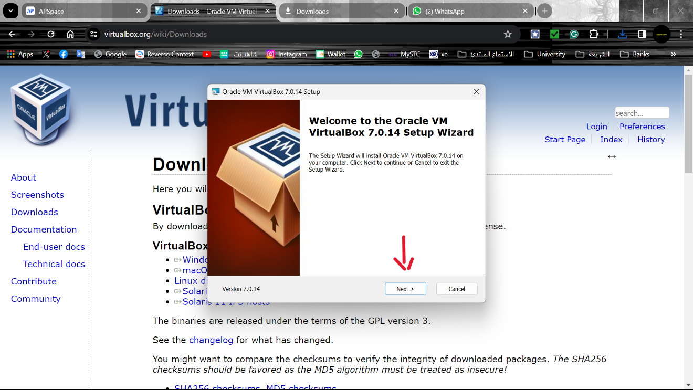

**Figure 2: setup up VirtualBox.**

Next, the installation will begin by clicking next and next.

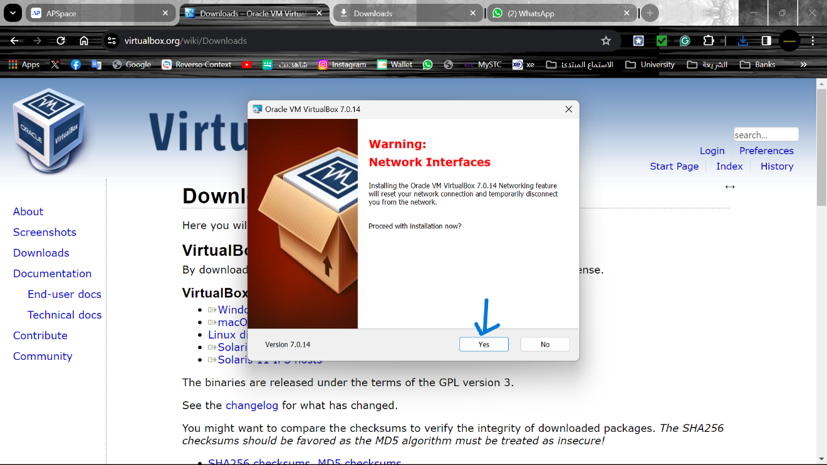

**Figure 3: Network Interface warning**

This warning lets the user know that setting up network interfaces is part of the VirtualBox installation process, which is necessary to activate network features in virtual machines (VMs). The computer's network connection will be reset during this phase, causing a temporary disconnect from the internet and any existing local area networks.   
Still, in order to proceed the installation, click Yes.

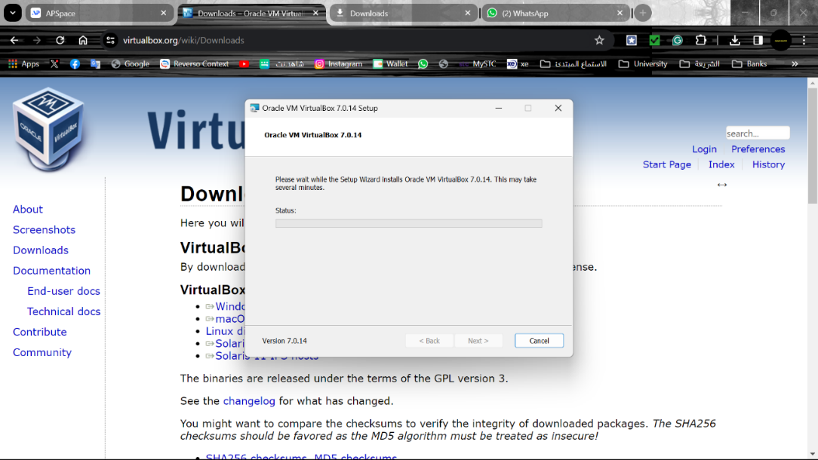

Figure 4: starting installation.

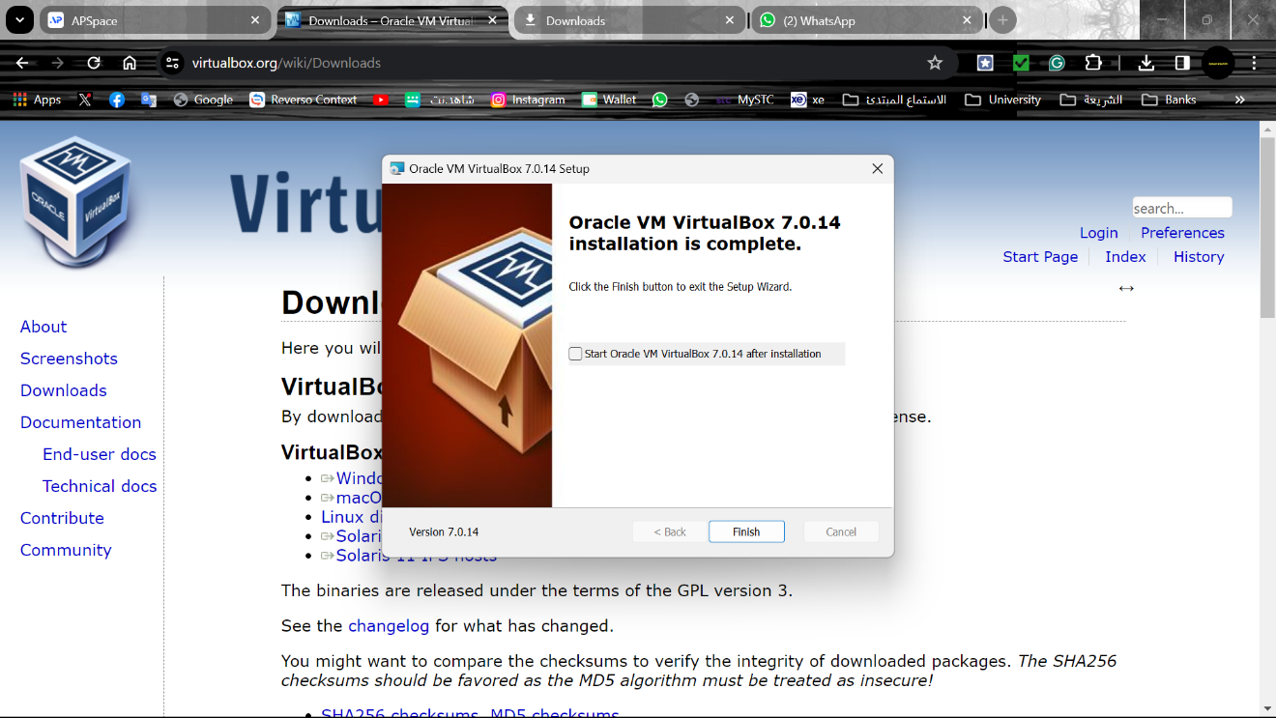

Figure 5: I‎3.0nstallation has been completed.

Now, VirtualBox is ready to use, the user can start using the Virtual machine after the installation has done and starting to install Rokey Server and Ubuntu.

## 3.2 Install the Rokey Server

Launch the virtual box, then select the new

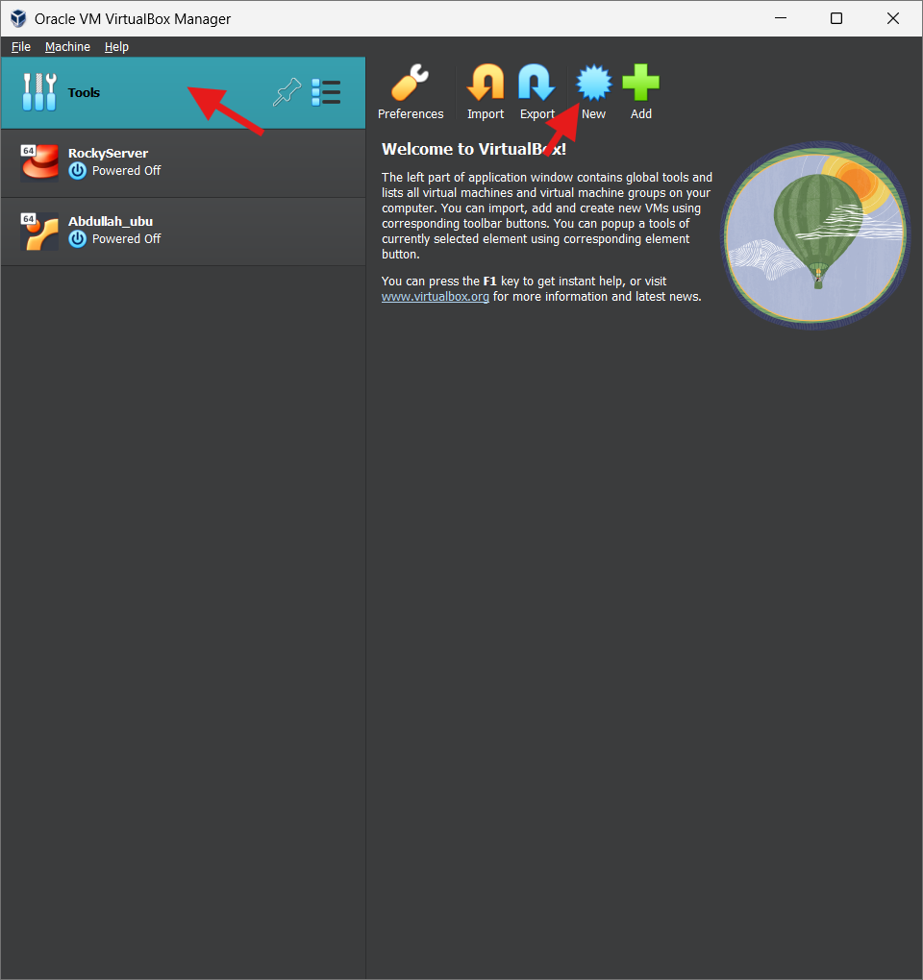

Figure 6: Click New

Next, Now we need to set a name and an ISO image for Rocky Server for our machine, in my case I named it as “TP075316Server” and set the ISO image as Figure 7 shown.

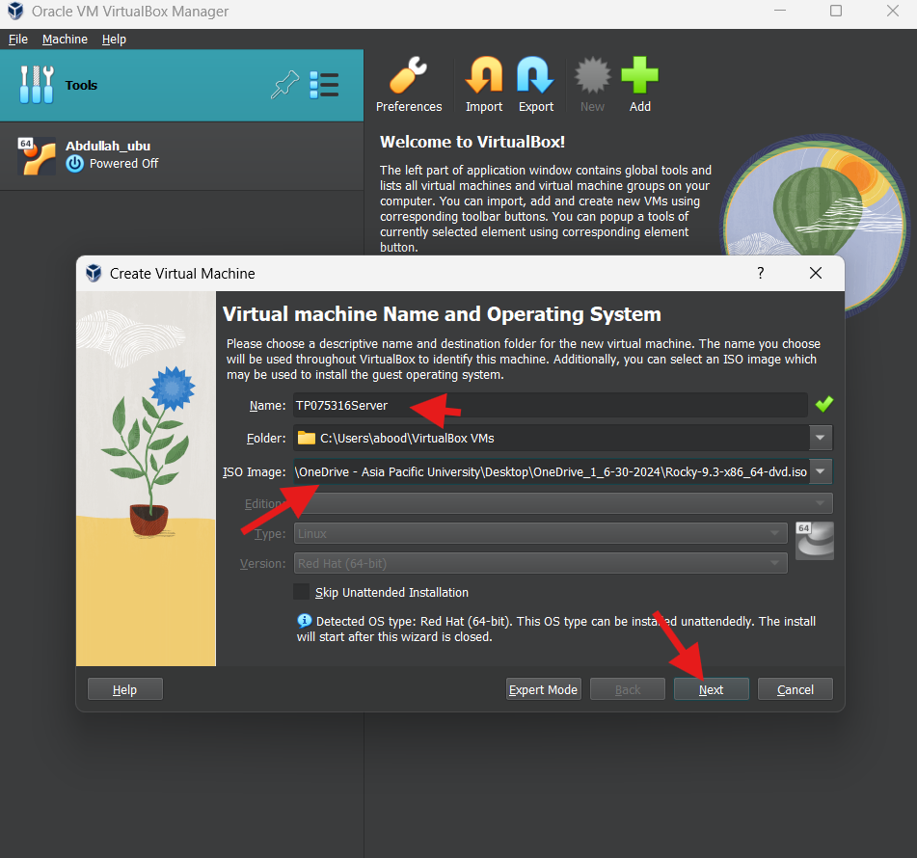 Figure 7: Select ISO image

We are setting the hostname and user name on this page, which is my “TP075316Rokey” and we are also setting up the password.

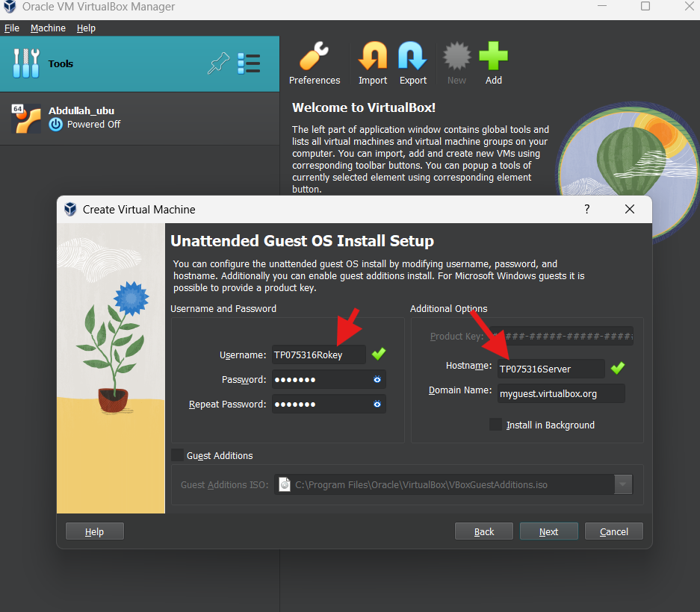 Figure 8: Set a username and password

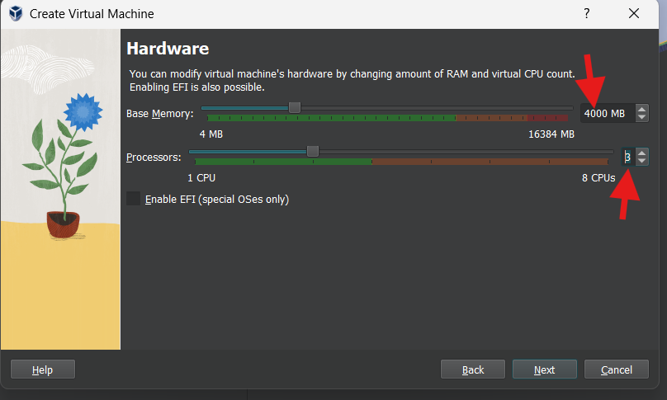Figure 9: Modify virtual machine hardware

In this step Make sure to select options within the green side when configuring the processor and memory.

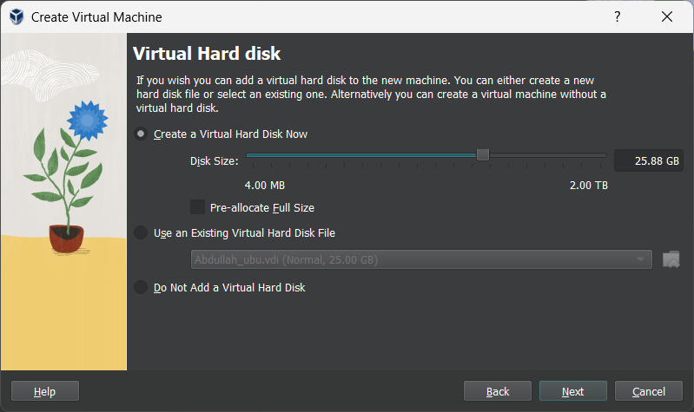

Figure 10: Creating virtual hard disk

Now set the hard drive for the virtual machine and is better to set it within 25-40GB.

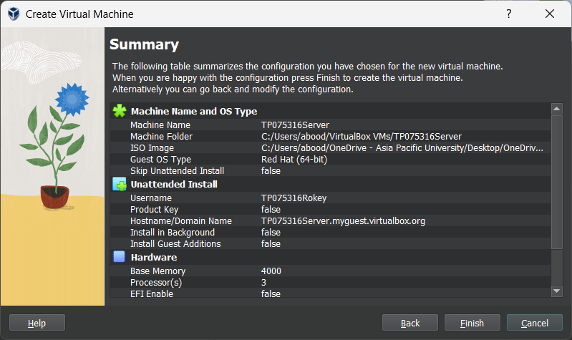

Figure 11: Summary

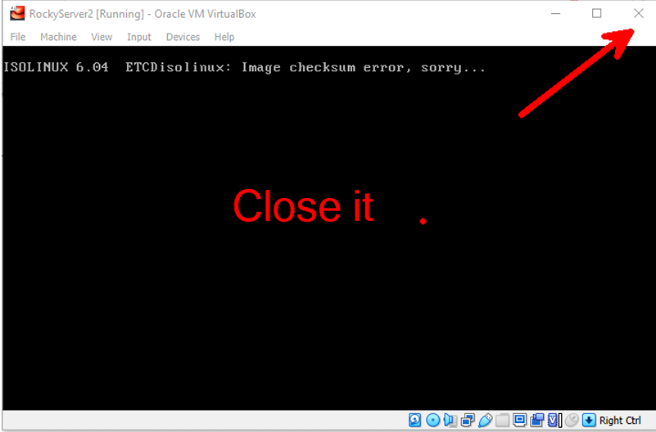Figure 12: Close the virtual machine

* Close the virtual machine

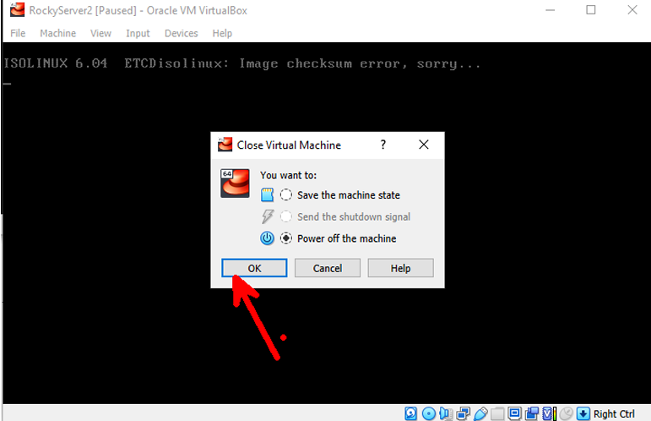

Figure 13: Powe off of the virtual machine

* Power off the machine option

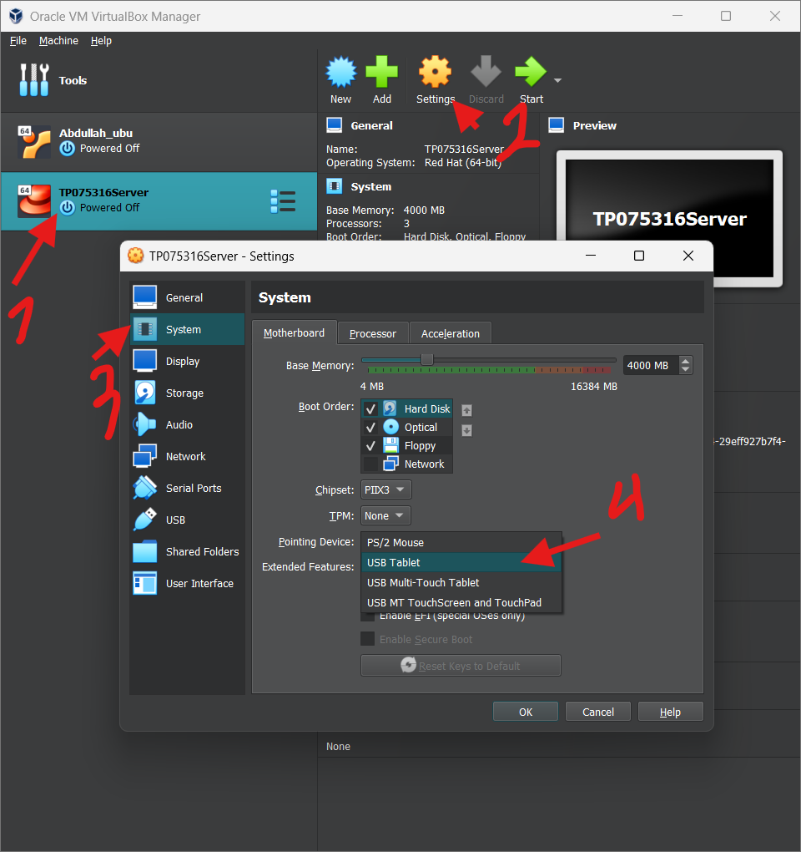 Figure 14: Editing system settings

Now, Once the newly created virtual machine has been selected, click Settings, followed by System.   
Switch from the pointing device to a USB Table.

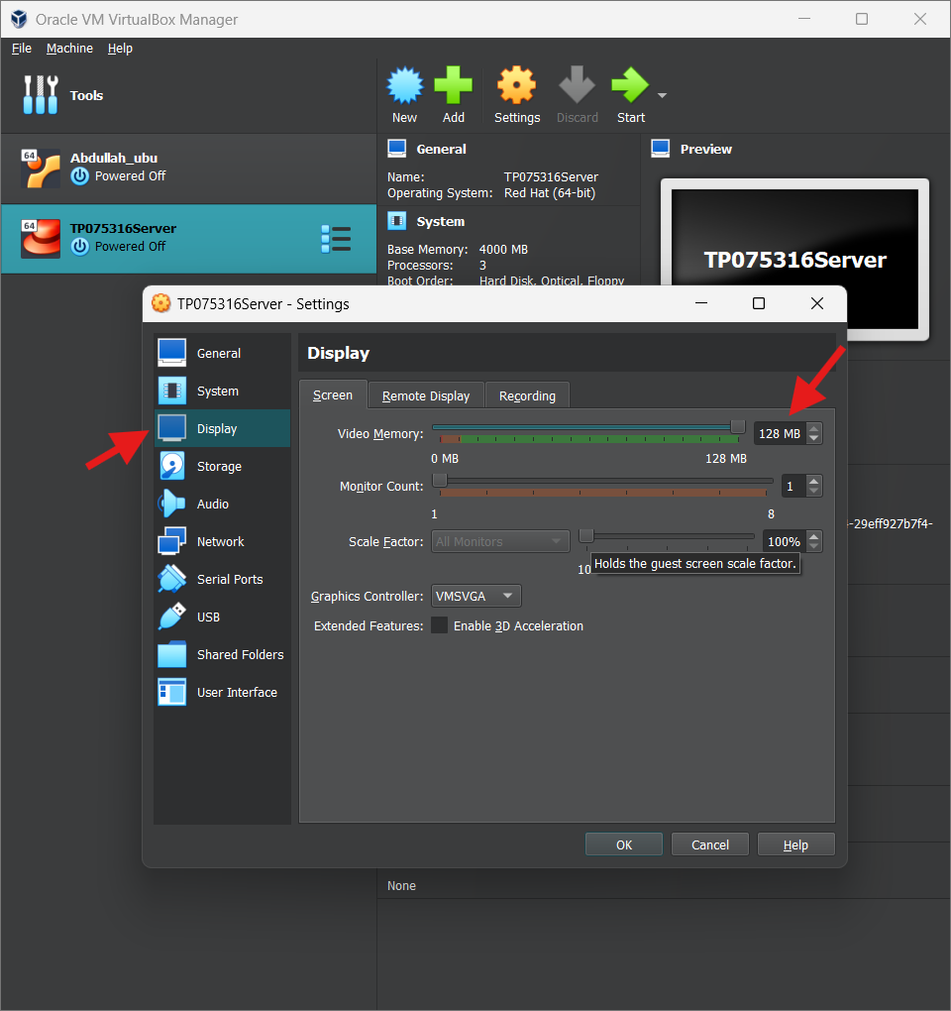 Figure 15: Editing display settings

* Next, the video memory can then be increased to 128 by clicking on the display section.

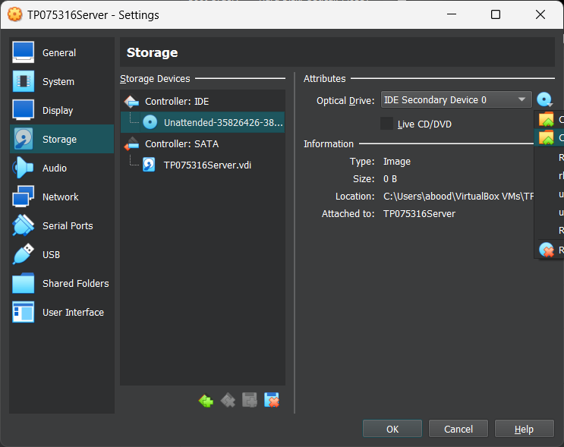 Figure 16: Adding ISO image of Rocky



* After that, we go to the storage sittings and we add Rocky USO image

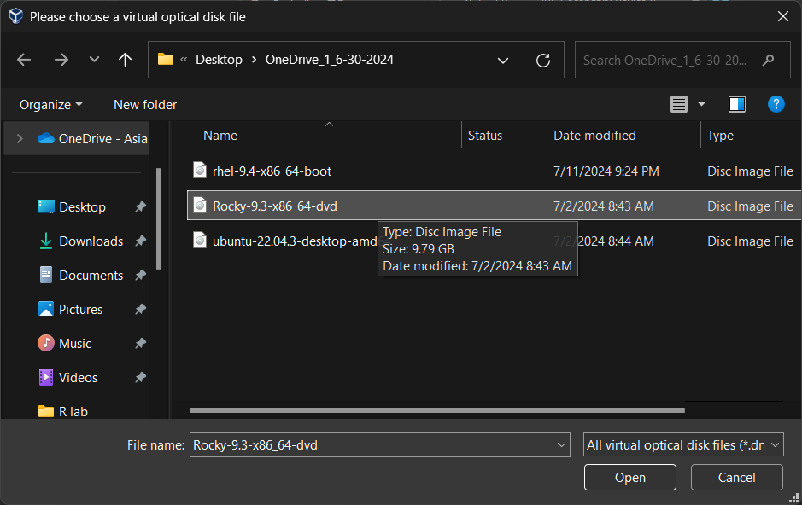 Figure 17: Choosing Rocky image

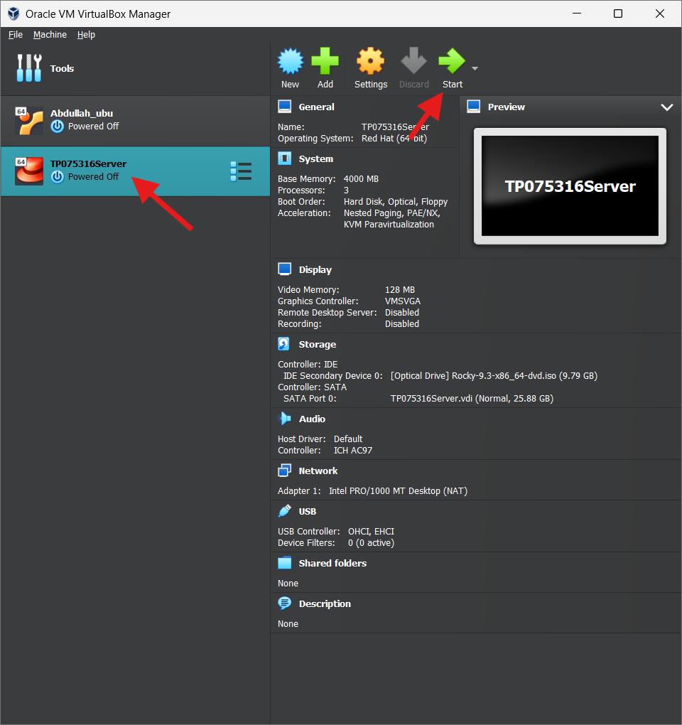 Figure 18: Starting the machine

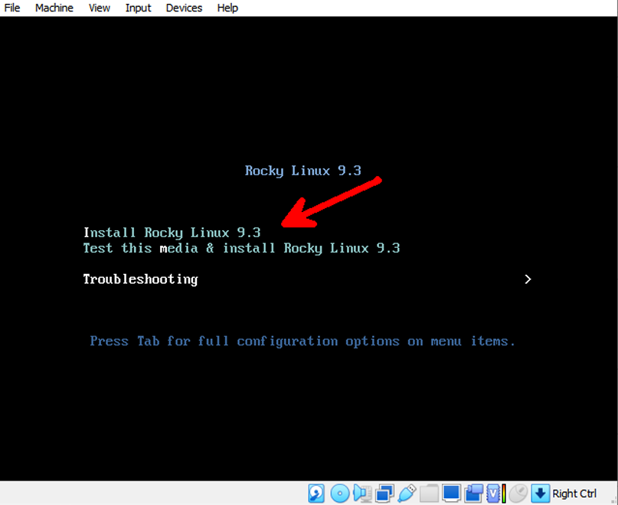 Figure 19: install rocky Linux 9.3

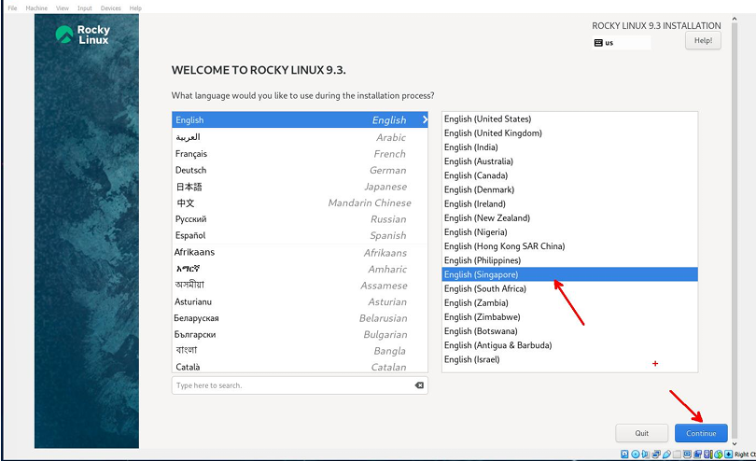 Figure 20: Picking language

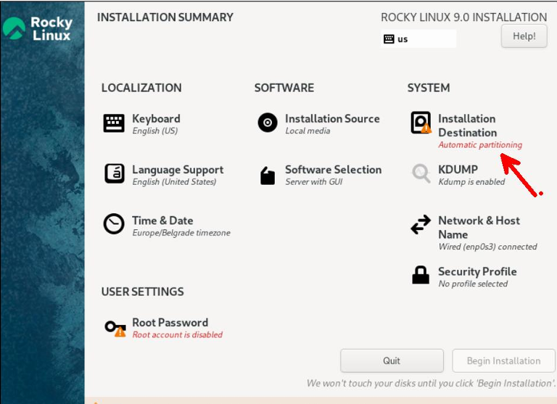Figure 21: System sittings

In this step we must confirm that our hard disk partition is appropriately set for the current installation destination at this screen:

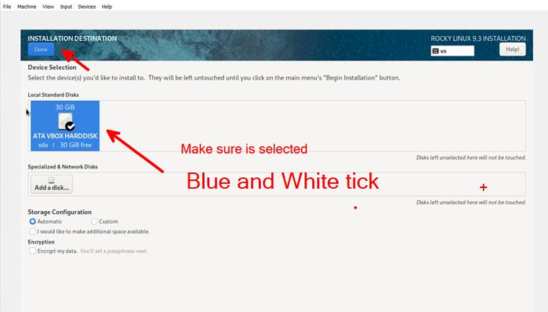Figure 22: Selecting the hard disk

* Make sure it is in the blue color with a check mark

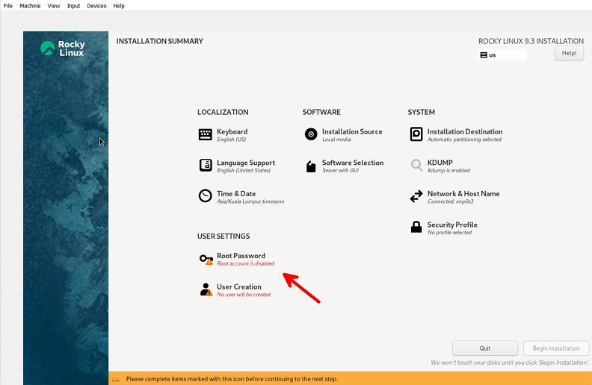Figure 23: Setting up the root password

The second step:

* setting a root password.
* Make sure you do not forget the password.
* Regarding the installation destination part, we shouldn't see the yellow warning icon.

Figure 24: Setting up the root password 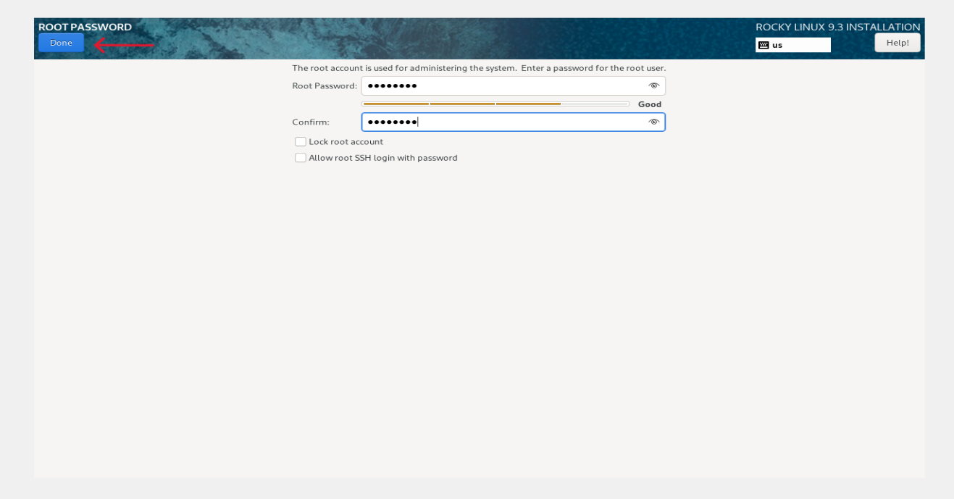

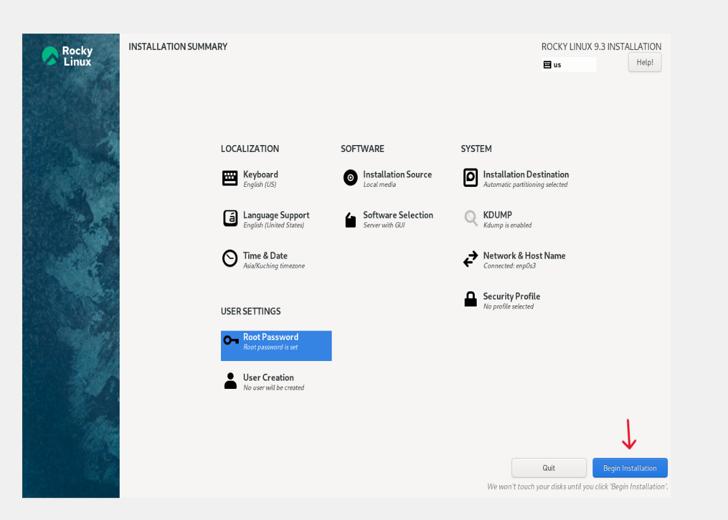

Figure 25: click begin installation 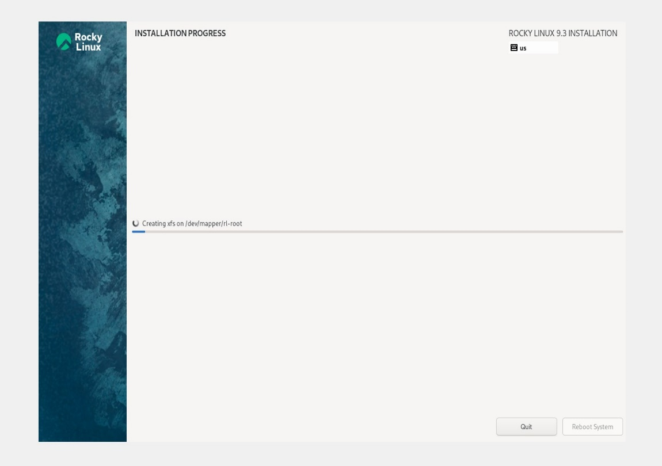

Figure 26: Installation

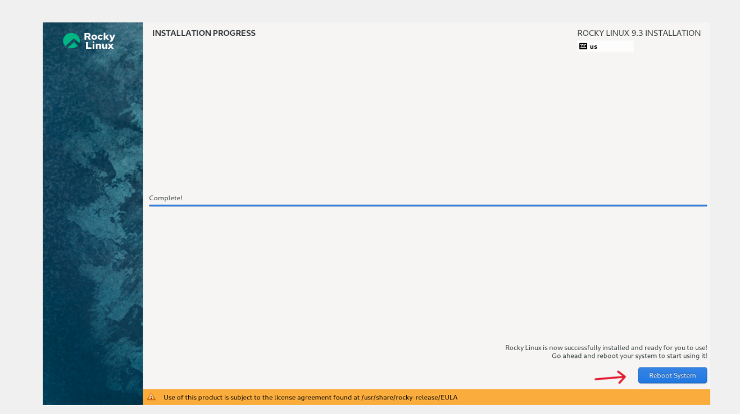

Figure 27: Finish installation

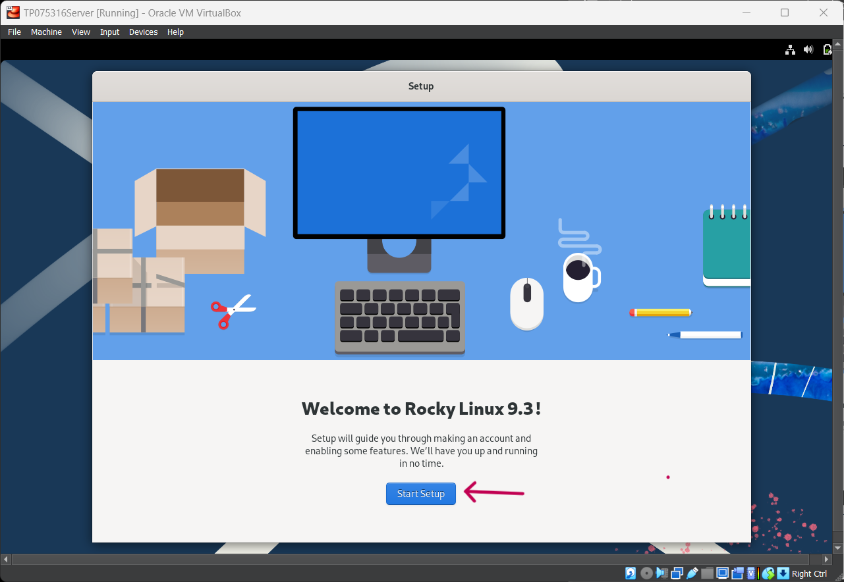Figure 28: Starting Rocky Linux

* Next, follow the steps

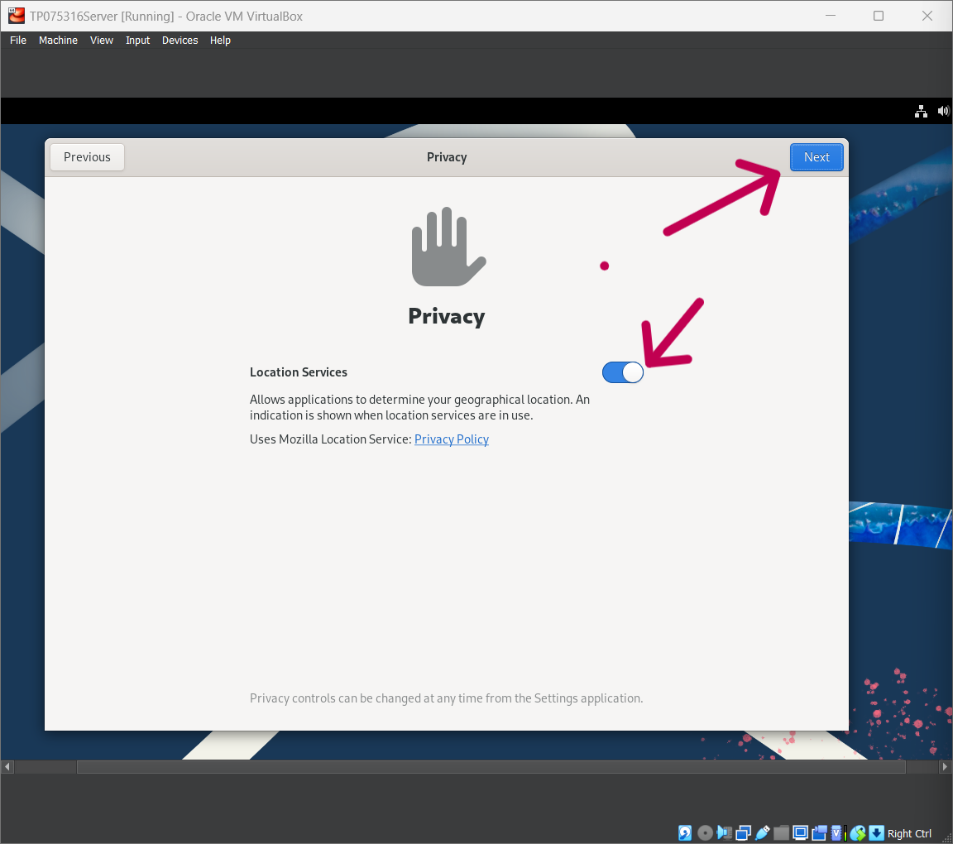Figure 29: Privacy page 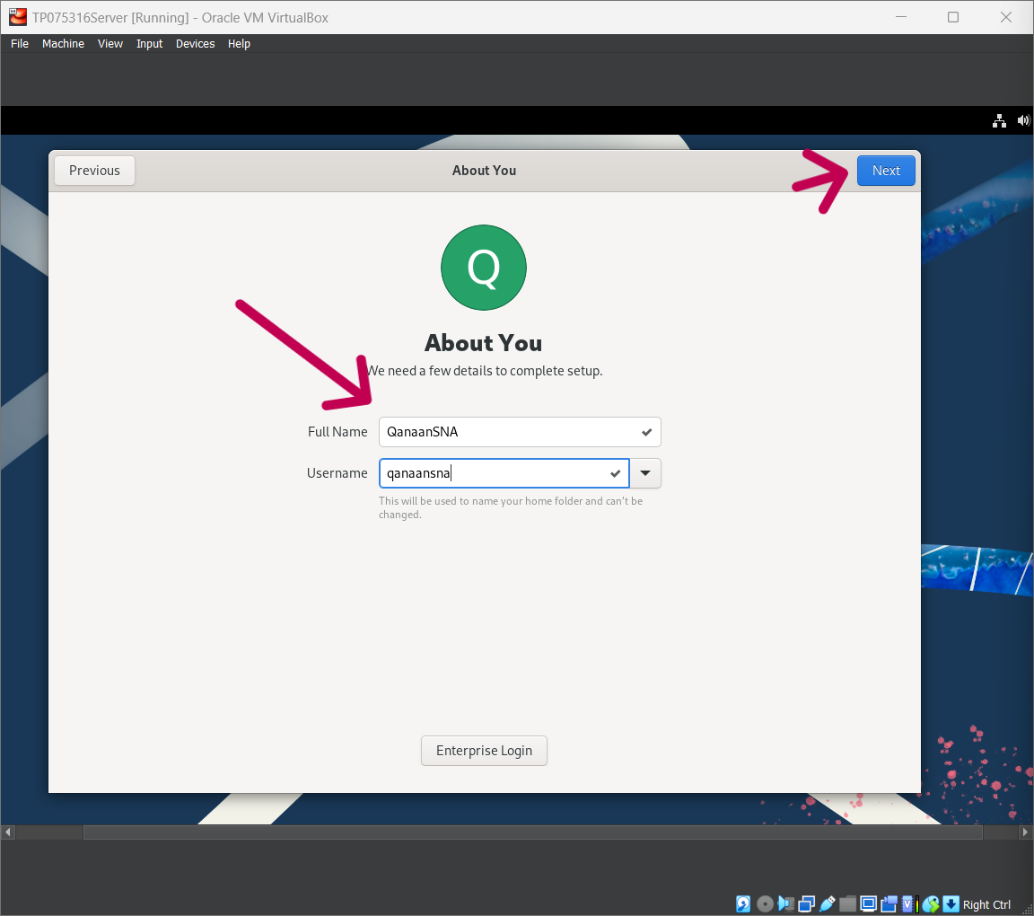 Figure 30: name and username

* Need to focus and keep this username in mind.

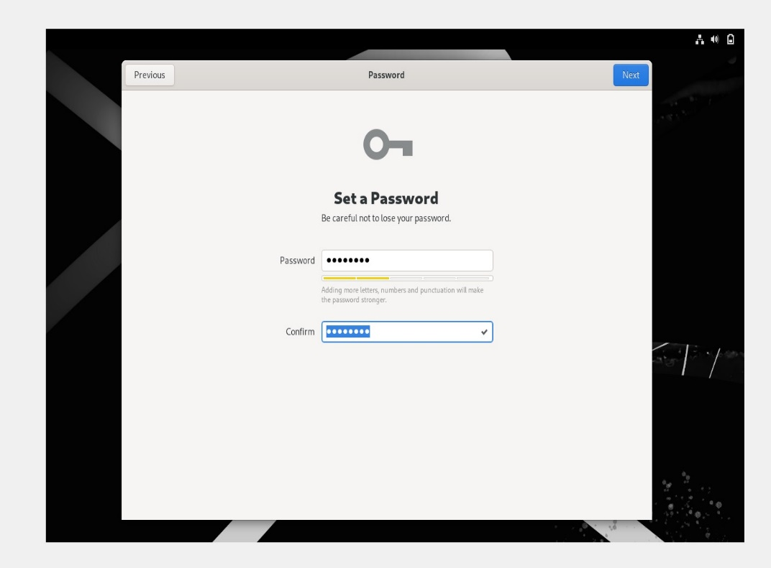  
Figure 31: Setting a password

* After that is the root password that we entered during installation, be sure not to forget the password because we will use it a lot during our assignment.

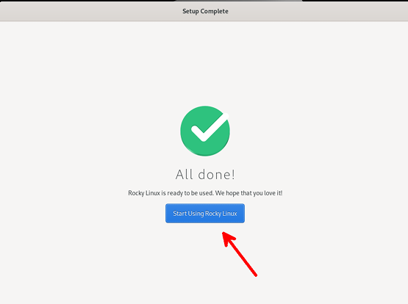 Figure 32: Settings completed 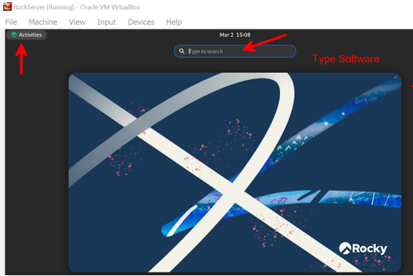 Figure 33: Updating the software

* Select the Activities tab and use the search textbox to search about the software.

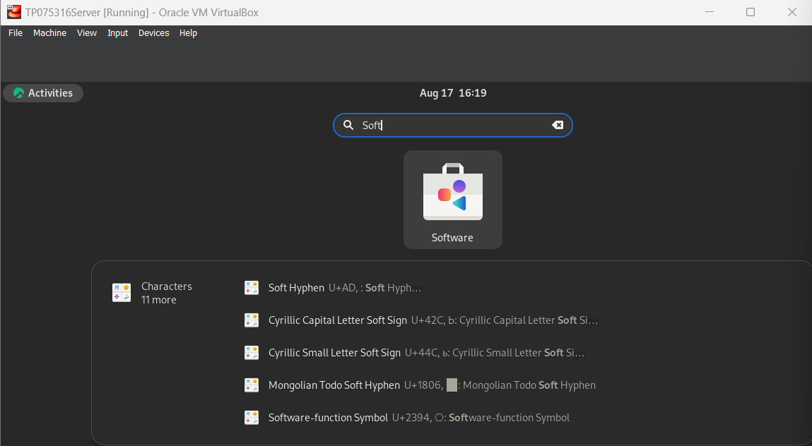  
Figure 34: Updating the software



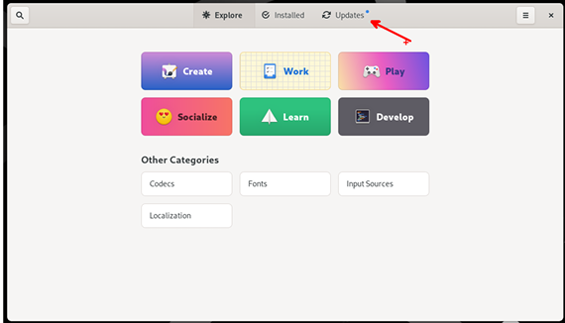  
Figure 35: Updating the software

* Select updates

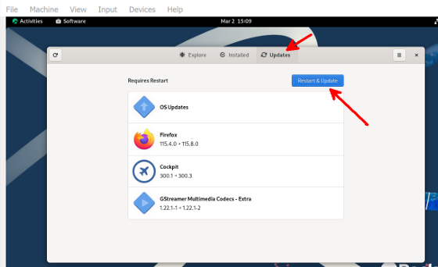 Figure 36: Updating the software

* Click on "Restart & Update" and the software will be updated and downloaded.

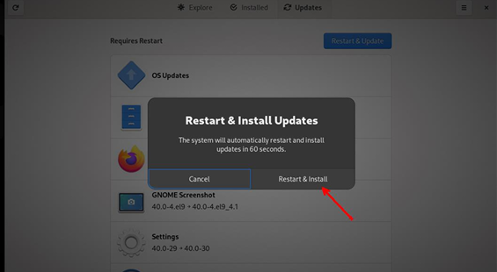   
Figure 37: Restart & install updates

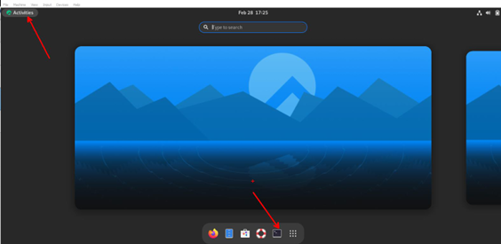 Figure 38: Entering the terminal

* Open terminal

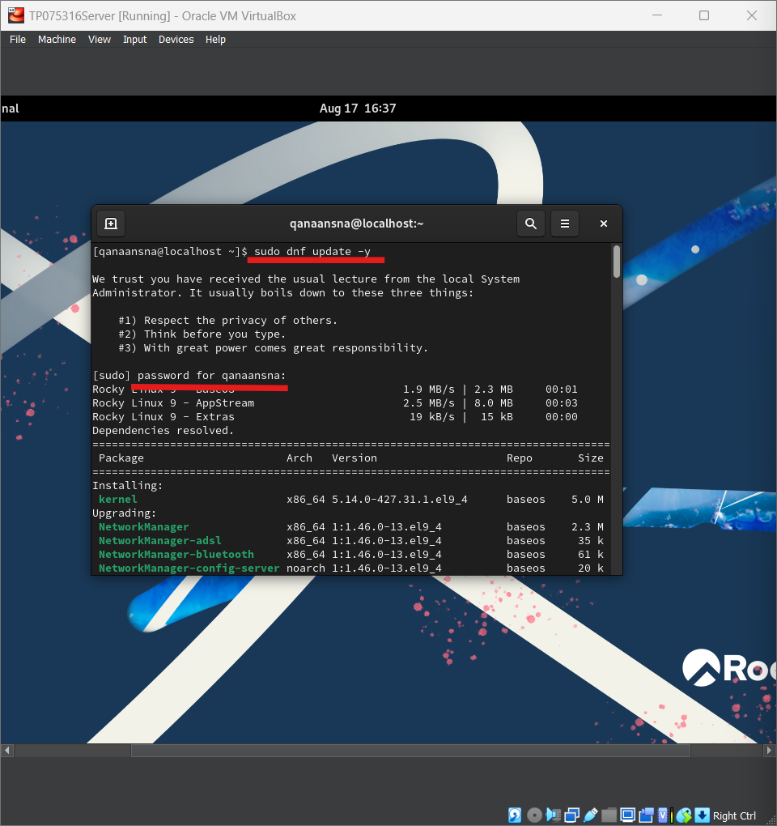 Figure 39: Updating the software

Now, we must update the system inside the terminal by using (“sudo dnf update -y”) command. Then we enter our password. This step needs to be done every time we go into our virtual machine.

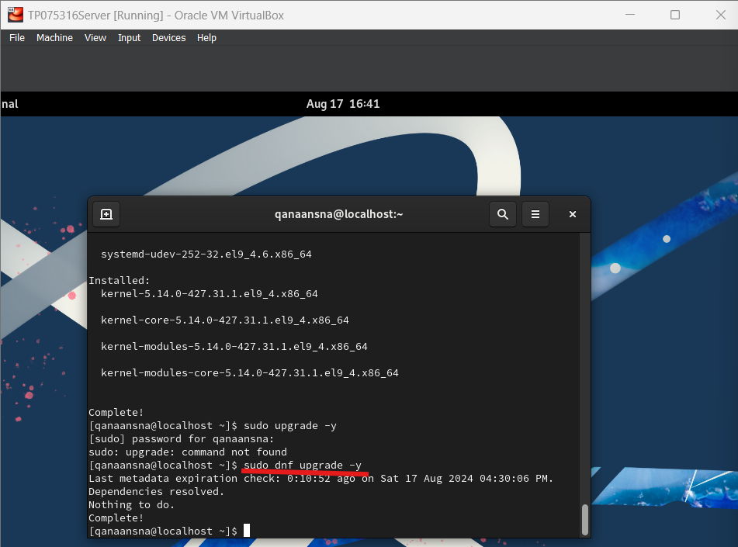  
Figure 40: Upgrading the software

* Upgrading the system inside the terminal, This step needs to be done every time we go into our virtual machine.

# 4.0 **Installation, updating & upgrading Ubuntu**

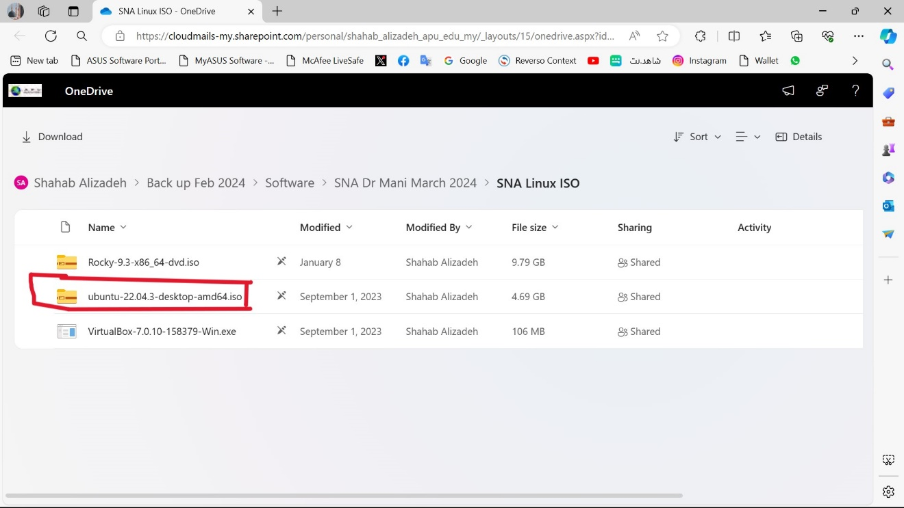  
Figure 41: Download Ubuntu folder

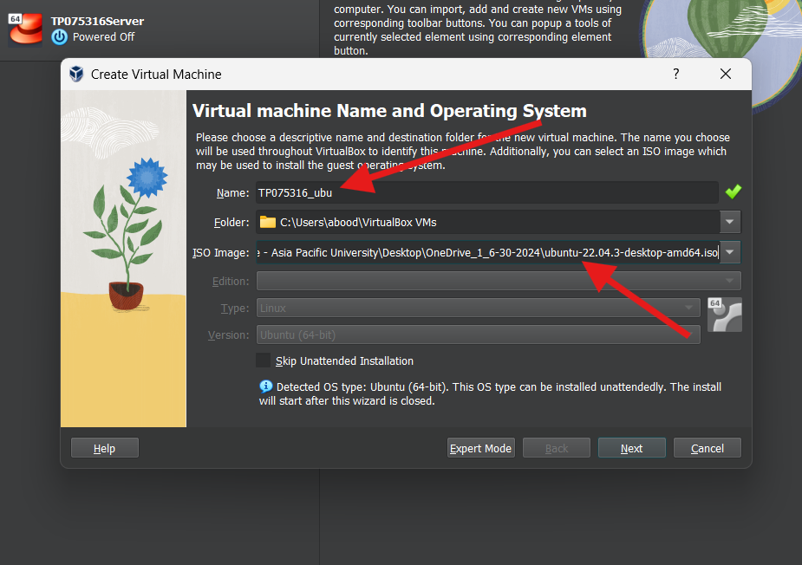  
Figure 42: Sitting a name & putting ISO image

To host our Ubuntu Linux, we need to first make a virtual machine, just like we did for the Rocky Linux server.

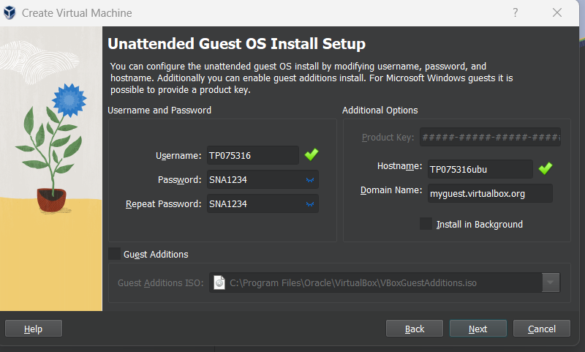

Figure 43: set up username and password.

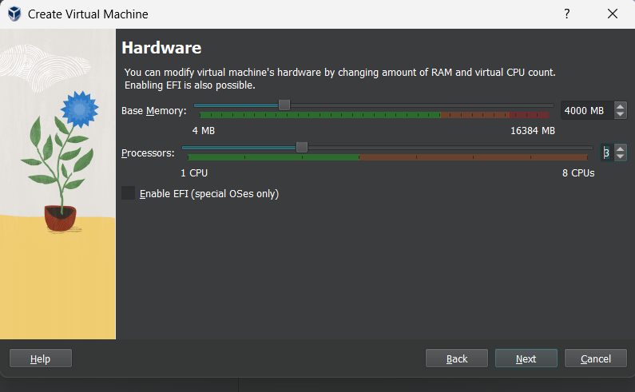  
Figure 44: set up the base memory and processors

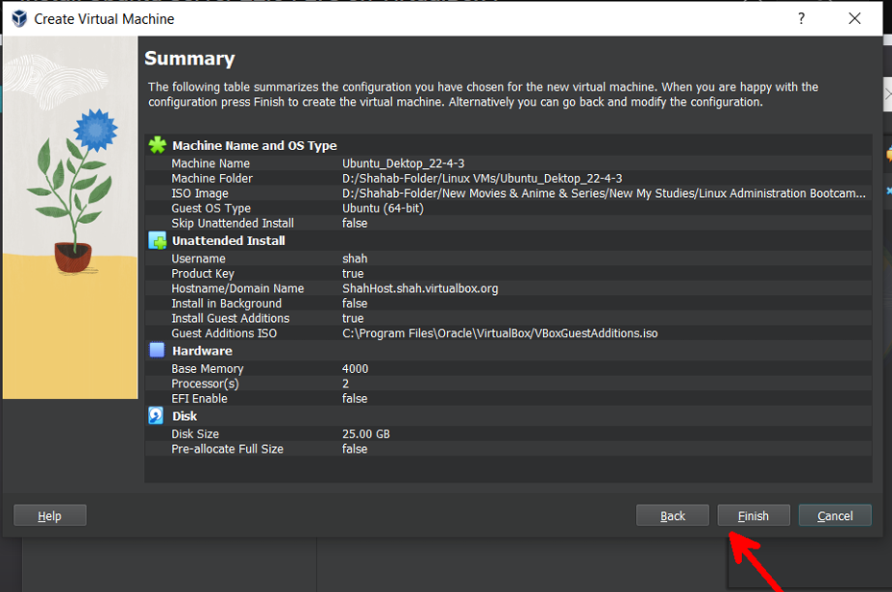  
Figure 45: Summary

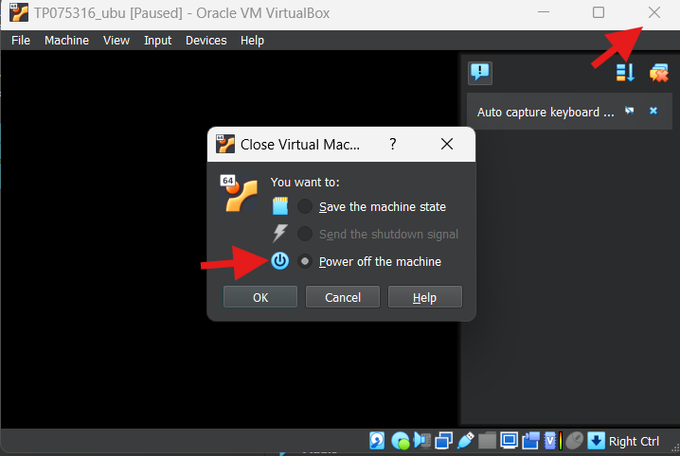  
Figure 46: power off the machine

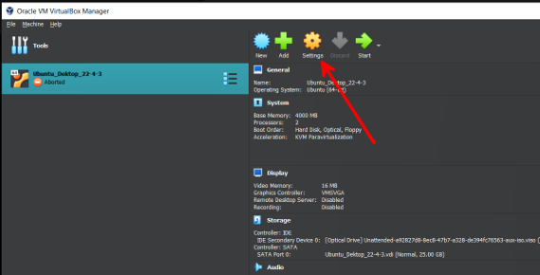  
Figure 47: settings

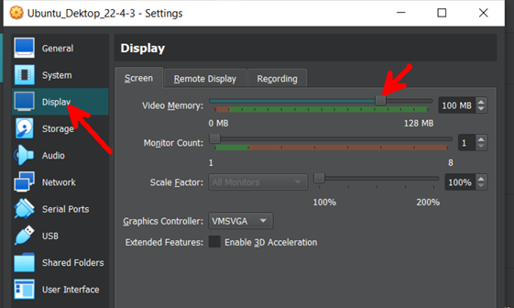  
Figure 48: Editing video memory

* Set Ubuntu's video memory to RM100 - 128.

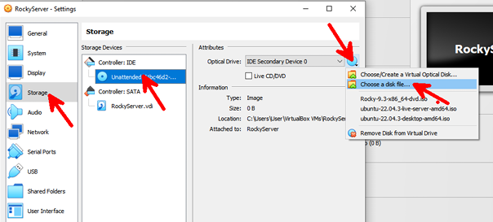  
Figure 49: Adding ISO image of Ubuntu

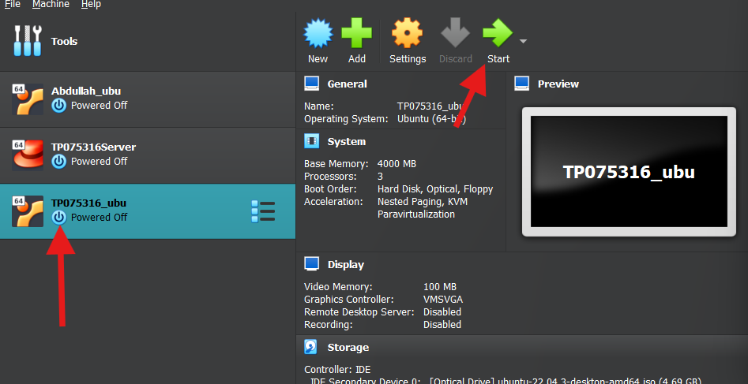  
Figure 50: Starting Ubuntu

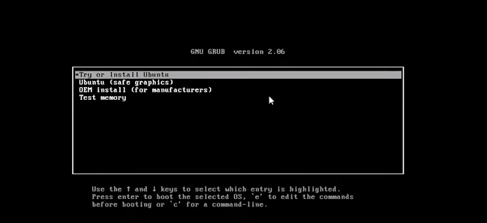

* choose the default option, and it will take time

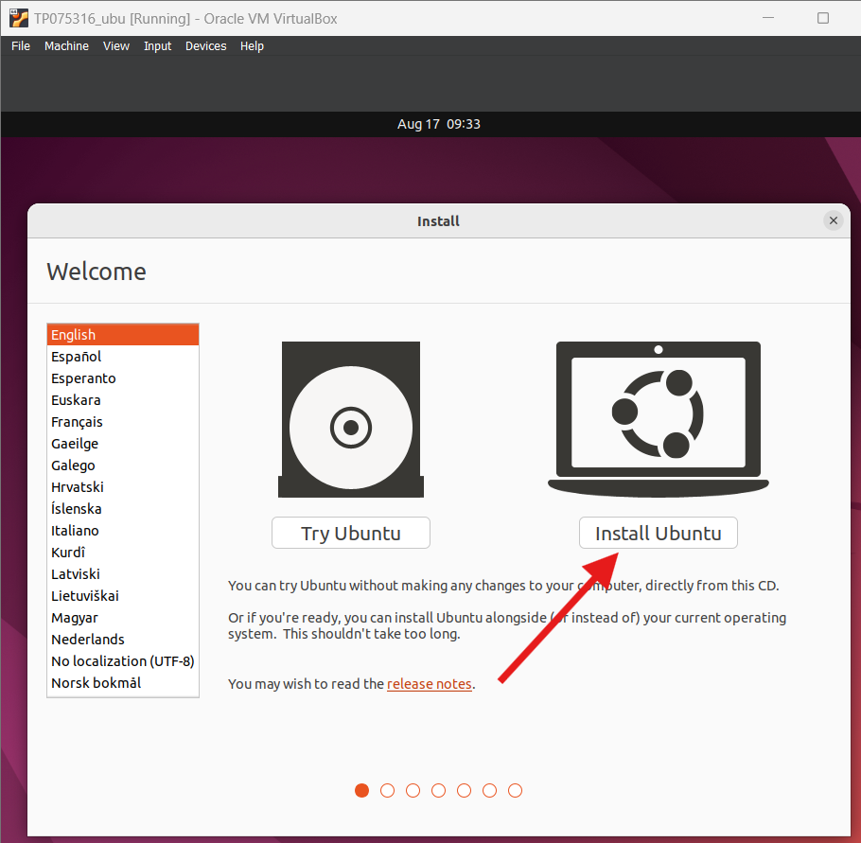  
Figure 51: Click Install Ubuntu

* In this step, we definitely want to install Ubuntu

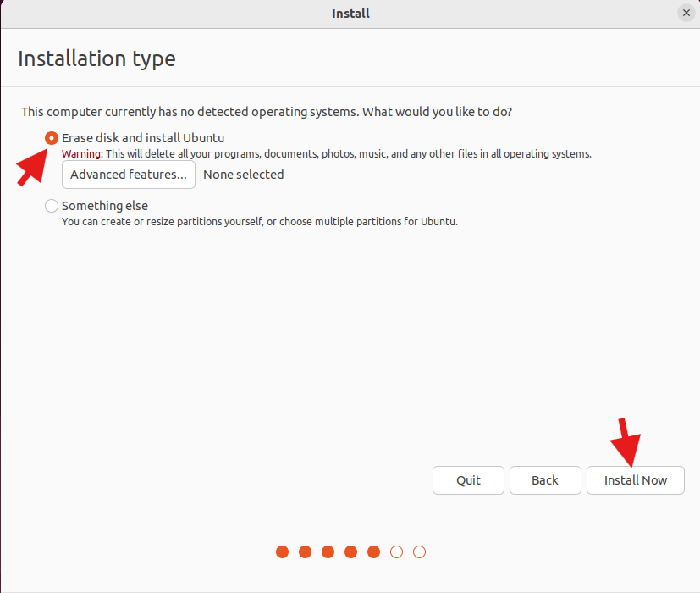  
Figure 52: Installation Type

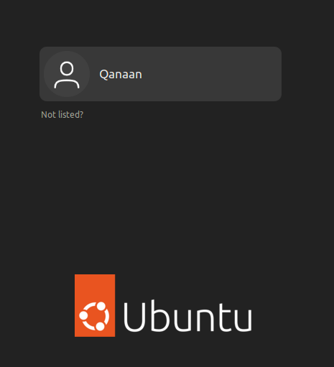  
Figure 53: Account

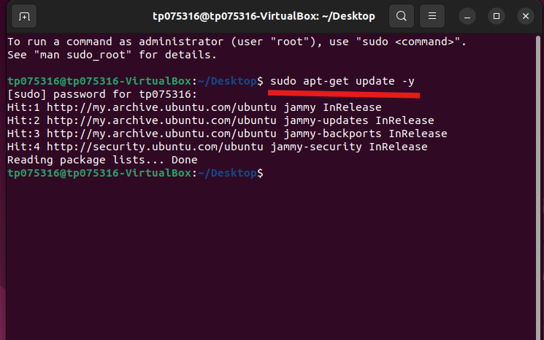Figure 54: update the system

* Right-click and open the terminal
* We use this command (“Sudo apt-get update -y”) to update the system

  
Figure 55: Entering root & add user command

* We must make the user we currently have sudoer.
* Now we enter to the root user by using (“sudo -i”) command
* Changes to the configuration file can only be made by the root user only.
* Type: (“visudo”)

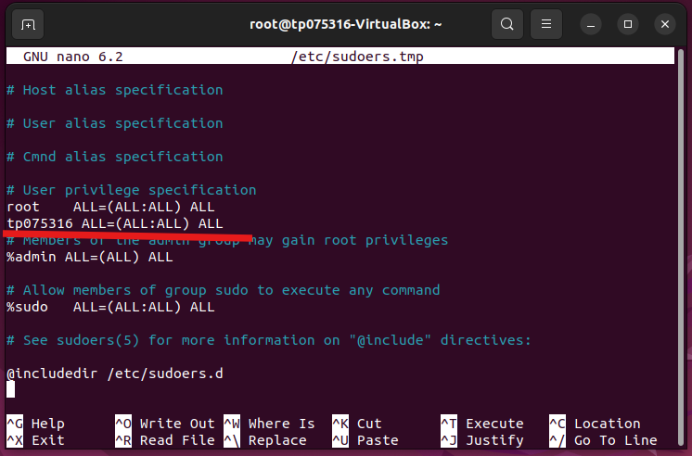  
Figure 56: Add user

* After we entered the file
* We need to type under the root line: the Ubuntu username ALL= ALL(ALL:ALL) ALL
* In my case will be tp075316 ALL= ALL(ALL:ALL) ALL

Once we are done press:

* Control + X
* Press Y
* Press Enter

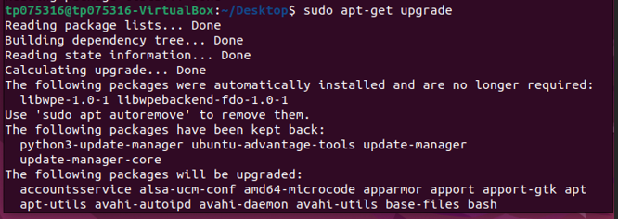

Figure57: update and reboot the system

* We use this command (“Sudo apt-get upgrade -y”) to upgrade the system
* Then type: reboot

# **5.0 Configuration network**

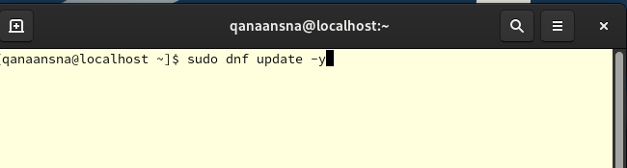  
Figure58: update Rocky Linux system

First, after logging in, we have to reboot and update the system.

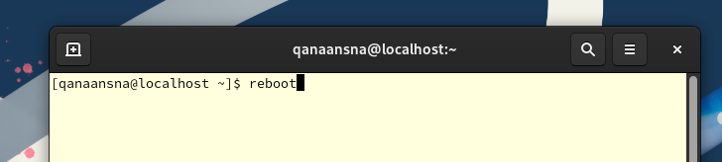  
Figure 59: reboot the system

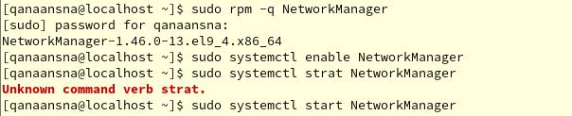  
Figure 60: Checking if Networkmanager installed

I used the command ("sudo rpm -q Network Manager") as Figure 60 shows. To check if NetworkManager is installed; in Rocky Linux, it is often installed by default.

And to check if the NetworkManager is installed, started and active we use these commands:

* sudo systemctl enable NetworkManager
* sudo systemctl start NetworkManager
* sudo systemctl status NetworkManager

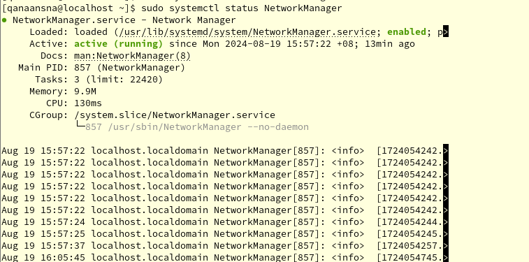  
Figure 61: Checking if Networkmanager installed

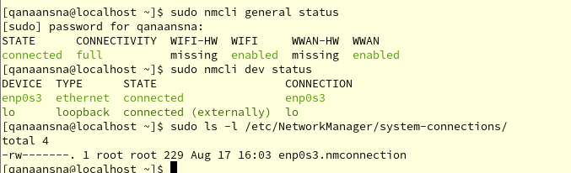  
Figure 62: information about system network configuration

## 5.1 Manual configuration for Rocky IP address

Figure 63: Access our network file

We will use (nano) editor to change the settings for our enp0s3.nmconnection network. We write this command to edit our configuration network (“sudo nano /etc/NetworkManager/system-connections/enp0s3.nmconnection”)

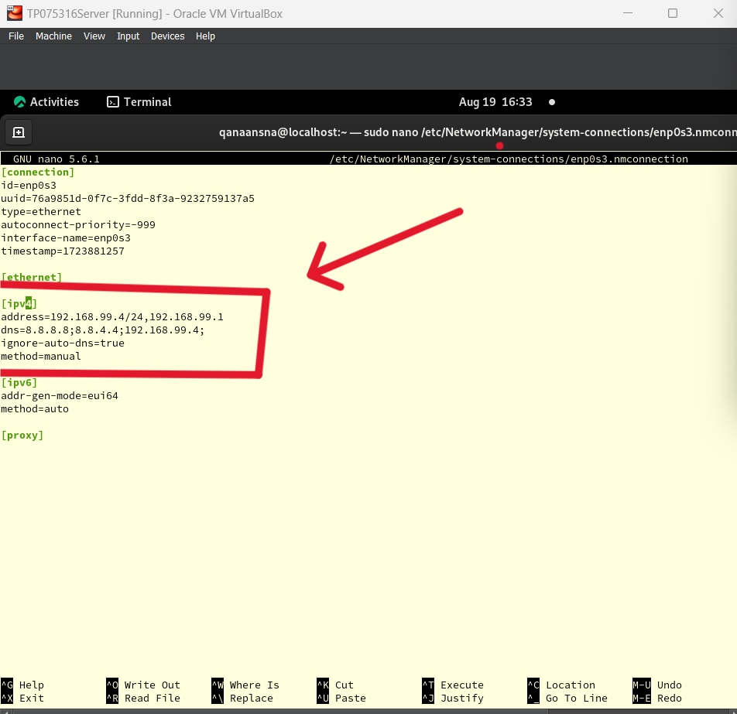  
Figure 64: IP configuration

I set an IP using 192.168.99.0 as my network address and 255.255.255.0 as the subnet mask, as illustrated in Figure 64. The Rocky server's IP address is 192.168.99.4/24. Also I selected Google Public DNS, which is 8.8.8.8 and 8.8.4.4.

Once we are done press:

* Control + X
* Press Y
* Press Enter

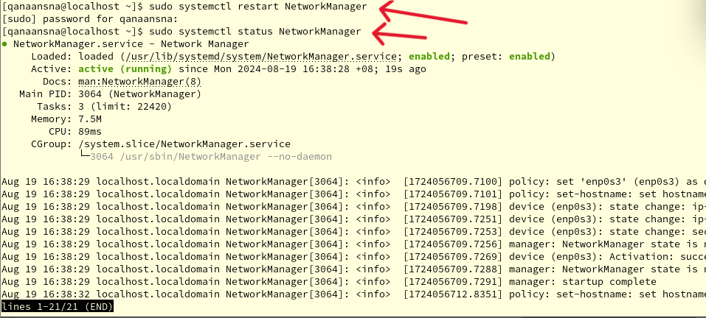  
Figure 65: restart network manager

Restarting the networkManager is necessary once the setup is complete. The network manager is still up and running, as seen in Figure 65.

Using these two next commands:

* sudo systemctl restart NetworkManager
* sudo systemctl status NetworkManager

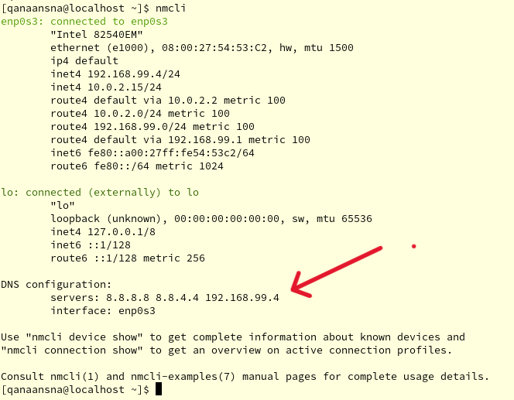  
Figure 66: server IP configuration

In figure 66: The IP server and DNS IP have changed to 8.8.8.8, 8.8.4.4, 192.168.99.4, and they are now linked to **"enp0s3”.**

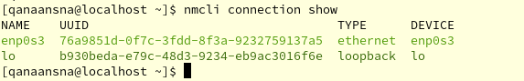  
Figure 66: Checking network settings

# 6.**0 Install and configure DNS Server**

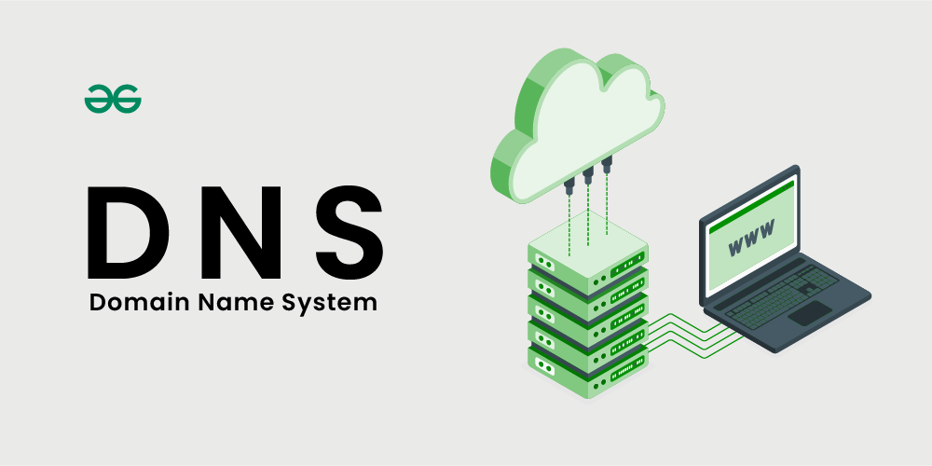

## 6.1 DNS server and what is a server?

The Domain Name System (DNS) functions as the Internet's phonebook. Domain names such as apspace.com or moodle.org are used by humans to access content on the internet. IP addresses are used by web browsers to communicate with one to another. For browsers to load resources from the Internet, DNS converts domain names to IP addresses. Every Internet-connected device has an own IP address that other computers may use to locate it. DNS servers make it unnecessary for people to memorize IP addresses, such as IPv4 addresses 192.168.1.1 or IPv6 addresses with more complicated hexadecimal addresses like 2400:cb00:2048:1::c629:d7a2.

A server is a piece of hardware or software that replies to queries received across a network by processing the requests. The device that sends a request to the server and waits for a response is called a client. In the context of the Internet, a "server" is the computer system that receives requests for online files and sends those files to the client.

## 6.2 Installation for BIND

  
Figure 67:BIND installation

* First we install BIND package

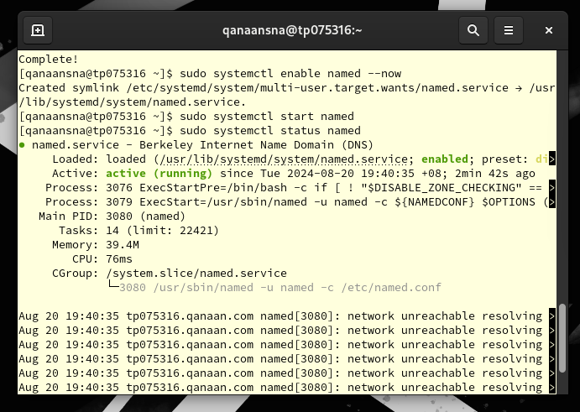  
Figure 68:Status of named

I used the command to turn on named (sudo systemctl enable named –now) and command start named (sudo systemctl start named). As shown in figure 68.

## 6.3 DNS configuration

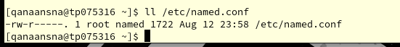

Figure 69: Checking named.conf file

* Go to the etc directory and look for the named.conf file.

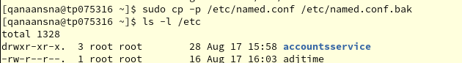 Figure 70: backup for named file

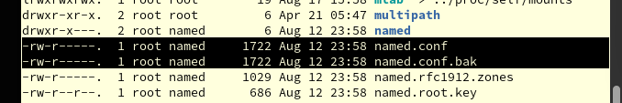 Figure 71: backup for named file

We create a backup copy by using these commands:

* sudo cp -p /etc/named.conf /etc/named.conf.bak

-p Keep the original file's permissions and ownership the same

Then, ls -l /etc (to list etc directory)

 Figure 72: root privilege command

The user enters a terminal session and types su - to switch to the root user account. The command then asks for the root password. The user opens the file /etc/named.conf with the text editor nano after getting root access, which is shown by the prompt changing from $ to #. To edit the named.conf file.

## 6.4 Modifying named.conf file

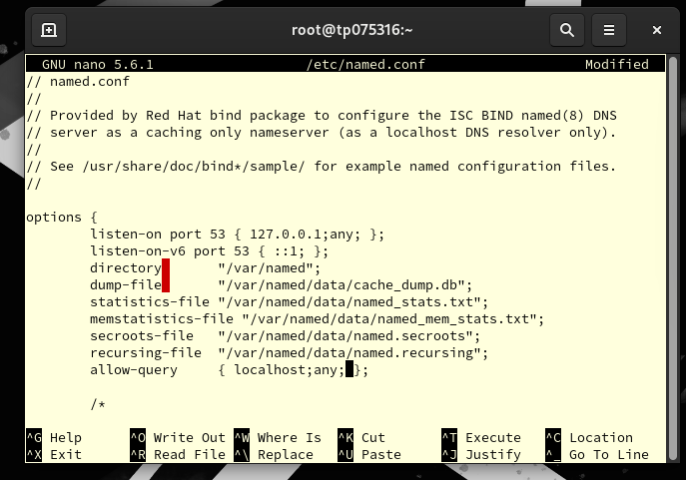 Figure 73: allowing port 53



We need to let all devices under the listen on port 53 use port 53, which is the DNS port. The option allow the query directive is set to let DNS queries come from both localhost and any other host. This setting is very important because it tells the DNS server which clients can use it to resolve domain names.

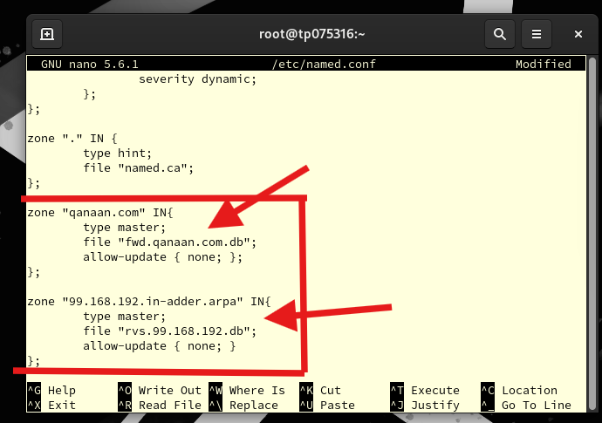 Figure 74: forward lookup and reverse lookup zone

Scroll down until you reach the end of the zone ". " IN ~

In this part “the first zone”, we need to make two zones: one for forward look-ups and one for reverse ones. Name of the forward lookup zone: "fwd.qanaan.com.db" This is the domain name of my server and the hostname of my client in this case.

"99.168.192.in-addr.arpa" is the second zone. It is used to do reverse DNS lookups on IP addresses in the 192.168.99.0/24 subnet. This zone is also a master zone, just like the first zone. This means that this server has the official list of IP addresses that match domain names for reverse lookups. It is saved in a file called "rvs.99.168.192.db" for reverse lookups.

Once we are done press:

* Control + X
* Press Y
* Press Enter

 Figure 75: Checking syntax errors

Run the following command to check for any syntax errors after configuring named.conf; there shouldn't be a message prompt.

## 6.5 Setup DNS and the zone file

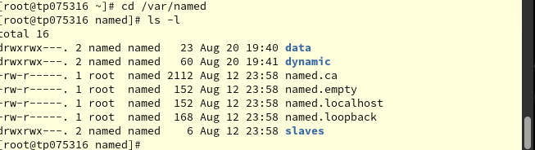 Figure 76: Switching to named directory



Now change our current directory to the named directory by using (“cd /var/named”), then we list all files and directories in our named directory.

 Figure 77: Entring fwd.qanaan.com.db file

* Editing fwd.qanaan.com.db

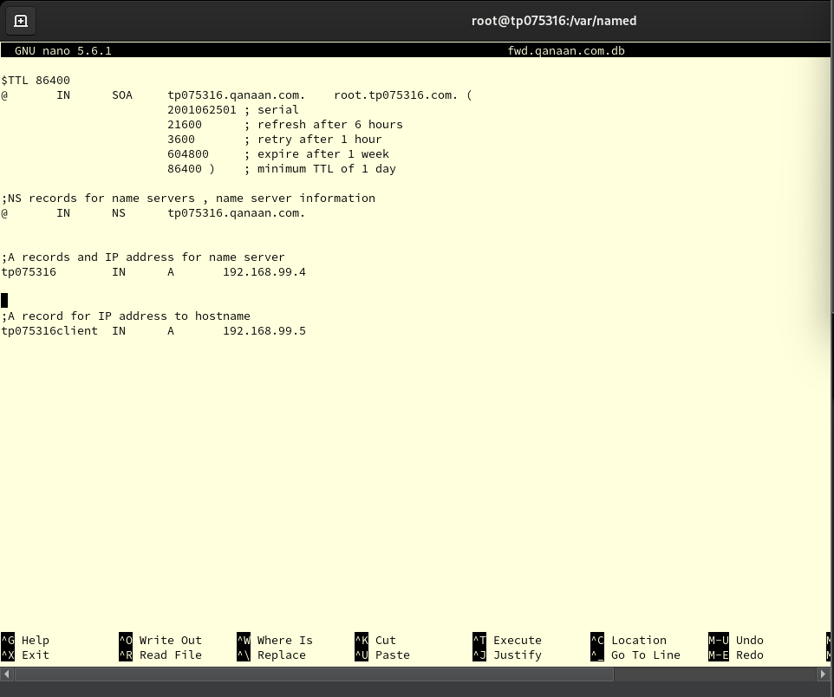 Figure 78: Setting configuration for forward file

Domain Name System (DNS) records for tp075316.com are in this file. These are the records that are shown:   
There are important pieces of information about a domain in a SOA record, like the primary name server (tp075316.qanaan.com), the responsible party for the domain (root.qanaan.com), and different timers that set the zone refresh rates and Time to Live (TTL) values. An NS record tells the domain's computers which name server is the official one.   
tp075316 and tp075316client are hostnames that are linked to IPv4 addresses (192.168.99.4 and 192.168.99.5) on a local network by two A records.   
  
Root has gone to the /var/named directory and used nano to open the fwd.qanaan.com.db file for editing, as shown in the terminal. When (“su –“) is used, it means that the user changed to the root user privilege, which gives them full control to change the DNS zone files.

Once we are done press:

* Control + X
* Press Y
* Press Enter

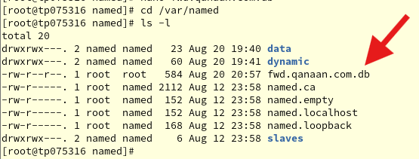  
Figure 79: Checking file exist

* As the figure above displays that( fwd.qanaan.com.db) exist.

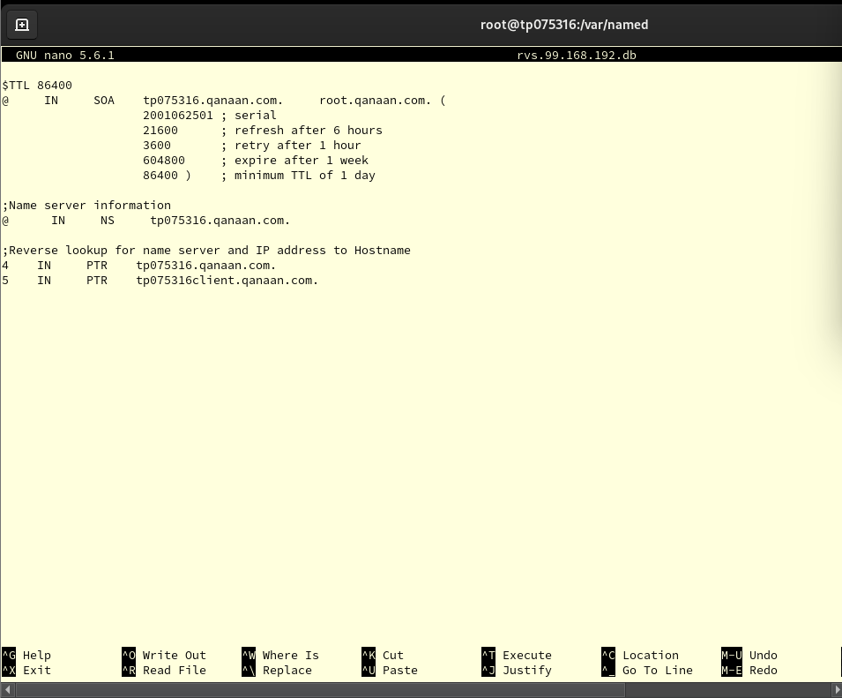 Figure 80: Setting configuration for reverse file

Names for reverse lookup zone files come from the IP network address. In my case is 192.168.99.0/24 network, then we need to reverse the 3 first octets to be 99.168.192.

The PTR records list IP addresses backwards, followed by the hostnames that go with them.

Important elements:

* $TTL: sets the time that records in the zone are expected to stay live.
* @: This is the beginning of the zone, which is the IP network address turned around.
* PTR: This link turns IP numbers into hostnames.
* NS: Lists the nameservers that are in charge of the zone.
* SOA: Sets the Start of Authority record, which has important zone-related data.

Once we are done press:

* Control + X
* Press Y
* Press Enter

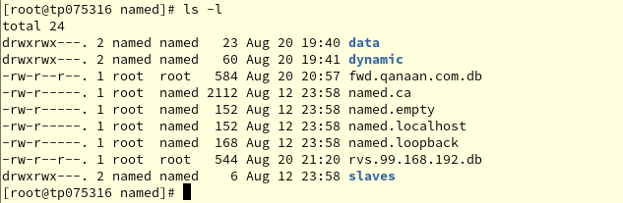 Figure 81: Checking file exist

* Now we check if both lookup zone exist.

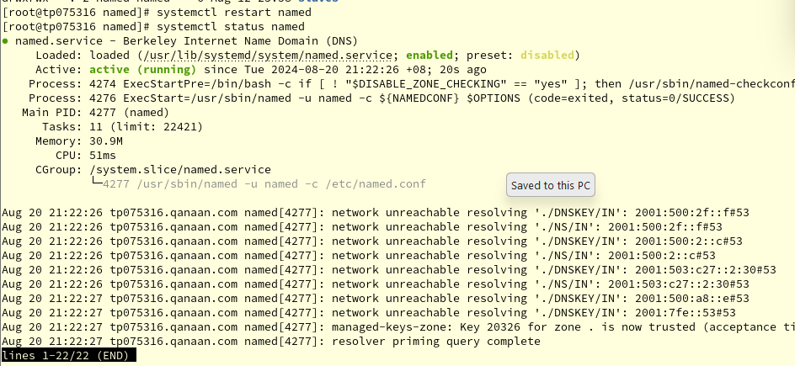 Figure 82: system status

Now we check and restart the status of the DNS

## 6.6 Allowing the firewall to pass the DNS ports

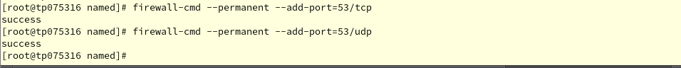 Figure 83: Adding ports

* Next, we need to let the firewall let UDP and TCP traffic through port 53.
* (“Sudo firewall-cmd --permanent –-add-port=53/udp”)
* (“Sudo firewall-cmd --permanent –-add-port=53/tcp”)

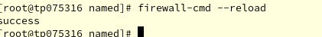  
Figure 84: Firewall reload

* As soon as the new set is success, we restart the firewall.
* (“Sudo firewall-cmd –reload”)

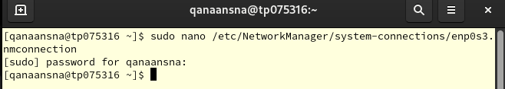Figure 85: Text editor

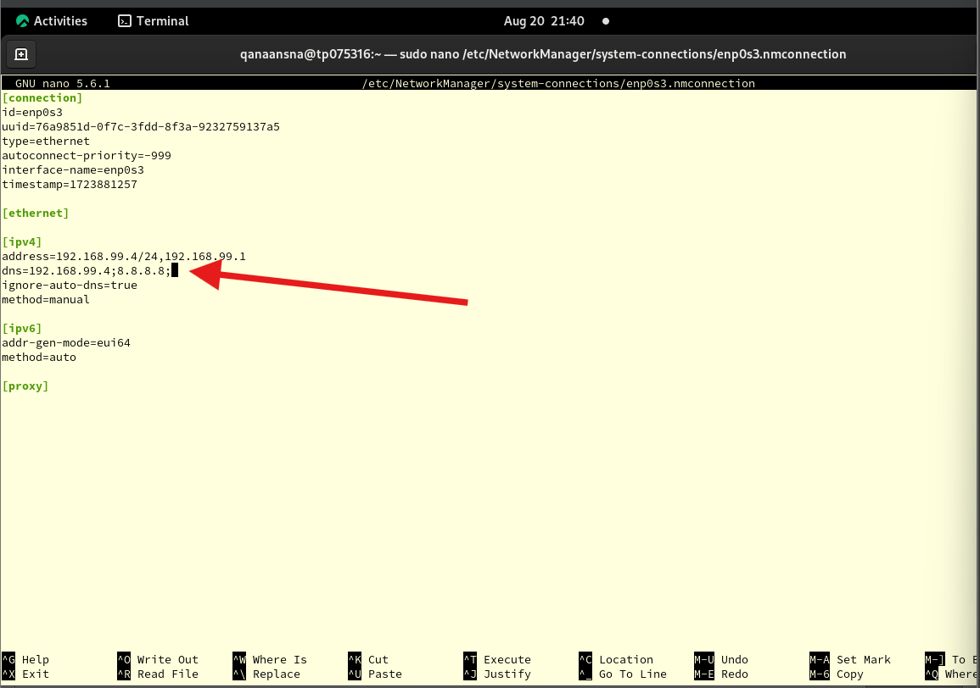 Figure 86: set DNS IP address

The picture above illustrates the GNU nano text editor being used to change a file that sets up a network. There is a file called enp0s3.nmconnection in the directory (“/etc/NetworkManager/system-connections”). This file is related to a network device that is managed by Network Manager.   
DNS tells you which DNS servers to use. The first ones are 192.168.99.4, which is the local DNS server, and 8.8.8.8, is Google's public DNS.

Once we are done press:

* Control + X
* Press Y
* Press Enter

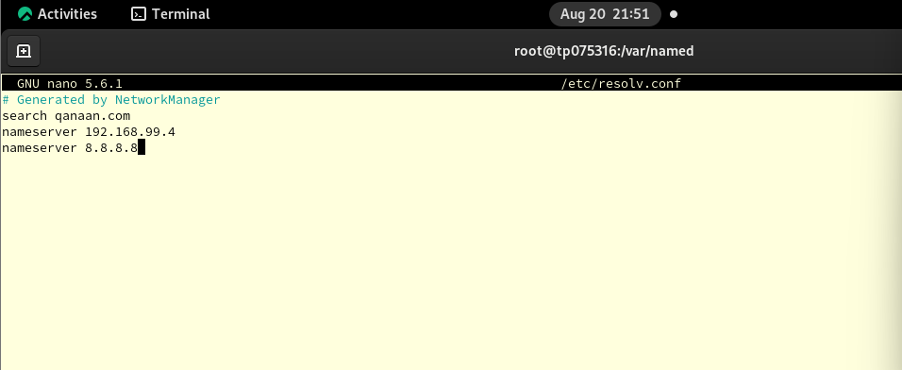 Figure 87: setting DNS server



Check the resolve.conf file for our DNS IP address and make sure that our DNS server IP (our Rocky Server) is at the beginning of the list, Using (“sudo nano /etc/resolv.conf”).

Once we are done press:

* Control + X
* Press Y
* Press Enter

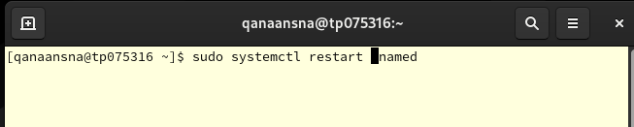 Figure 88: Restart named system

* Restarting the DNS server

## 6.7 Testing our DNS by using nslookup method in Rocky Server

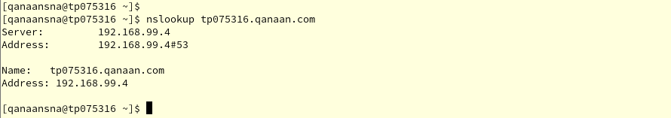 Figure 89: nslookup the server



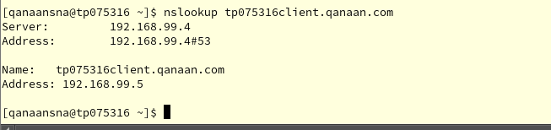 Figure 90: nslookup the client



To check if the DNS is working we use nslookup commands:

* (“nslookup tp075316.qanaan.com”)
* (“nslookup tp075316client.qanaan.com”)

## 6.8 Testing DNS by using ping method

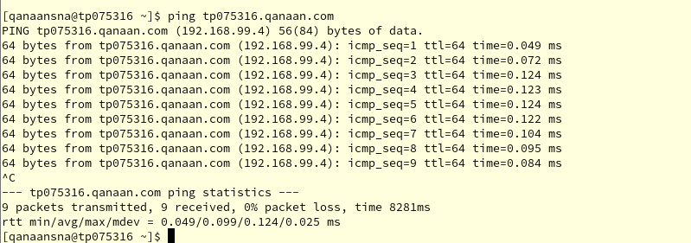 Figure 91: Ping the server by the domain

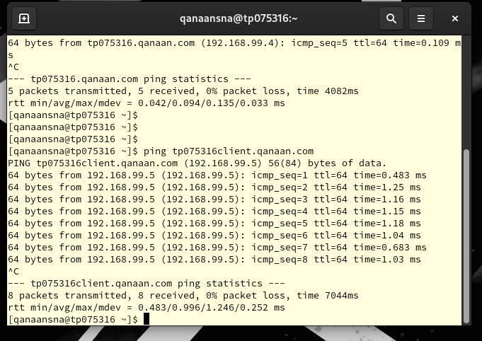Figure 92: Ping the client by the domain

# 7.0 **Ubuntu DNS client testing**

 Figure 93: update the system

* Starting with the command (sudo apt-get update), we need to update the system.

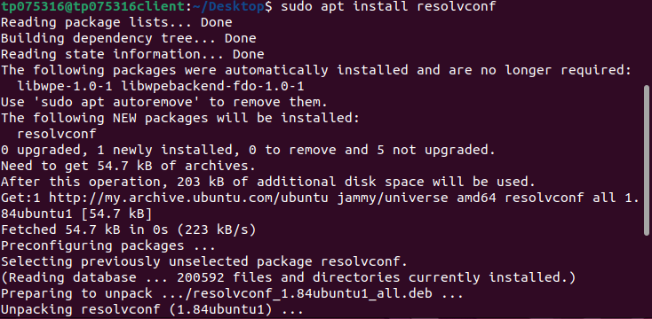 Figure 94: installation resolve package

In Rocky Linux, the /etc/resolv.conf file can be made from scratch with the sudo resolvconf -u command. When you run this command, the information in the resolvconf database is used to update the DNS resolver database. And use this command to install the resover package (“sudo resolvconf -u”).

 Figure 95

*  Figure 96: Edit texter resolve file
* This step is to add our Rocky DNS IP address to our resolver configuration file.

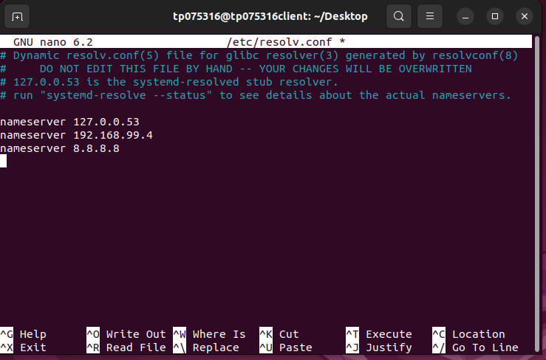 Figure 97: Adding Rocky IP & DNS

* Here we adding our IP address for Rocky Server and Google DNS server.

Once we are done press:

* Control + X
* Press Y
* Press Enter

 Figure 98

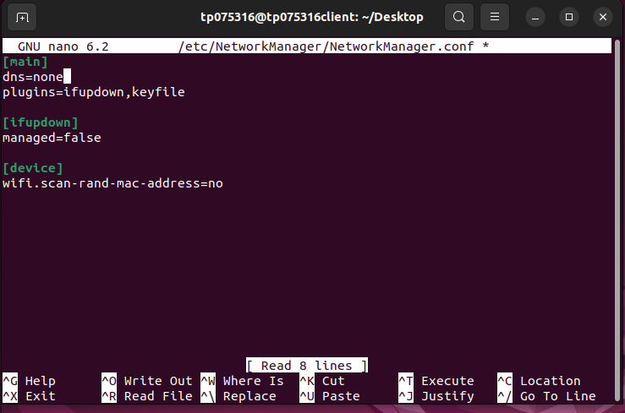Figure 99: set DNS as none



* Here we edit NetworkManager.conf file. We make sure that DNS=none

Once we are done press:

* Control + X
* Press Y
* Press Enter

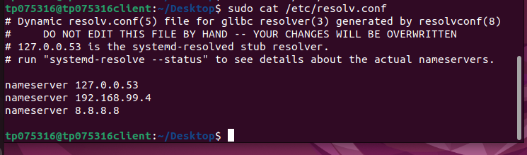 Figure 100: display resolv.cof



* This step to be sure that our Rocky IP address and Google DNS server is added to the file by using this command (“sudo cat /etc/resolv.conf”)

## 7.2 Testing the DNS in Ubuntu

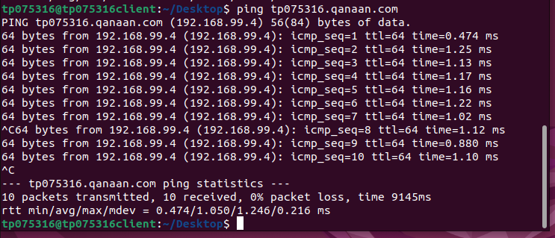 Figure 101: ping Rocky server by domain name



Ping is one way to see if our DNS Rocky server is up and running. The figure above shows that the client and the server are able to communicate with 0% packets lost, by typing (“ping tp075316.qanaan.com”) which is the hostname of my Rocky server.

# 8.0 **Install and configure DHCP server on Rocky Linux**

## 8.1 DHCP server:



Dynamic Host Configuration Protocol (DHCP) is a client or server protocol to manage the network using dynamic assigning an IP address to any device. With DHCP, hosts can get the necessary TCP/IP configuration data from a DHCP server.

DHCP provides network administrators with the ability to assign new IP addresses to devices when they move from one place to another. This eliminates the need for network administrators to manually configure each device with a working IP address or to reconfigure the device if it moves to a new location (Gillis, 2023).

Figure 102: Network manger file

First, we need to use the command (sudo nano /etc/NetworkManager/system-connections/enp0s3.nmconnection) to make sure that has nothing changed and the network configuration is correct.

## 8.2 DHCP installation

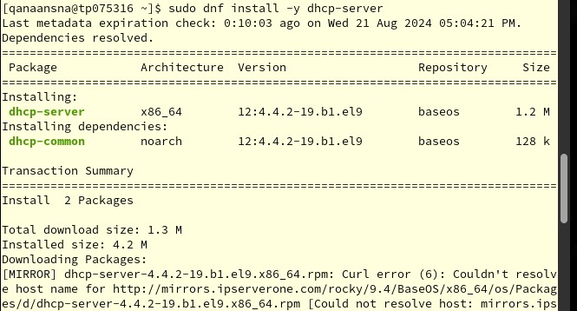Figure 103:DHCP installation

* In this step we will install the DHCP server in Rocky Linux by using the following command (“dnf install -y dhcp-server”)

## 8.3 DHCP configuration

  
Figure 104:BIND installation

* Creating configuration file for DHCPd:
* (“Sudo nano /etc/dhcp/dhcpd.conf”)

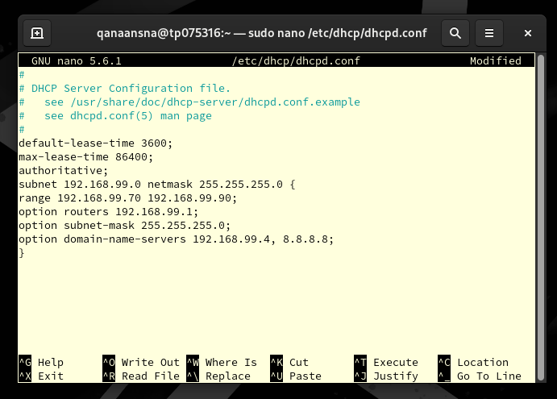Figure 105: DHCP configuration



Next, we need to set up our DHCP server. To do this, we will go to the dhcpd.conf file and add our IP address range, the default gateway, and the IP addresses of the DNS server.

**default-lease-time 3600**: Sets the DHCP lease's default lease time in seconds. The time is set to 3600 seconds here.

**max-lease-time 86400:** Sets the longest lease time that can be given to a DHCP client. In this case, 86400 seconds (24 hours) is chosen as the maximum.

**Authoritative**: This DHCP server is the authoritative server for the local network, as shown. This is important for getting rid of bad DHCP servers.   
**subnet** 192.168.99.0 **netmask** 255.255.255.0:

**range**: The set of IP addresses that the DHCP server can give out.

**option routers**: For this subnet, this is the default gateway.

**option subnet-mask:** The subnet mask of the network.

**option domain-name-servers:** domain-name-servers: This is the network's DNS servers.

**option domain-name**: The network domain name

Once we are done press:

* Control + X
* Press Y
* Press Enter

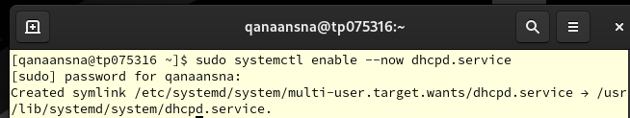Figure 106: enable DHCP service

* Enable our DHCP service by entering (“sudo systemctl enable --now dhcpd.service”) command
* Next let’s start our DHCP (“sudo systemctl start dhcpd”)

 Figure 107: start DHCP

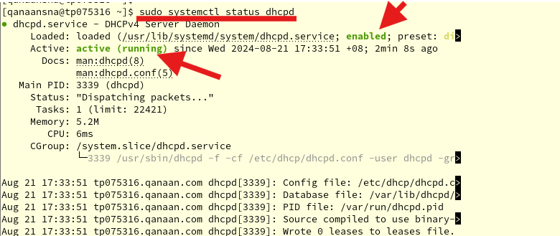Figure 108: status of our DHCP service

* Here we are checking the status of our DHCP service (“sudo systemctl status dhcpd”).

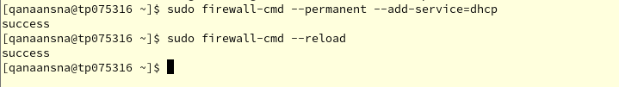Figure 109: Add DHCP and reload firewall

* In this step, we need to let DHCP client requests through the firewall using:
* (“sudo firewall-cmd --permanent --add-service=dhcp”)
* (“sudo firewall-cmd –-reload”)

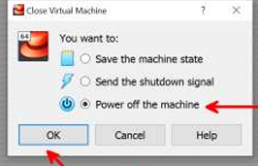  
Figure 110: Power off

* Now turn off the Rocky Linux

## 8.4 Modification for the network

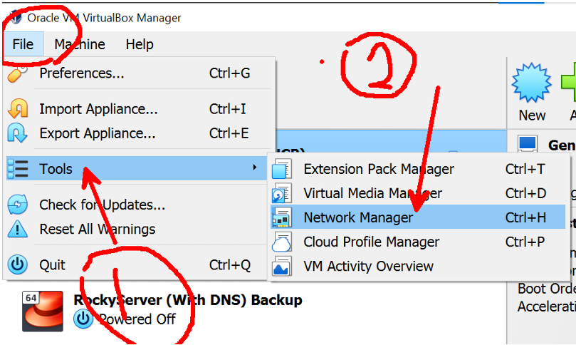Figure 111: Network manager

* Go to the network manager

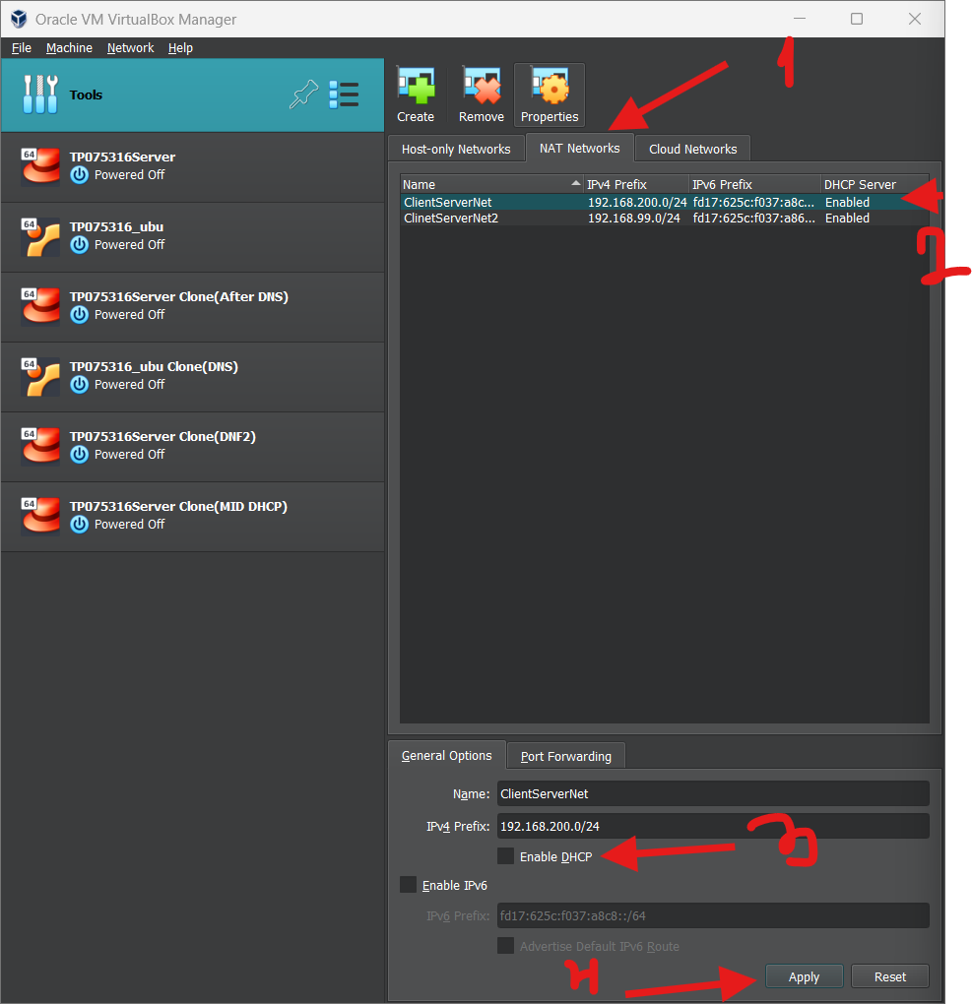Figure 112: Disable DHCP

* This step is important to let your client to receive an IP address within the range we set above.
* Now, We turn off DHCP on the virtual machine now that we have set up our own DHCP server on Rocky Linux. So, instead of getting its IP address from the virtual box, our client now gets it from the Rocky server.
* We can get into our NAT network and turn off DHCP. My NAT network might be different than the picture in my case is (“ClientsSrverNet2”).

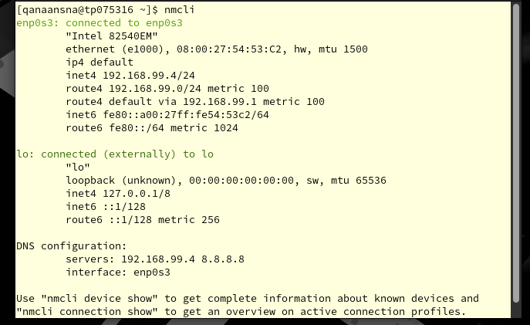Figure 113: nmcli



* To verify our connection ID we use (“nmcli”) command.

Figure 114

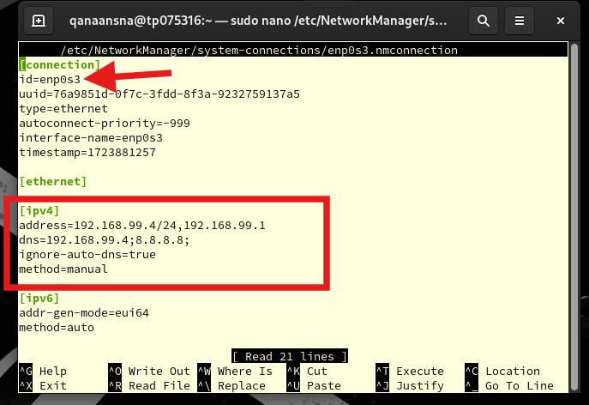  
Figure 115: Network manager file

After we enter the text editor for (“sudo nano /etc/NetworkManager/system-connections/enp0s3.nmconnection”), and then we check these two areas are set up correctly, and id has the same name as our connection.

Once we are done press:

* Control + X
* Press Y
* Press Enter

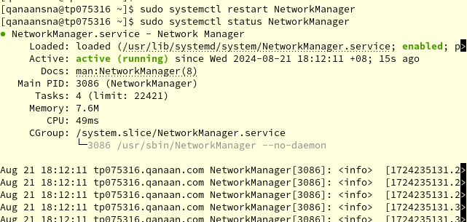 Figure 116: restart and status network manager

* AS the screenshots illustrate that our NetworkManager is active now

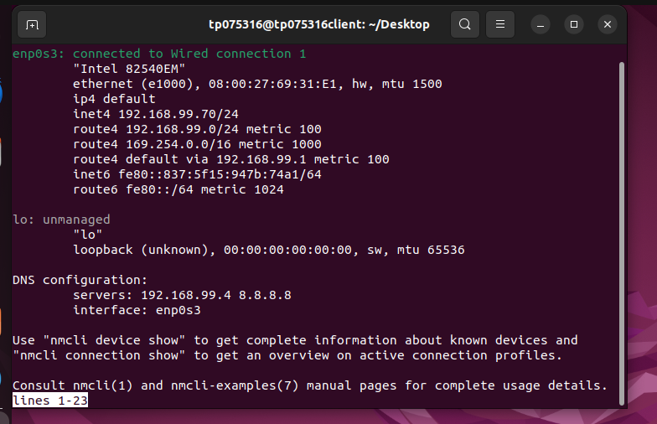 Figure 117: Ubuntu testing



* The client's new IP address, 192.168.99.71, is being sent by our Rocky DHCP server.

# 9.0 **BACK-UP steps**

## 9.1 Step 1

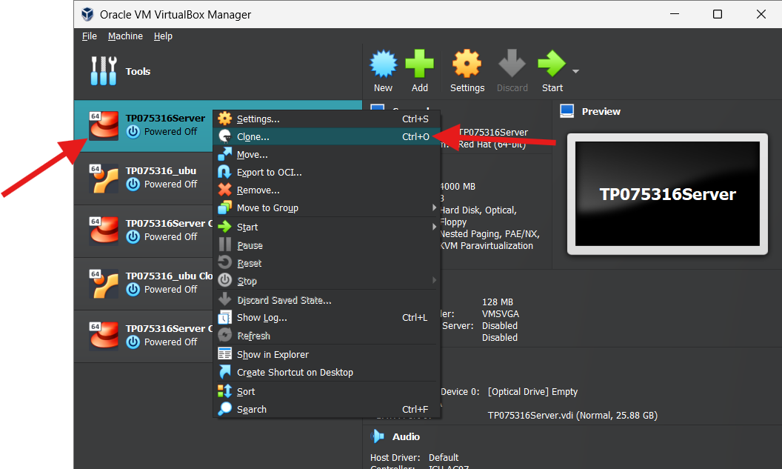  
Figure 118: Clone option

## 9.2 Step 2

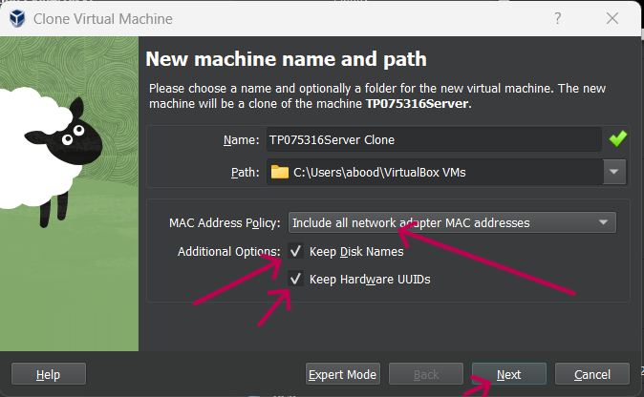  
Figure 119

## 9.3 Step 3

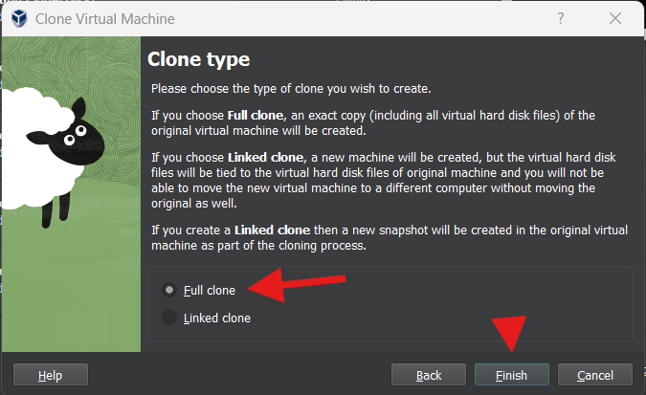  
Figure 120

# 10.0 **Email Server**



## 10.1 What is an email server?

Email server is a computer system that sends and receives emails, also known as a mail server. An email travels through several servers before arriving at its final destination. Emailing and receiving have a lot of complex components, even though the process is speedy and effective.   
  
Email communication requires a number of complicated processes and protocols. The email server is typically a computer or server with a complete system that includes various apps or services. Email servers can be divided into incoming and outgoing groups according to the kind of operation they carry out.

## 10.2 Installation of postfix

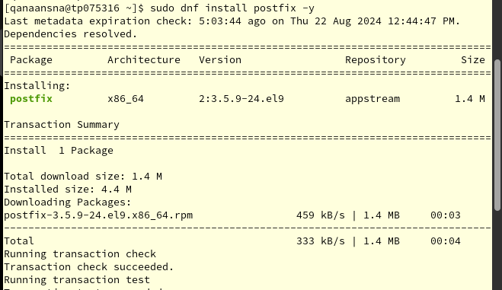 Figure 121: Postfix installation

First, we must install Postfix by using this command (sudo dnf install postfix -y ).

Postfix is a mail transfer agent , which means it sends and receives emails between servers. Set up Postfix and Dovecot as an email server. Postfix is an email transfer agent that lets people share emails over the Internet and within their own network. Postfix's benefit is that it's easy to set up and configure. The system message can be sent with this.

## 10.3 Postfix configuration

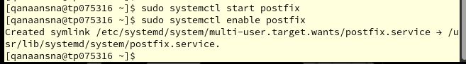 Figure 123: start and enable Postfix

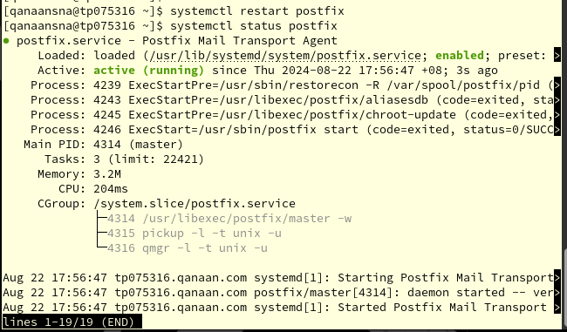 Figure 124: postfix status

* We start Postfix, enable, restart, and display the status and now our Postfix is active as it shown above.

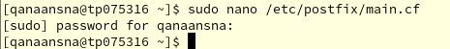  
Figure 125

* We go to the text editor of (**sudo nano /etc/postfix/main.cf) file**

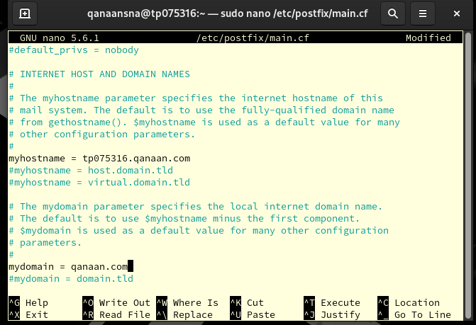 Figure 126: Postfix main file configuration

We take the # out of "myhostnaame." In the same figure, I set the hostname to tp075316.qanaan.com. We can also uncomment "mydommain" and set it to (qanaan.com)

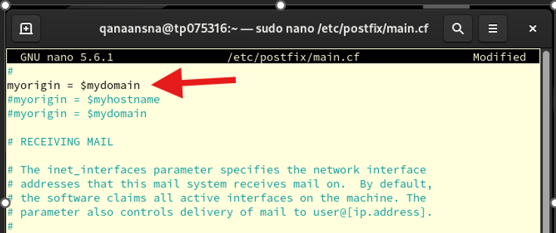 Figure 127: Postfix main file configuration

Also, we uncomment (myorigin =$mydomain).

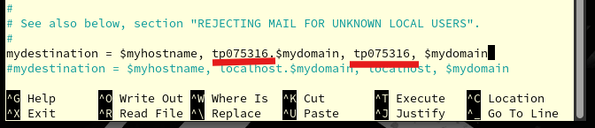 Figure 128: Postfix main file configuration

We take out the comment and set the destination to (mydestination = $myhostname, tp075316, $mydomain, tp075316, $mydomain)

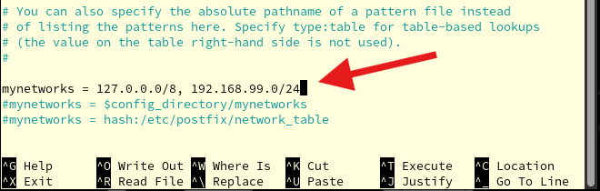  
Figure 129: Postfix main file configuration

In this step we put our IP within mynetworks.

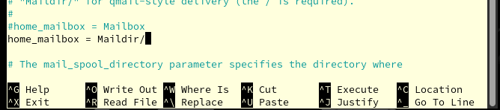 Figure 130: Postfix main file configuration

Uncomment (home_mailbox)

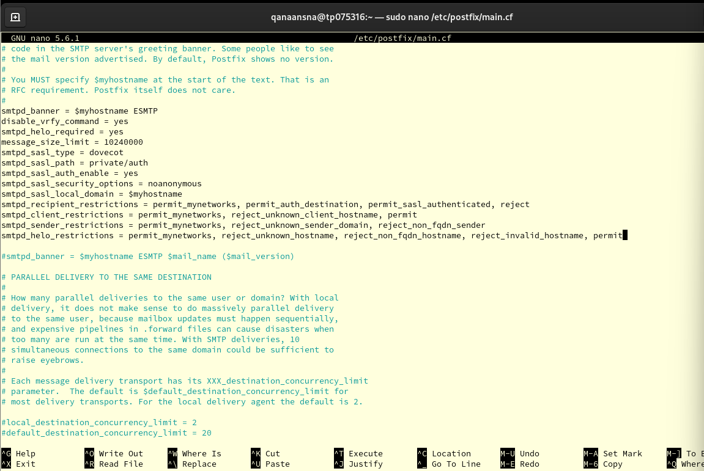 Figure 131: Postfix main file configuration

Brief explanation of the commands:

1. **smtpd_banner:** Sets the message that the SMTP server sends to clients as a banner when they join.
2. **disable_vrfy_command**: Turns off the VRFY command, which is used to make sure that an email address exists.
3. **smtpd_helo_required:** Clients must send either HELO or EHLO before they can send any other orders.
4. **message_size_limit:** It tells the computer how big of an email it can handle.
5. **smtpd_sasl_type:** Picks the type of SASL verification to use, which in this case is Dovecot.
6. smtpd_sasl_path: Sets the SASL identity database's path.
7. **smtpd_sasl_auth_enable:** Enables SASL authentication.
8. **smtpd_sasl_security_options:** Sets the SASL security options (no anonymous authentication allowed).
9. **smtpd_sasl_local_domain:** Sets the local domain for SASL authentication.
10. **smtpd_recipient_restrictions:** Sets the restrictions for recipient addresses.
11. **smtpd_client_restrictions:** Sets the restrictions for client connections.
12. **smtpd_sender_restrictions:** Sets the restrictions for sender addresses.
13. **smtpd_helo_restrictions:** Sets the restrictions for HELO/EHLO commands.

Once we are done press:

* Control + X
* Press Y
* Press Enter

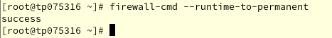  
Figure 132: Save firewall settings

* Now, we save the current firewall settings.

## 10.4 Dovecot Installation and Configuration

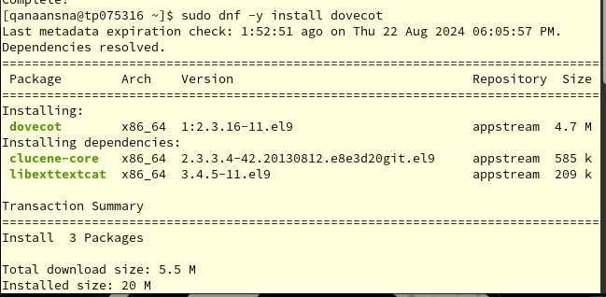 Figure 133: Dovecot installation

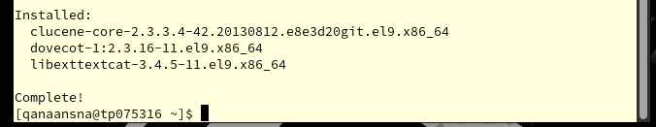 Figure 134: Dovecot installation

* We used the command (sudo dnf -y install dovecot) to install Dovecot

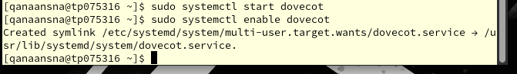 Figure 135: start and enable Dovecot

- (“ sudo systemctl start dovecot”) starts the Dovecot email server service

-(“ sudo systemctl enable dovecot”) sets Dovecot to start automatically on system boot.

## 10.5 What is Dovecot?

Security is critical for any email server, and Dovecot's developers had this in mind when they created it. However, this open-source IMAP and POP3 email server is capable of more.   
  
This is best suited for both large and small installations, and it is made for systems that resemble Linux/UNIX. Dovecot is memory-light, fast, simple to set up, and requires no additional administrative effort (*What Is Dovecot? Hosting Wikipedia*, 2021)

## 10.6 Dovecot configuration

  
Figure 136

* The command (“sudo nano /etc/dovecot/dovecot.conf”) opens the Dovecot configuration file

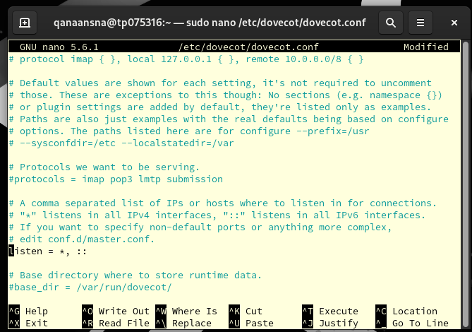  
Figure 137: Dovecot main file configuration

* ("listen = *,::"): indicates that Dovecot will listen on all available IPv4 and IPv6 interfaces.

Once we are done press:

* Control + X
* Press Y
* Press Enter

 Figure 138

* The Dovecot authentication configuration file can be edited by running the command (“sudo nano /etc/dovecot/conf.d/10-auth.conf.”)

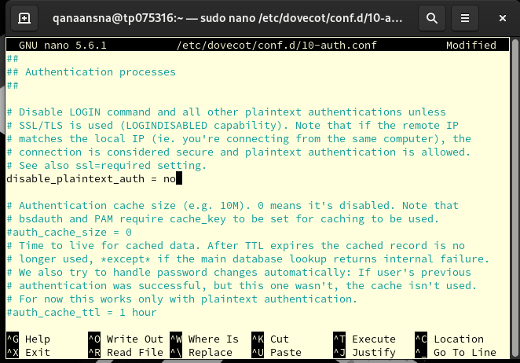 Figure 139: 10-auth.con

In the Dovecot authentication setup file, the setting (disable_plaintext_auth = no) decides if plaintext authentication is allowed or not. If this option is set to no, plaintext authentication will not work unless SSL/TLS is used. This makes things safer by keeping passwords from being sent in plain text.

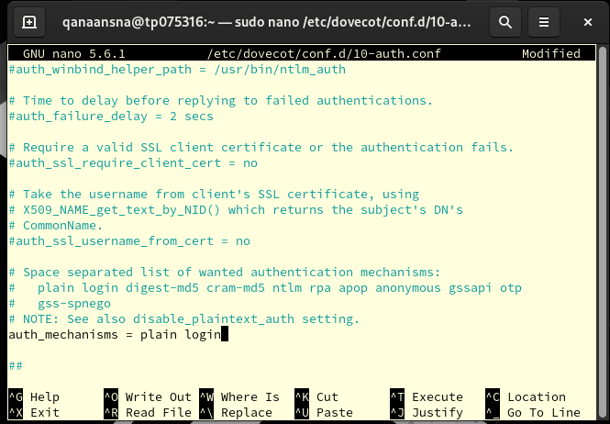 Figure 140: 10-auth.con

The (auth_mechanisms) setting in the Dovecot authentication setup file tells Dovecot what kinds of authentication to accept. At this point, only plain and login security are turned on.

Once we are done press:

* Control + X
* Press Y
* Press Enter

 Figure 141

* (“sudo nano /etc/dovecot/conf.d/10-mail.conf”) opens the Dovecot mail configuration file

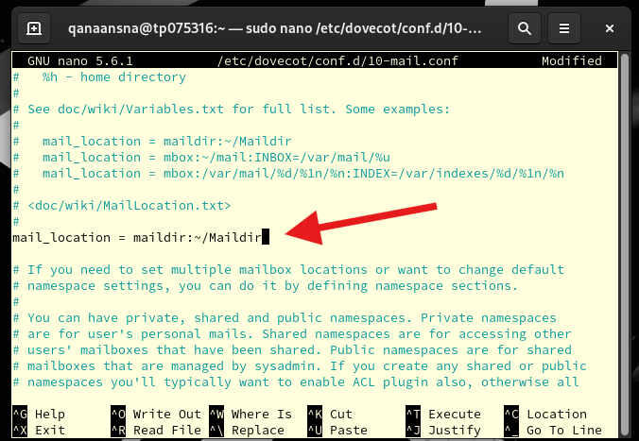  
Figure 142: 10-mail.conf

* (mail_location = maildir:~/Maildir) shows that mailboxes should be kept in the user's home directory in the Maildir format.

Once we are done press:

* Control + X
* Press Y
* Press Enter

  
Figure 143

* The command sudo nano /etc/dovecot/conf.d/10-master.conf opens the Dovecot master configuration file

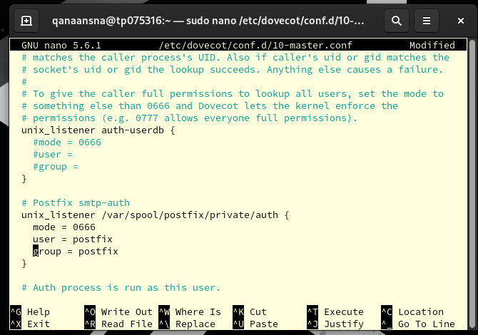  
Figure 144: 10-master.conf

In the Dovecot master configuration file, the (unix_listener) blocks set up the UNIX ports that Dovecot will use to listen for authentication requests. Other services, like Postfix, use these links to make sure that users are who they say they are.  
In Dovecot, the (auth-userdb) listener is used for authentication against the user database. In Postfix, the /var/spool/postfix/private/auth listener is used for authentication against Postfix's own user database.

unix_listener /var/spool/postfix/private/auth {

mode = 0666

user = postfix

group = postfix

}

The mode is set to 0666. Assigns the socket permissions as 0666, granting both read and write access to all users. This permission level is essential for facilitating communication between Postfix and Dovecot.   
The user and group named "postfix" should be assigned as the owners of the socket. This will ensure that Postfix has the necessary rights for using the socket.

Once we are done press:

* Control + X
* Press Y
* Press Enter

 Figure 145

* opens the Dovecot SSL configuration file using (“sudo nano /etc/dovecot/conf.d/10-ssl.conf”)

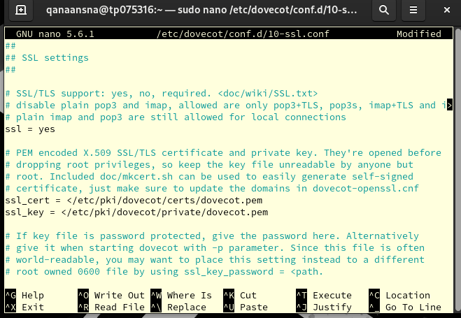  
Figure 146: 10-ssl.conf

* **SSL = yes**: This tells Dovecot to accept SSL/TLS.
* **ssl_cert = </etc/pki/dovecot/certs/dovecot.pem:** This tells the computer where to find the X.509 SSL/TLS certificate file that is stored in PEM.
* **ssl_key = </etc/pki/dovecot/private/dovecot.pem**: This tells the computer where to find the SSL/TLS certificate's PEM-encoded private key file.

Once we are done press:

* Control + X
* Press Y
* Press Enter

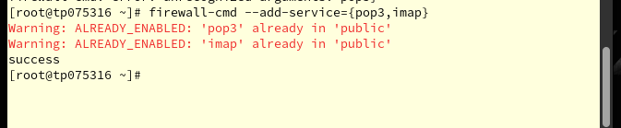  
Figure 147: Adding pop3 & imap to the firewall

The command (“firewall-cmd --add-service={pop3,imap}”) tries to make the public zone of the firewall include the POP3 and IMAP services.

  
Figure 148

The command echo ('export MAIL=$HOME/Maildir' >> /etc/profile.d/mail.sh) adds the line export (MAIL=$HOME/Maildir to the /etc/profile.d/mail.sh) script. This will set the MAIL environment variable to $HOME/Maildir for all users who log in. This is often used to provide the default location for email storage.

## 10.7 Testing the email server

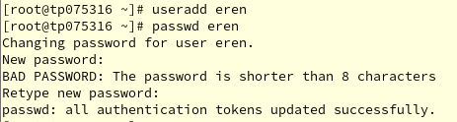  
Figure 149: Create a user & set a password

In this step we create a new user by using the command (“useradd eren”) and set a password by using the next command (“passwd eren”) in my case eren is my other account

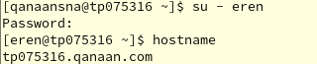  
Figure 150: Switch to the new user

* Now we check if we can switch to our new user.
* Then we return to our main account by using (“su”) or press (“control + D”)

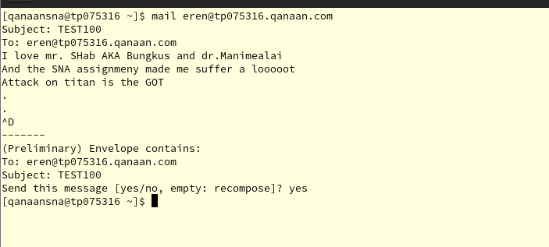 Figure 151: Sending an email

This command (“mail eren@tp075316.qanaan.com”) is going to send an email to the address (eren@tp075316.qanaan.com).

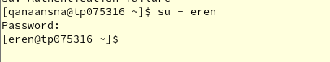  
Figure 152: Switch to eren user

* After that we switch the user to the eren account by typing (“su - eren”)

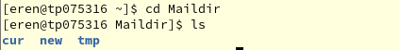  
Figure 153: Entering to Maildir directory

* The first command (“cd Maildir”) changes the current directory to the Maildir directory
* (“ll”) command lists the contents of the current directory, in this case are the subdirectories cur, new, and tmp

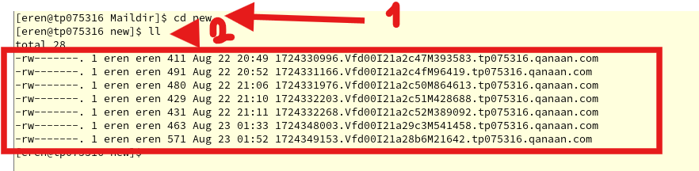 Figure 153: Entering to new subdirectory

After you type (“cd new”), the current directory switch to the new subdirectory in the Maildir directory. Usually, new emails are stored in this folder, as the figure illustrates that has been received 7 emails.

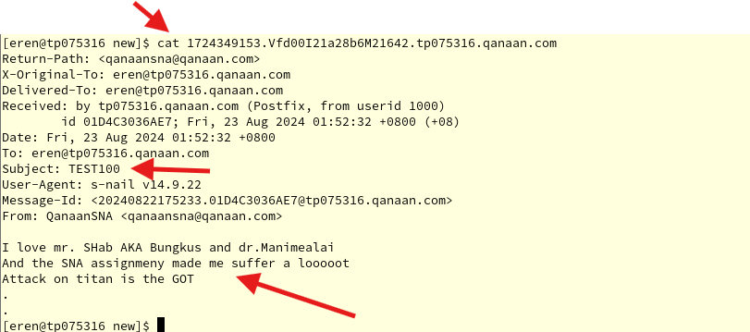 Figure 154: Displaying the email

* We use the cat command to displays the contents of the email message stored in the file like this example: (“cat 1724349153.Vfd00121a28b6M21642.tp075316.qanaan.com”)
* Just type the command (cat) and a few numbers, then click the tab to auto-write the rest.

## 10.8 Thunderbird mail

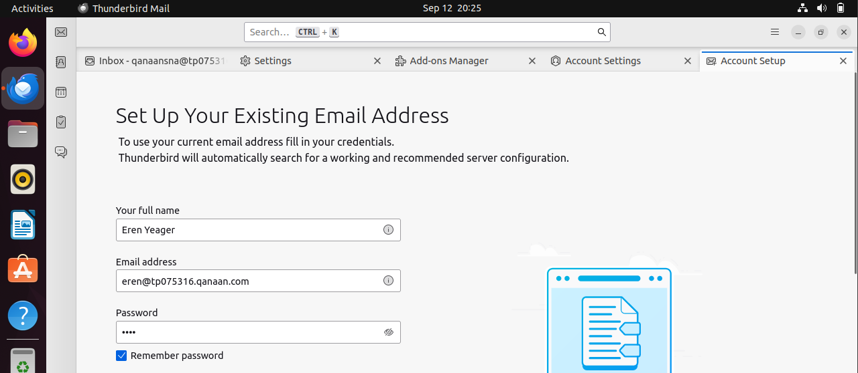Figure 155: Thunderbird Mail in Ubuntu

Next, we test the email server in Ubuntu by going to the Thunderbird Mail platform and setting up our email address.

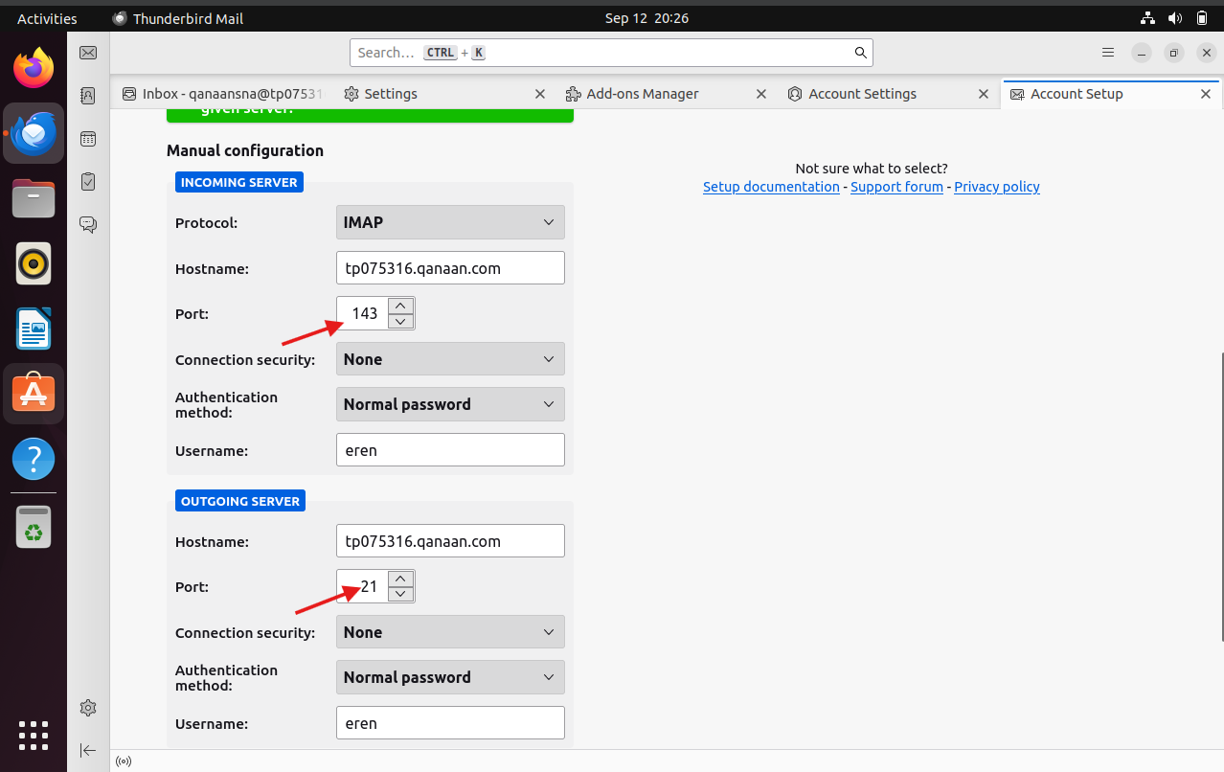  
Figure 156: Set up the account



The figure above illustrates the setup of the email server

Incoming Server:

* Protocol: IMAP
* Hostname: tp075316.qanaan.com
* Port: 143
* Connection security: None
* Authentication method: Normal password
* Username: eren

Outgoing Server:

* Hostname: tp075316.qanaan.com
* Port: 21 (Here the port number is supposed to be 25 which is for SMTP sending and receiving emails however, in my case Thunderbird mail find a connection in port 21.)
* Connection security: None
* Authentication method: Normal password
* Username: eren

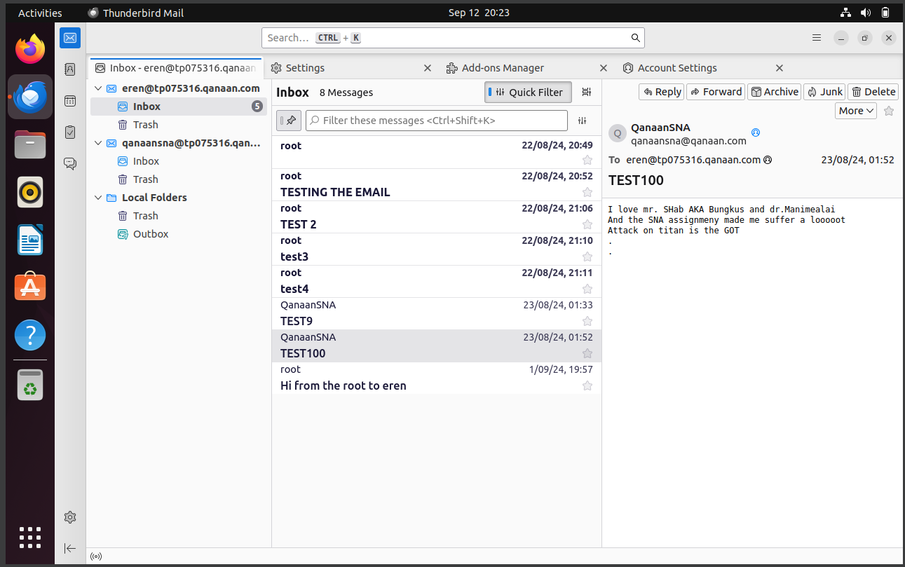Figure 157: All emails received in Thunderbird Mail

Now we can see the emails that are being sent to the email.

# 11.0 **Apache web Serer**

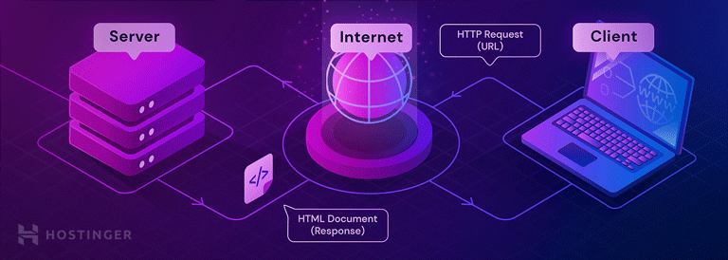

## 11.1 What is Apache?

Apache web Server is an open-source and free web server that delivers online content. Although it was clarified back in 2000, it is commonly believed that Apache got its name from its development history and process of improvement through the application of patches and modules. It was discovered that the Native American tribe respected the name because of its resilience and durability (Hernandez, 2019).

## 11.2 Uses of Apache Web Server:

Web hosting: It's the most popular web server used to host websites of all kinds, from massive e-commerce sites to individual blogs.

Operating web applications: PHP, Python, and Ruby-coded dynamic web applications can be served by Apache.

Reverse proxying: Apache is capable of transferring requests to different servers or programs in a proxy fashion.

## 11.3 Installation of Apache Web Server

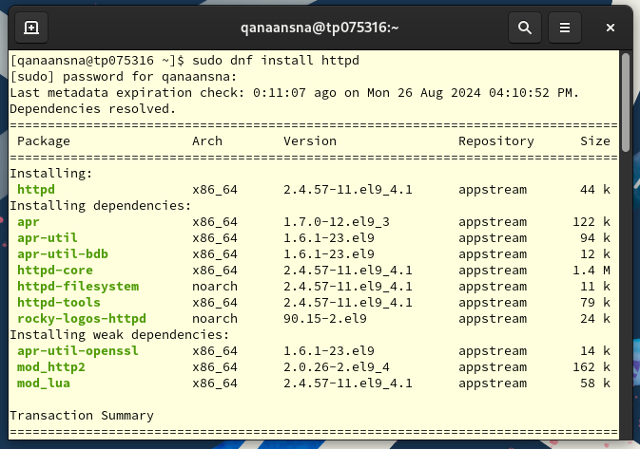 Figure 158: install httpd

* This command installs the httpd package, the main Apache HTTP Server package.

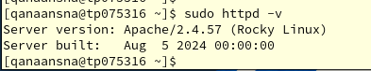  
Figure 159: version of the Apache HTTP

* Checking the version of the Apache HTTP Server installed

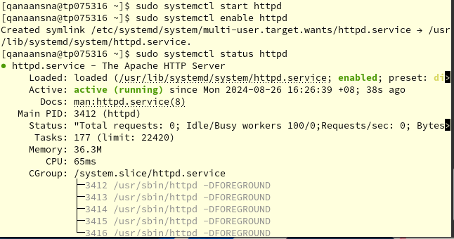 Figure 160: Start, enable and status httpd

* (“sudo systemctl start httpd”) starts the Apache HTTP Server
* (“sudo systemctl enable httpd”) sets Apache to start automatically on system boot
* (“sudo systemctl status httpd”) checks the status of the Apache HTTP Server

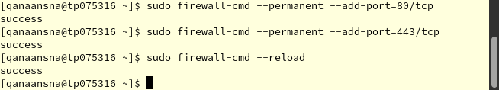 Figure 161: Adding ports to firewall

* The first command allowing incoming traffic on this port 80/tcp (“sudo firewall-cmd --permanent --add-port=80/tcp”)
* Second command add the port 443 (HTTPS) to the firewall (“sudo firewall-cmd --permanent --add-port=443/tcp”)
* Lastly, (“sudo firewall-cmd –reload”) applying the changes to the firewall

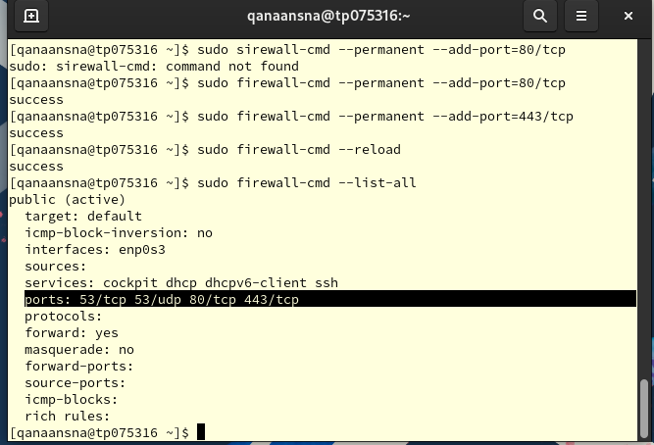 Figure 162: Checking the added ports

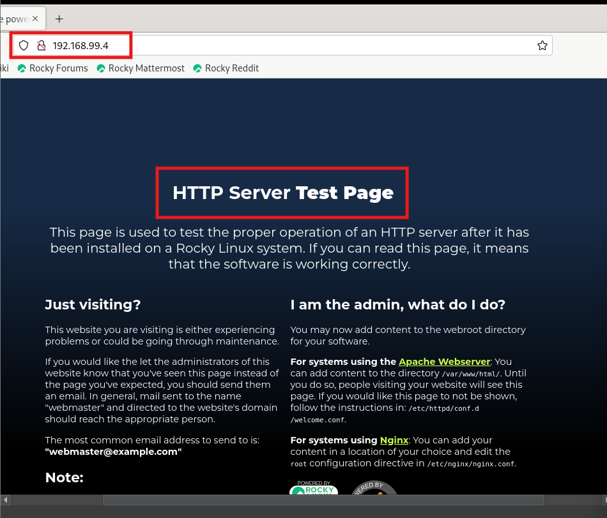 Figure 163: HTTP server test page

* we check the page to see if the HTTP server is working right. If you can see this page, that means the server is working right.

 Figure 163

* Now we go to the text editor in this configuration file (“sudo nano /etc/httpd/conf.d/tp075316-qanaan.net.conf”)

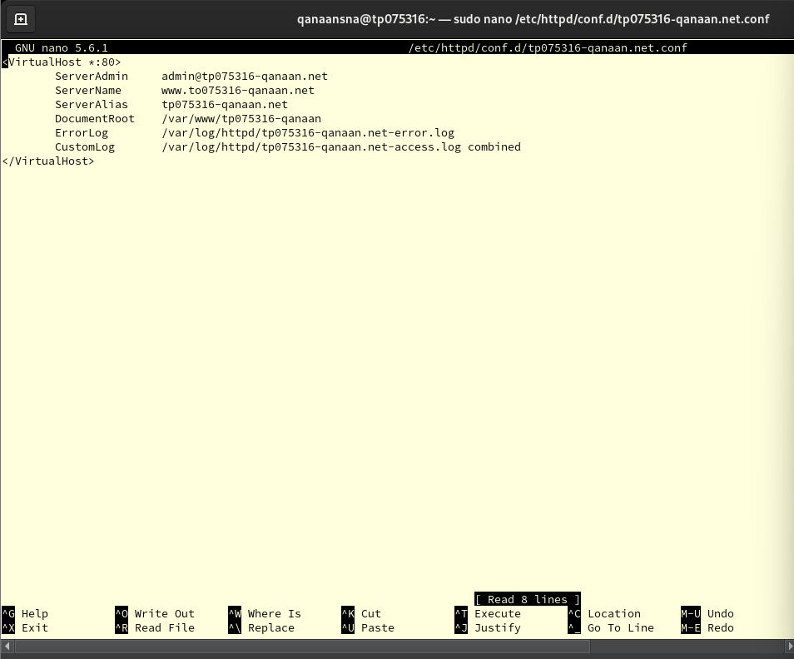 Figure 164: set up for virtual host

* The first block tells the Apache server how to set up a virtual host. All network devices will listen on port 80 for this virtual host, which is shown by the *:80.
* (“ServerAdmin [admin@tp075316-qanaan.net](mailto:admin@tp075316-qanaan.net)”): It sets the server administrator's email address.
* (“ServerName [www.tp075316-qanaan.net](http://www.tp075316-qanaan.net)”): This line will set up the server name.
* (“DocumentRoot /var/www/tp075316-qanaan”): Names for the directory where the website's information will be saved.
* (“ErrorLog /var/log/httpd/tp075316-qanaan.net-error.log”): set the path for the error log file.
* (“CustomLog /var/log/httpd/tp075316-qanaan.net-access.log combined”): The path to the access log file and the style for the log entries as a whole are set.

Once we are done press:

* Control + X
* Press Y
* Press Enter

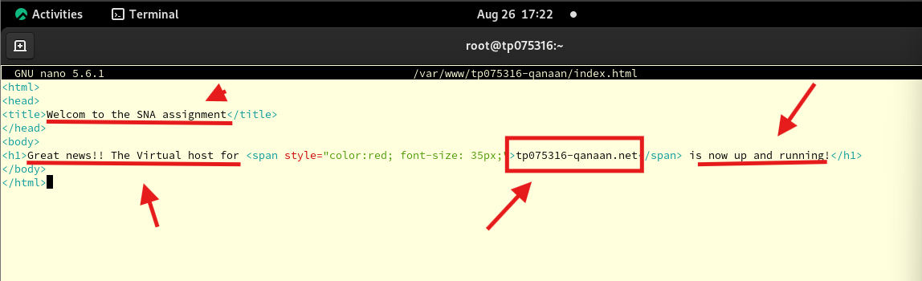 Figure 165: Set a message for the website

Next, we edit this file (“sudo nano /var/www/tp075316-qanaan/index.html”). This HTML file is a basic webpage with a message indicating that the virtual host setup for tp075316-qanaan.net was successful. "Welcome to SNA assignment" is the title of the page, and the announcement that the virtual host is operational appears in the main heading. To attract attention, the domain name tp075316-qanaan.net is larger in font and highlighted in red. This page confirms that the virtual host is reachable and that the web server configuration is operating as intended.

Once we are done press:

* Control + X
* Press Y
* Press Enter

Figure 166:Changing ownership

The command above (“sudo chown -R $USERD: $USER /var/www/tp075316-qanaan/index.html”) changes the ownership of the file (/var/www/tp075316-qanaan/index.html) and also do the same thing for all its subdirectories.

Figure 167: Details of the file

* Displaying the details of the file

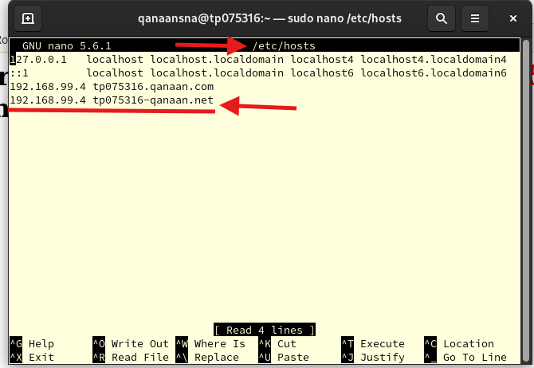 Figure 168: Adding Apache website name and IP server

* In this step we need to go to (“sudo nano /etc/hosts”) to add our Apache website domain

Once we are done press:

* Control + X
* Press Y
* Press Enter

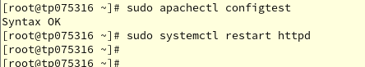  
Figure 169: Checking syntax errors

* Here we check if there are any syntax errors by using (“sudo apachectl configtest”) command
* Lastly, we restart our httpd server by running (“sudo systemctl restart httpd”) command

## 11.4 Testing Apache server:

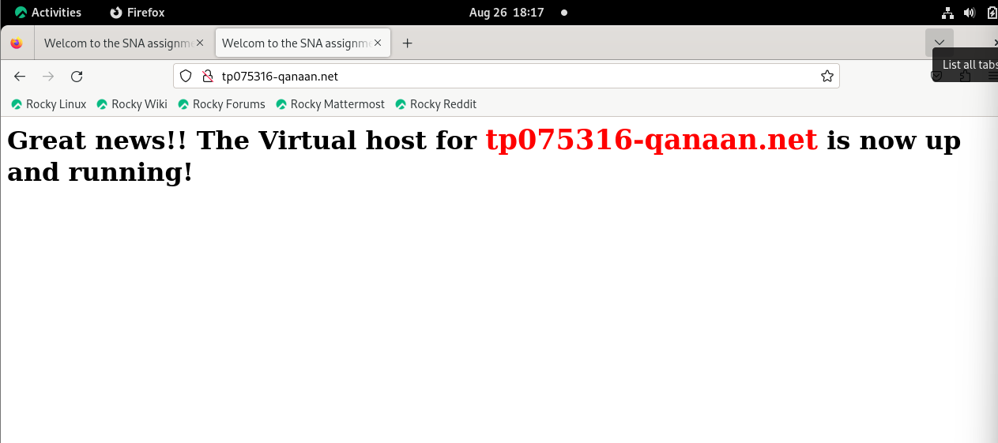 Figure 170: Open the Apache web server by domain



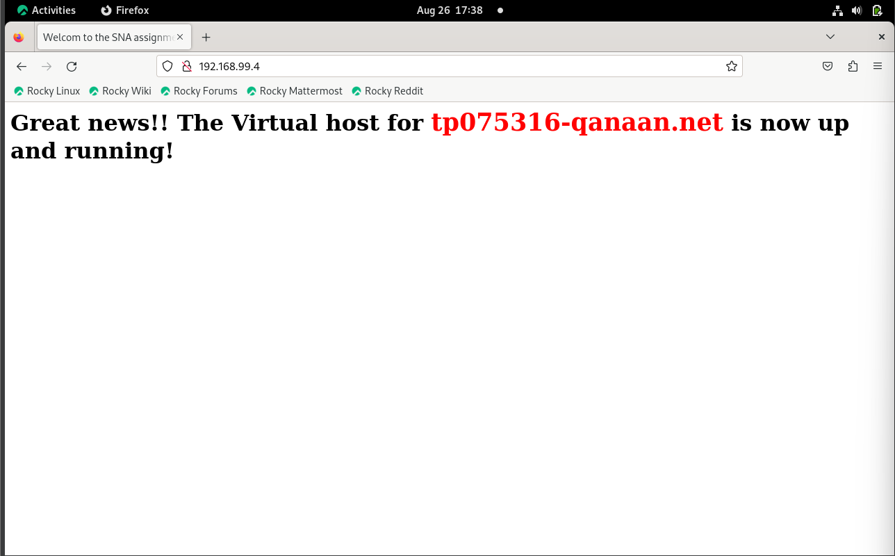 Figure 171: Open the Apache web by IP address



## 11.5 Implementation SSL/TLS for Apache web server

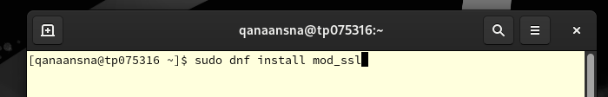 Figure 172: Download mod_ssl

By installing the (mod_ssl) module for the Apache HTTP Server, the command (“sudo dnf install mod_ssl”) makes SSL/TLS encryption available for secure communication.

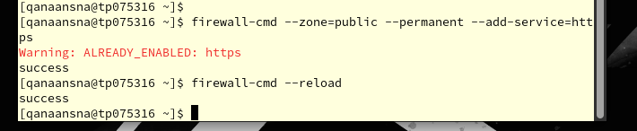 Figure 173: Firewall

* By adding the command (“sudo firewall-cmd --zone=public --permanent --add-service=https”) the HTTPS service to the firewall's public zone, this command opens port 443 (HTTPS) to incoming traffic.
* Next, we reload the firewall to apply the changes by typing (“firewall-cmd --reload”)

 Figure 174: creating files

* For the Apache HTTP Server, this command creates a fresh self-signed SSL/TLS certificate. (“sudo openssl req -newkey rsa:2048 -nodes -keyout /etc/pki/tls/private/httpd.key -x509 -days 365 -out /etc/pki/tls/certs/httpd.crt”)

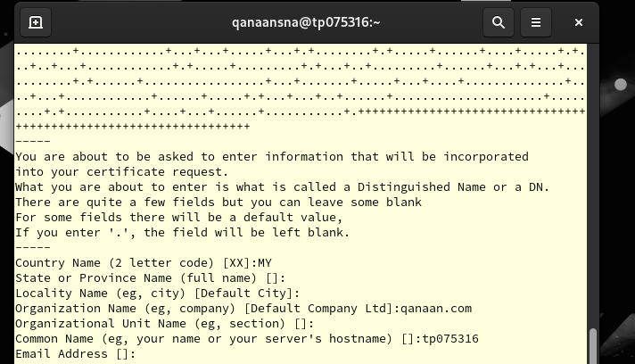 Figure 175: Certificate information

* Here we write our organization information that will be displayed in our certificate

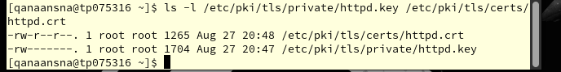 Figure 176: Displaying the created files

* In this step we check the SSL/TLS certificate that was created in the earlier step.

  
Figure 177

* (“sudo nano /etc/httpd/conf.d/ssl.conf”): This command is used to open the SSL configuration file.

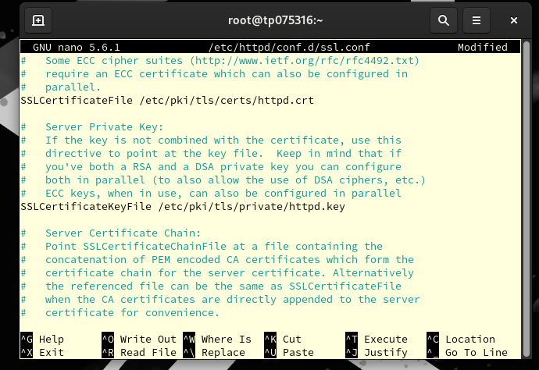 Figure 178: SSL configuration



* (“/etc/pki/tls/certs/httpd.crt”) is the SSLCertificateFile. This line gives the location of the SSL certificate file that HTTPS connections will use.
* (“SSLCertificateKeyFile /etc/pki/tls/private/httpd.key”): This line specifies the path to the private key associated with the SSL certificate.

Once we are done press:

* Control + X
* Press Y
* Press Enter

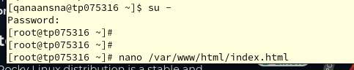  
Figure 179: Switching to root

* Now we go to the root user, then we go to the text editor for (“nano /var/www/html/index.html”) file.

3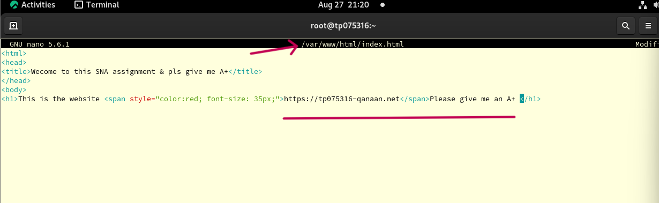  
Figure 180: Set a message for Apache website

Structure:

* **<html>:** his tag tells HTML where to start and stop a document.
* **<head>:** This tag holds meta-information about the HTML file, like the title.
* **<title>:** This tag makes the page's title "Welcome to this SNA assignment; please give me an A+."
* **<body>:** This tag contain the visible content of the web page.

Content:

* **<h1>:** This tag defines the heading of the page, which displays the message "This is the website <https://tp075316-qanaan.net> Please give me an A+".
* **<span>:** is used to style the text inside it. It makes the text red and the font size 35 in this case.

Once we are done press:

* Control + X
* Press Y
* Press Enter

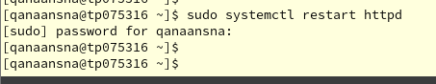  
Figure 181: Restart httpd

* Lastly, we restart the Apache server using (“sudo systemctl restart httpd”).

## 11.6 Testing Apache Website

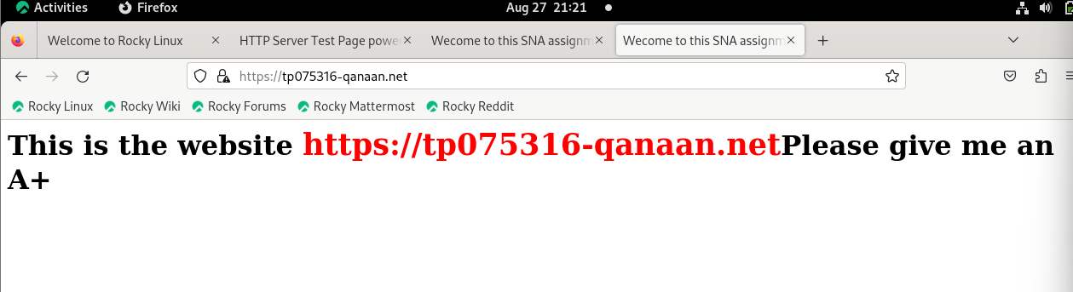 Figure 182: Apache website is secure with https



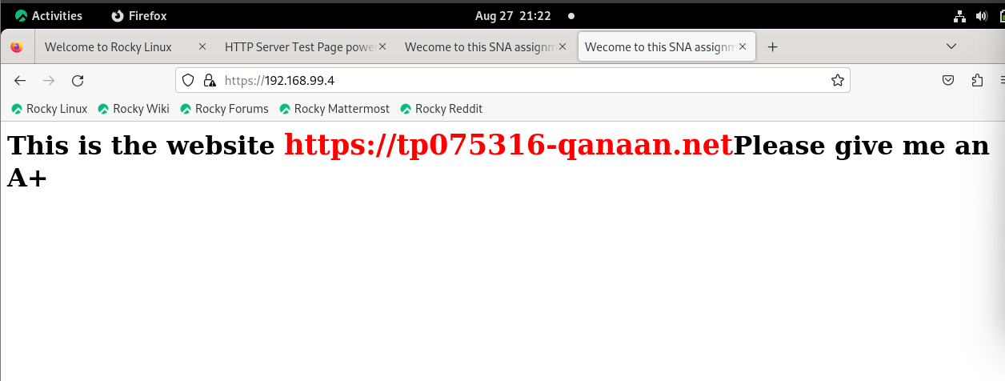 Figure 183: Apache website is secure with https



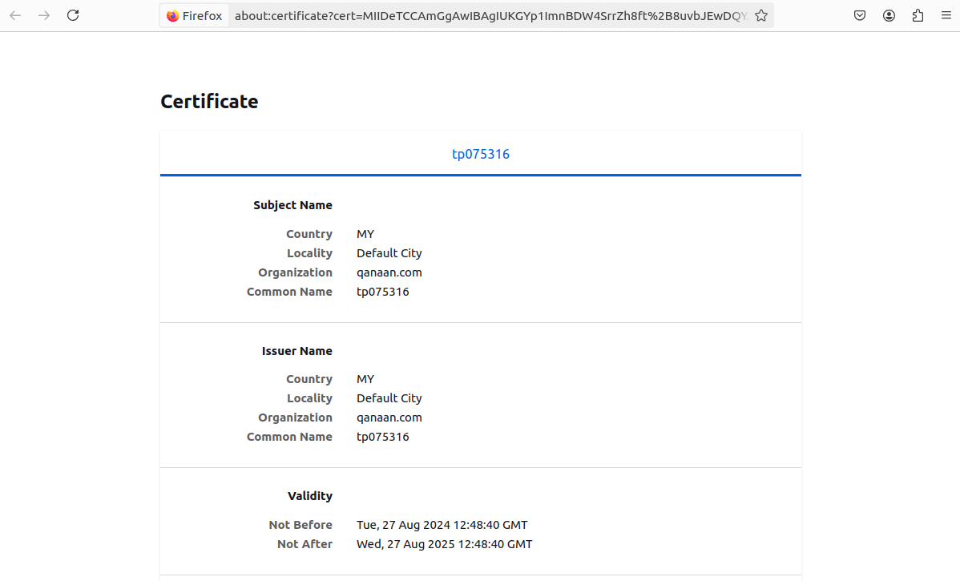  
Figure 184: Certificate

- As shown in the figures above, the Apache web server is now secure with HTTPS and has its own self signed certificate.

## 11.7 Testing Apache website on Ubuntu

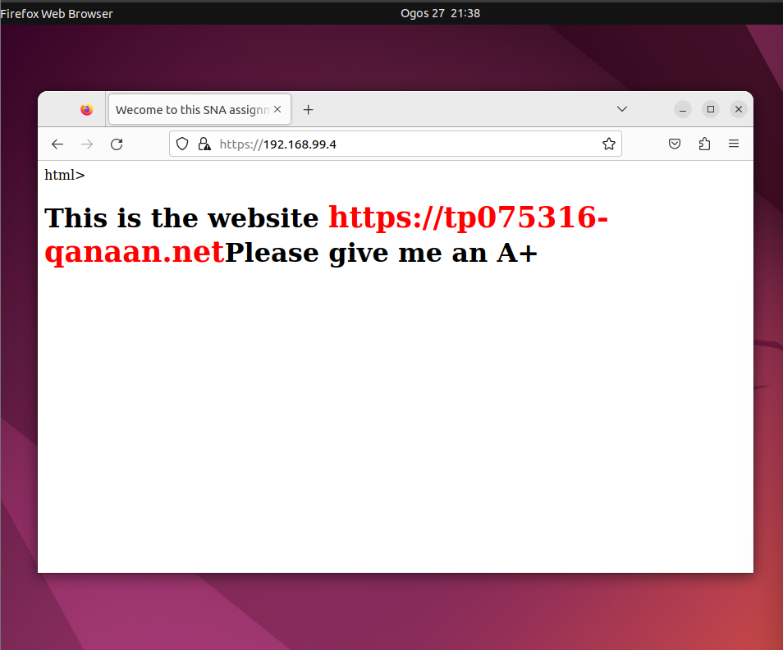 Figure 185: Apache website is secure with https



  
Figure 186: Certificate

* The Apache web server now has its own self signed certificate and is secured using HTTPS.

# 12.0 **FTP**

## 12.1 FTP Server

File transfer protocol server ( FTP Server) is software for computers that makes it easier to exchange files securely over a TCP/IP network. It uses the file transfer protocol (FTP), a common network-level communication protocol, to securely connect the devices in a client-server architecture and effectively send data across the internet.

## 12.2 FTP installation for Rocky Server

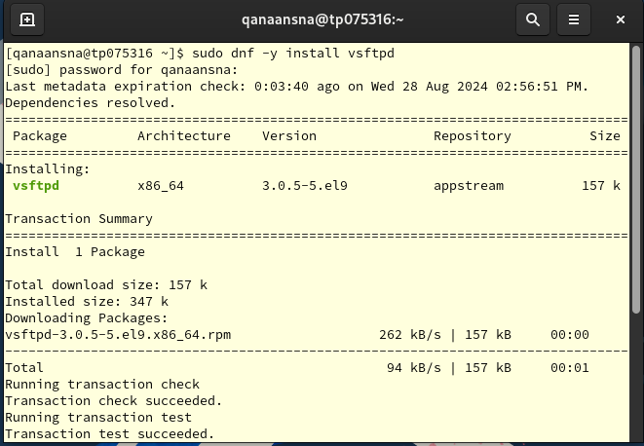Figure 187: vsftpd installation

* Installing the vsftpd package

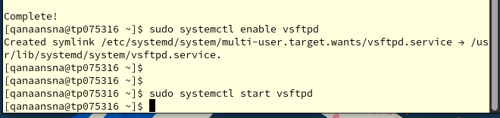  
Figure 188: enable and start vsftpd

* First,we must enable the (“sudo systemctl enable vsftpd”) service to start automatically on system boot.
* (“sudo systemctl start vsftpd”) This command starts the vsftpd service.

  
Figure 189

* Open configuration file (“sudo nano /etc/vsftpd/vsftpd.conf”).

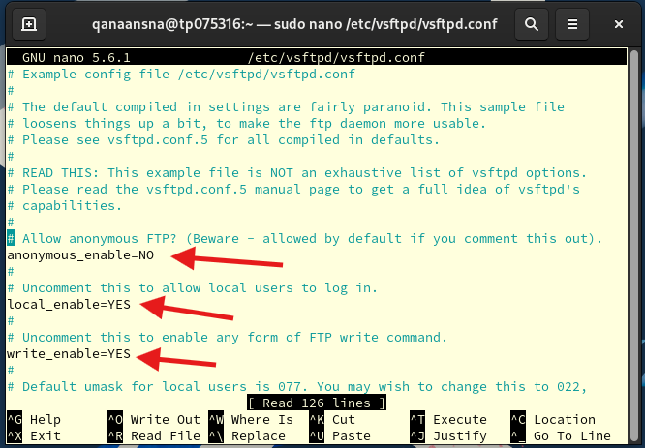 Figure 190: vsftpd main configuration file

Configuration settings in the VSFTPD:

* **anonymous_enable=NO:** By doing this, users are prevented from logging in without a working username and password and anonymous FTP access is disabled.
* local_enable=YES: This allows local users with system accounts to access files through FTP.
* write_enable=YES: This enables users to use FTP to upload files to the server.

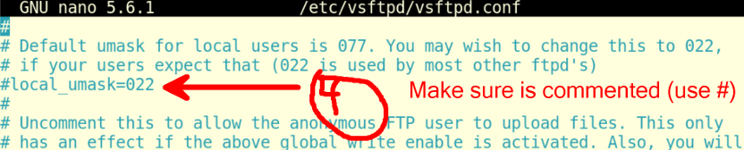Figure 191: vsftpd main configuration file

* Make sure the command (“local_umask=022”) is using hashtag sign at the beginning of the line # because this causes newly created files and directories to have 022 as their default mask which makes the owner obtain authorization to read, write, and execute (6) and for the groups get permission read only (4).

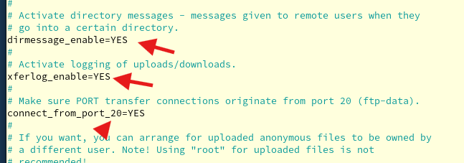  
Figure 192: vsftpd main configuration file

* **xferlog_enable=YES:** This records FTP file transfers in a log file for oversight and auditing needs.
* **connect_from_port_20=YES:** FTP clients can connect to the server using the standard FTP port 20.

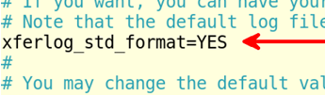  
Figure 193: vsftpd main configuration file

* **xferlog_std_format=YES:** Because it follows the standard format for the transfer log, this is simpler to interpret.

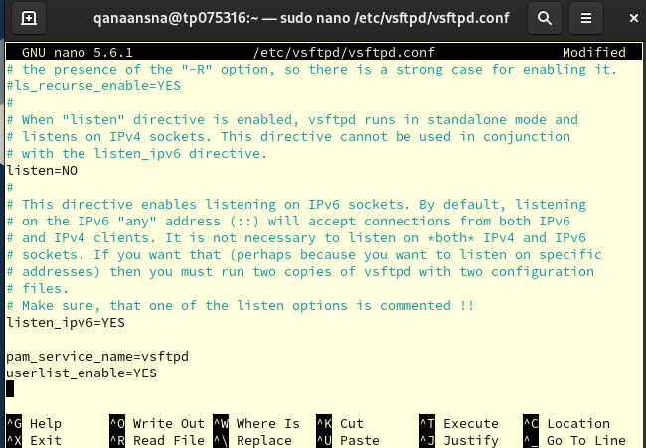Figure 194: vsftpd main configuration file

* **listen=NO**: This stops the server from listening on IPv4 for FTP connections; compatibility or security concerns may be the cause of this.
* **listen_ipv6 =YES:** This makes it possible for the server to accept IPv6 addresses and listen for FTP connections.
* **pam_service_name = vsftpd**: This indicates that PAM (Pluggable Authentication Modules), which integrate with system-wide authentication mechanisms, should be used by the server for user authentication.
* **userlist_enable =YES:** This prevents FTP access from being managed via a user list file.   
  Unless otherwise restricted, this setting allows all local users to access FTP by default.

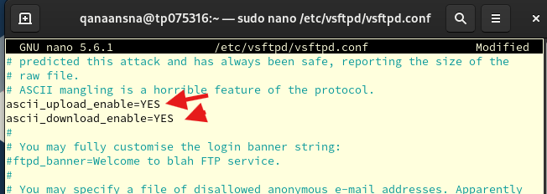  
Figure 195: vsftpd main configuration file

* In this step, (remove #) from these 2 commands.
* **ascii_upload_enable=YESallows** file uploads in ASCII mode.
* **ascii_download_enable=YES** enables ASCII mode for file downloads.

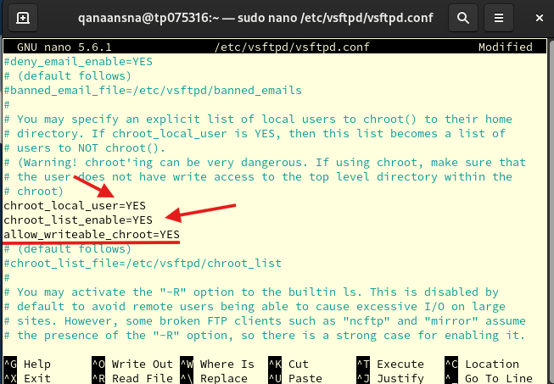

Figure 196: vsftpd main configuration file

* chroot_local_user=YES: makes chrooting enabled by default for local users.
* chroot_list_enable=YES: enables the chroot list file to be used.
* allow_writeable_chroot=YES: The vsftpd configuration file's (“allow_writeable_chroot=YES”) setting tells the FTP server to grant FTP users write permissions inside the chroot directory.

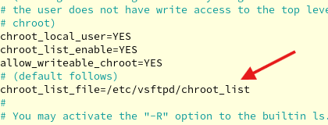  
Figure 197: vsftpd main configuration file

* In this step (remove #) from (“chroot_list_file=/etc/vsftpd/chroot_list”)
* (“chroot_list_file=/etc/vsftpd/chroot_list”): The text file that controls which users are exempt from chroot restrictions can be found at the location specified in the vsftpd configuration file.

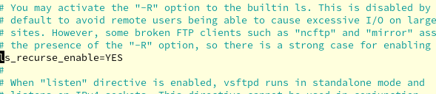  
Figure 198: vsftpd main configuration file

* (“ls_recurse_enable=YES”): allows FTP clients to use the ls -R command to recursively list the contents of directories and their subdirectories.
* Accordingly, the server will list not only the files and subdirectories contained in a directory, but also the contents of those subdirectories, and so on, when a user runs ls -R on a directory.

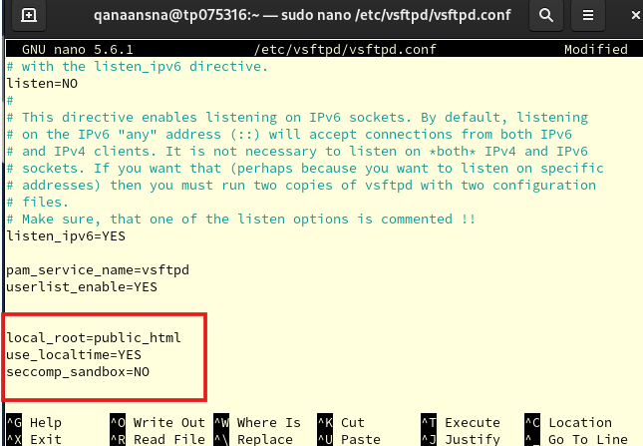  
Figure 199: vsftpd main configuration file

* First line is (“local_root=public_html”): This configuration specifies the home directory users connecting to vsftpd. This means the user will see the contents of the /public_html directory and subdirectories as their root directory when they log in via FTP. So any performance made by the user such as uploading, downloading, or deleting will be related to this directory.
* Second line is (“use_localtime=YES”): This option tells vsftpd to display file listings and timestamps for FTP users using the server's local time zone.
* Lastly (“seccomp_sandbox=No”) is a security feature called seccomp sandboxing is turned off in the vsftpd configuration file. This is considered as a security feature that limits the amount of system call requests for kernel functions that an application is permitted to make. Seccomp sandboxing can potentially mitigate certain vulnerabilities and make it more difficult for malicious code to run within vsftpd by restricting system calls.

Once we are done press:

* Control + X
* Press Y
* Press Enter

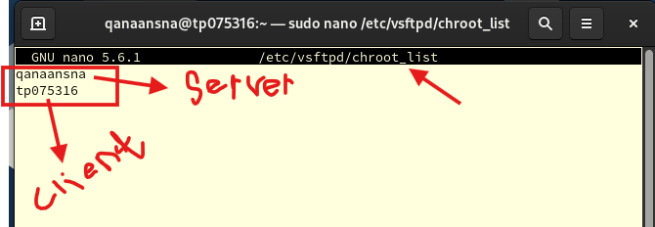  
Figure 200: Adding Rocky & Ubuntu username

* Here we add the Rocky server username and Ubuntu client username (note: if our username is the same in Rocky & Ubuntu do not add the username twice)

Once we are done press:

* Control + X
* Press Y
* Press Enter

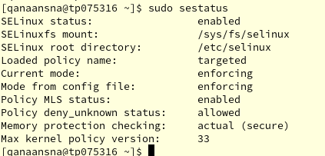  
Figure 201: status of Linux



* (“Sudo sestatus”) is to check the status of SELinux, as shown in the figure above is enabled.

  
Figure 202: full access

* Breakdown of the command above:
* (“setsebool”) : This command is used to manage SELinux booleans, which are discrete SELinux settings that regulate particular behaviours or permissions.
* -p: Using this option makes the modification permanent, so it will hold even after a system reboot.
* (“ftpd_full_access”): This particular boolean is what is being set. It controls the level of access that the system's files and directories are accessible to the FTP daemon (ftpd).
* On: To make the Boolean true.

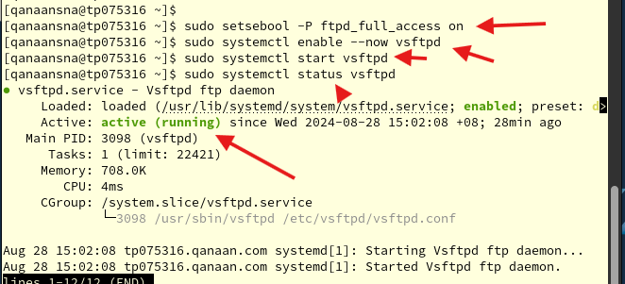  
Figure 203: enable, start and status vsftpd

Now, we enabled the FTP service and started by applying the next commands:

* (“Sudo systemctl enable –-now vsftpd”)
* (“Sudo systemctl start vsftpd”)
* (“Sudo systemctl status vsftpd”)

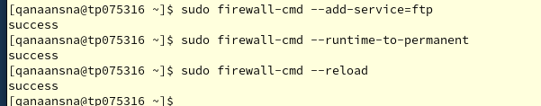Figure 204: Firewall

After that, we permanently permit FTP through the firewall and reload by typing the next commands:

* (“Sudo firewall-cmd –-add-service=ftp”)
* (“Sudo firewall-cmd –-runtime-to-permanent”)
* (“Sudo firewall-cmd –reload”)
* (“Sudo firewall-cmd –-list-all”)

# 13.0 **FTP Ubuntu Configuration & Testing**

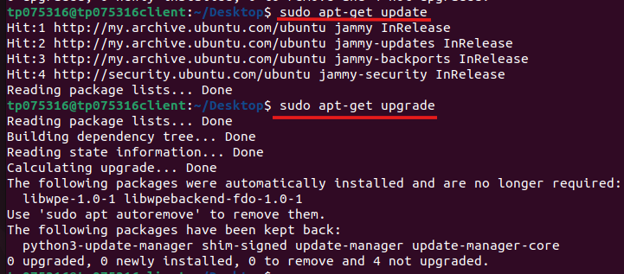  
Figure 205: Updating & Upgrading the Ubuntu system

First, we update & upgrade the software by using:

* (“Sudo apt-get update”)
* (“Sudo apt-get upgrade”)

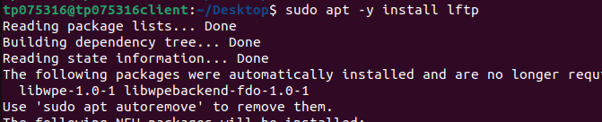Figure 206: lftp installation

FTP installation for Ubuntu to allow us to access our Rocky server by typing:

* (“Sudo apt -y install lftp”)

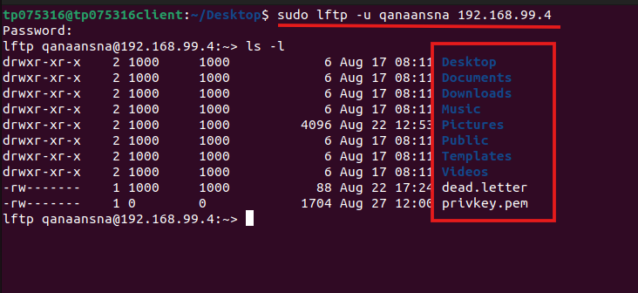  
Figure 207: Login to Rocky server



The Ubuntu Client can now connect to our Rocky File Transfer Server:

* -u: username of our Rocky server
* qanaansna: in this case is my username in Rocky (note: yours might be different)
* 192.168.99.4: IP address for Rocky server (note: yours might be different)
* Executing (“Sudo lftp -u qanaansna 192.168.99.4”) command to access Rocky server through FTP
* (“ls -l”) displays directories and files in our Rocky server

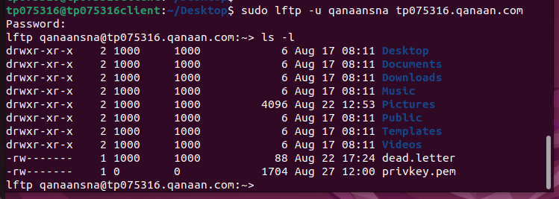Figure 208: Login to Rocky server

Another method to connect to Rocky server:

* (“lftp -u qanaansna tp075316.qanaan.com”)
* (“ls -l”)

## 13.1 Testing FTP

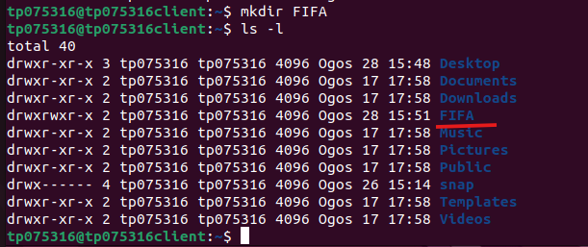  
Figure 209: create FIFA directory

Now let’s test our FTP in Ubuntu:

* Create a FIFA Directory by using (“ mkdir FIFA”) command
* (“ls -l”)

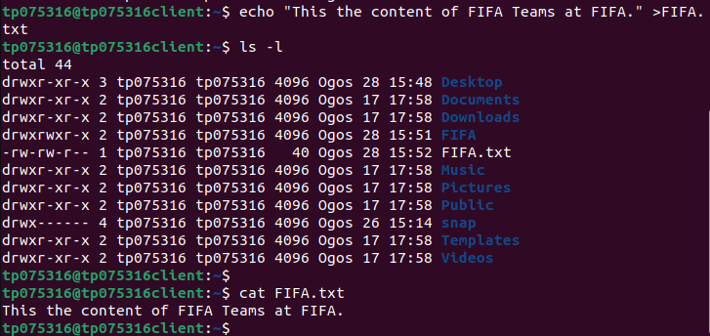Figure 210: create FIFA.txt file

Next step, we create a file by using the echo method:

* (“echo “ This is the content of Football Teams at Fifa. “ > Football.txt “).
* (“ls -l “).
* (“cat Football.txt”) We use the command (“cat”) to illustrate the context of the file.

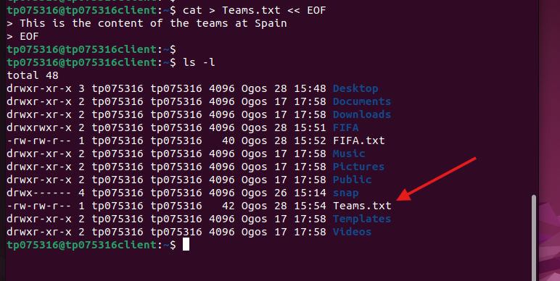Figure 211: create Teams.txt file

In this step, we used a different method to create another file named Teams.txt call (EOF):

* cat > Teams.txt << EOF   
  >This is the content of Teams in Spain.  
   >EOF
* (“ls -l”)

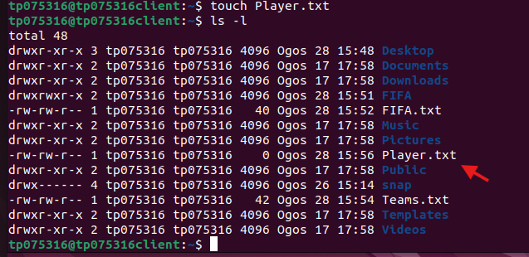  
Figure 212: create Player.txt file

Now will use the touch Method to Create a File named (Player.txt):

* (“touch Player.txt”)
* (“ls -l”)

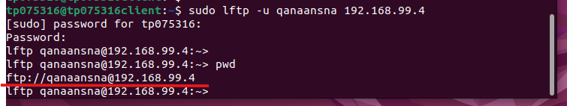 Figure 213: pwd command

The figure above shows that we re-login to our Rocky server and see our current directory:

* (“Sudo lftp -u qanaansna 192.168.99.4”)
* (“!pwd”)

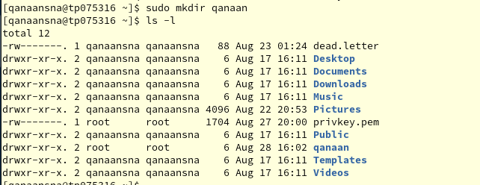  
Figure 214: Creating qanaan directory in Rocky

Now, we will create a new directory call (qanaan) in our Rocky server:

* (“sudo mkdir qanaan”)
* (“ls -l”)

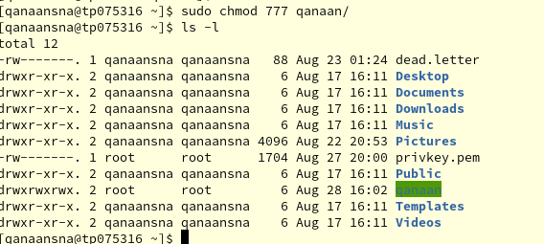  
Figure 215: Give full permissions

In the step above, Verify the full permissions for our (qanaan) directory on the Rocky server. And the color of the directory is going to be green.

* (“sudo chmod 777 Bungkus”)
* (“ls -l”)

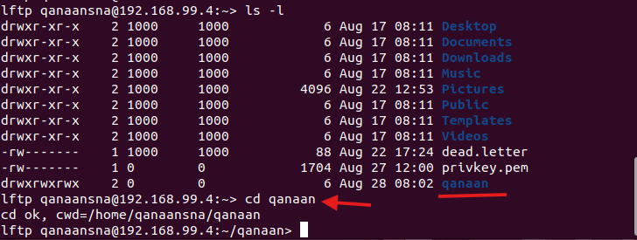  
Figure 216: Entring qanaan directory

Using FTP from the Ubuntu client, we switch the current directory on the server side to the (qanaan) directory.

* (“ls -l”)
* (“cd qanaan”)

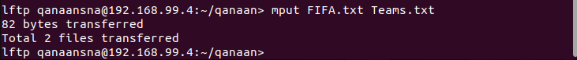  
Figure 217: Transferring files

Using the mput command, we move two of our files from the Ubuntu client to Rocky Server.

* (“mput FIFA.txt Teams.txt”)

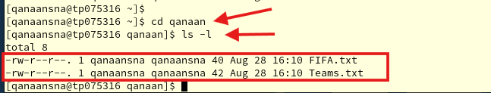  
Figure 218: Checking files in Rocky server

Now we check the transferred files:

* (“cd qanaan”)
* (“ls -l”)

  
Figure 219: Transfer file

Transferring a single file with the put command:

* (“put Players.txt”)

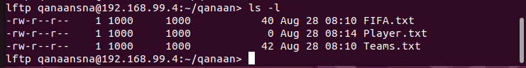  
Figure 220: Checking files

* (“ls -l”) in Ubuntu

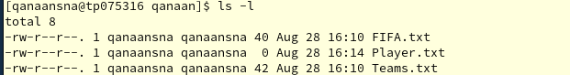  
Figure 221: Checking files

* (“ls -l”) in Rocky

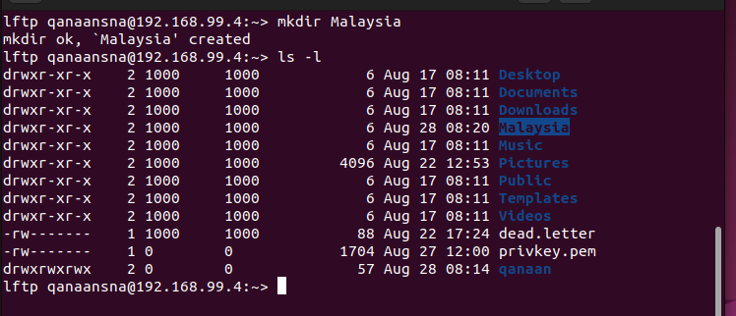 Figure 222: mkdir Malaysia



create a new directory named (Malaysia):

* (“mkdir Malaysia”)
* (“ls -l”)

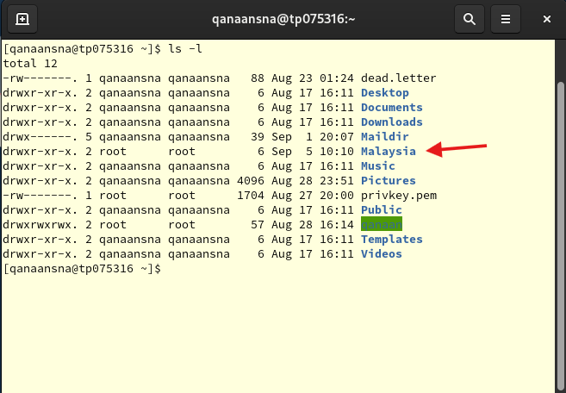  
Figure 223 Malaysia directory exists

* (“ls -l”)

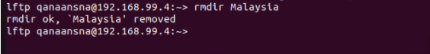  
Figure 224: Remove directory

Remove (Malaysia) file from Rocky server through Ubuntu:

* (“rmdir Malaysia”)

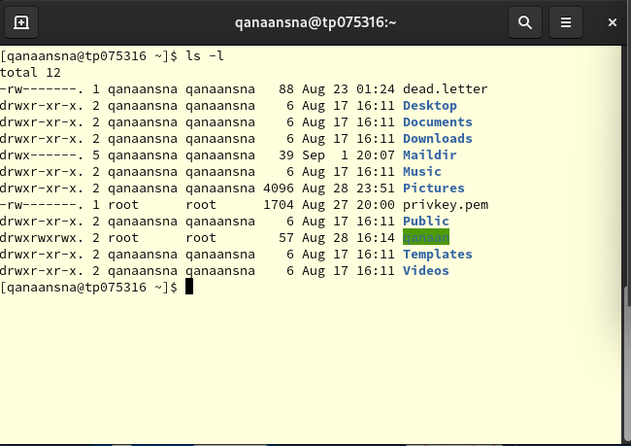  
Figure 225: Malaysia directory removed

* (“ls -l”)

## 13.3 FTP Server with SSL Installation

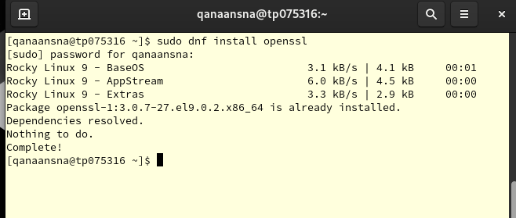 Figure 226: openssl installation

install OpenSSL:

* sudo dnf install openssl

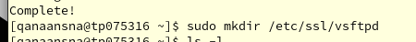  
Figure 227: Creating file

Our FTP server (vsftpd) will use the certificate file and our private key file, which we create in a directory called (vsftpd) under /etc/ssl.

* (“sudo mkdir /etc/ssl/vsftpd”)

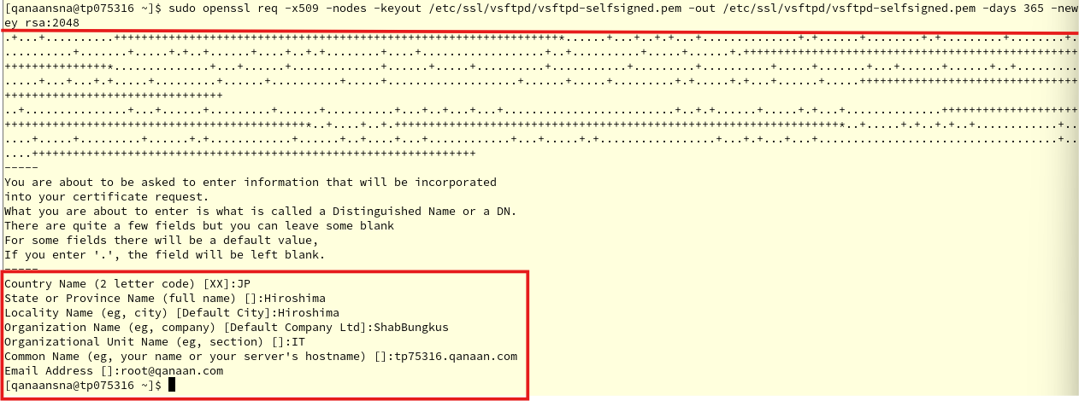 Figure 228: Certificate information

Now we create (VSFTPD) certificate and key, and enter the organization detail:

* (“sudo openssl req -x509 -nodes -keyout /etc/ssl/vsftpd/vsftpd selfsigned.pem -out /etc/ssl/vsftpd/vsftpd-selfsigned.pem -days 365 -newkey rsa:2048”)

  
Figure 229

The following SSL entries need to be added to the vsftpd configuration file in order to enable SSL for our FTP server:

* sudo nano /etc/vsftpd/vsftpd.conf

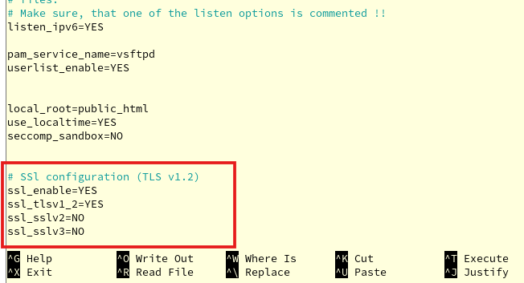  
Figure 230: add configurations

To enable the use of SSL with our FTP, we add the following configurations at the end of the file.

* # SSL configuration (TLS v1.2)
* (“ssl_enable=YES “)
* (“ssl_tlsv1_2=YES “)
* (“ssl_sslv2=NO “)
* (“ssl_sslv3=NO”)

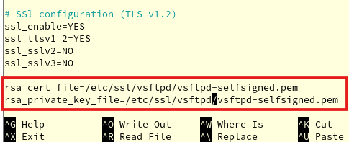  
Figure 231: add configurations

Next step, we specify where the SSL Certificate and Private Key are located.

* (“rsa_cert_file=/etc/ssl/vsftpd/vsftpd-selfsigned.pem “)
* (“rsa_private_key_file=/etc/ssl/vsftpd/vsftpd-selfsigned.pem”)

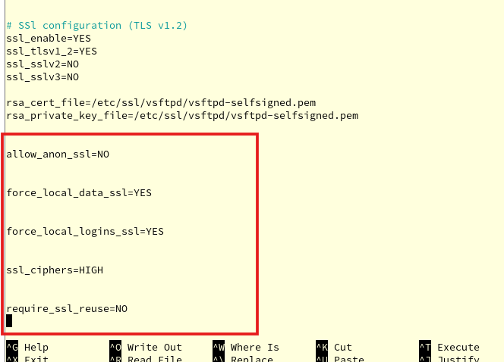  
Figure 232 add configurations

Here, we do more configurations foe SSL settings:

* (“allow_anon_ssl=NO “)
* (“force_local_data_ssl=YES”)
* (“force_local_logins_ssl=YES “)
* (“ssl_ciphers=HIGH “)
* (“require_ssl_reuse=NO”)

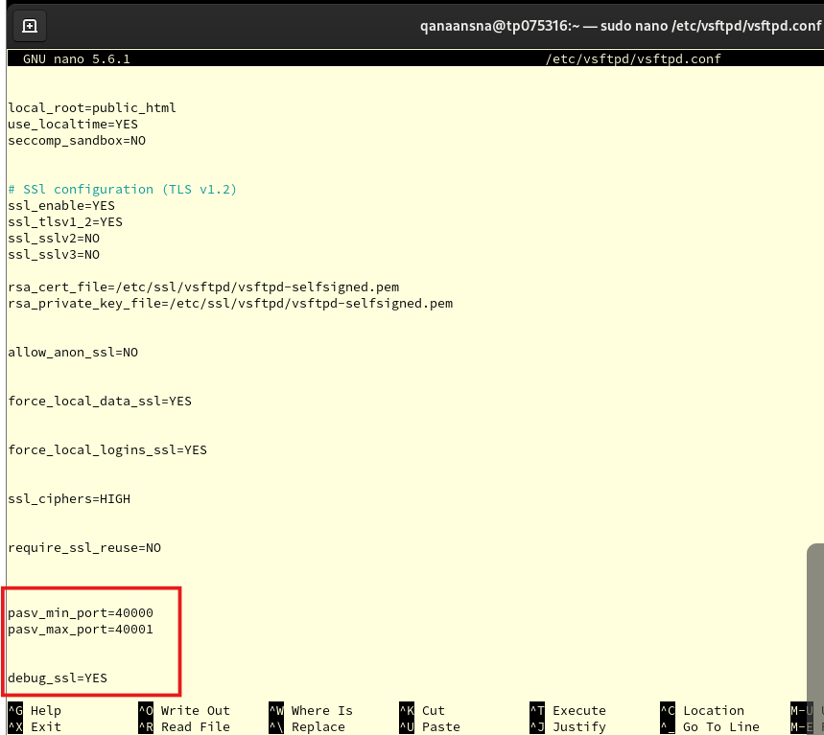 Figure 233 add configurations

Lastly, we do the configuration of pasv_min_port=40000 and pasv_max_port=40001 in our vsftpd.conf file:

* (“pasv_min_port=40000”)
* (“pasv_max_port=40001”)
* (“debug_ssl=YES”)

Once we are done press:

* Control + X
* Press Y
* Press Enter

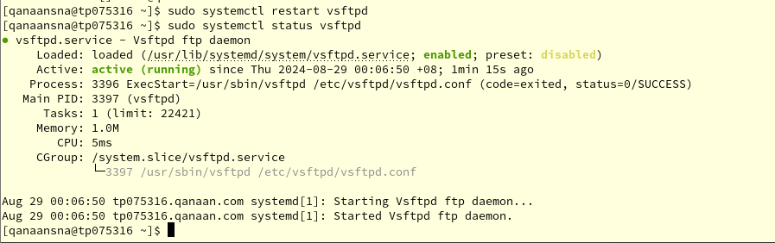 Figure 234: Restart and status vsftpd

Restart FTP server:

* (“sudo systemctl restart vsftpd”)
* (“sudo systemctl status vsftpd”)

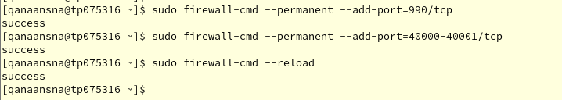 Figure 235: Adding ports to firewall

Adding a firewall rule to permit TLS connections via port 990 is the final step. We must open passive ports 40000–40001 in the firewall.

* (“sudo firewall-cmd --permanent --add-port=990/tcp “)
* (“sudo firewall-cmd --permanent --add-port=40000-40001/tcp “)
* (“sudo firewall-cmd –-reload”)

## 13.4 Installation FileZilla with SSL/TLS

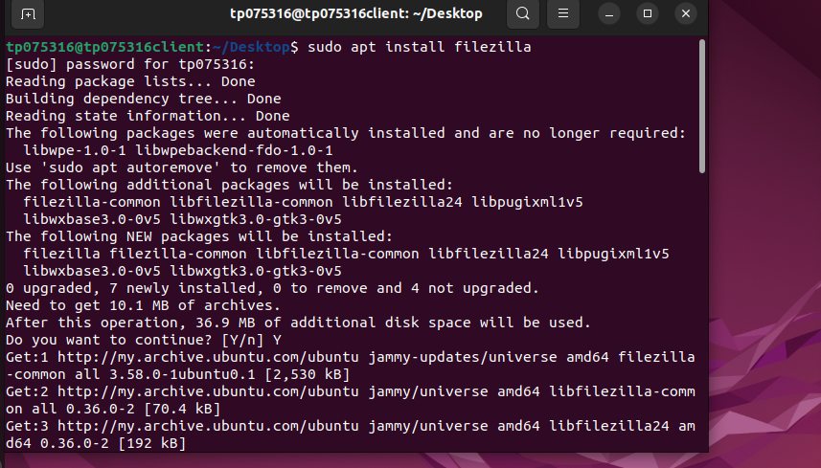  
Figure 236: Installation FileZilla

We need an FTP client that supports SSL/TLS in order to establish connections with it.   
This can be accomplished with the widely used FTP, SFTP, and FTPS client program FileZilla. Now we install the FileZilla program on our Ubuntu client:

* (“sudo apt install filezilla”)

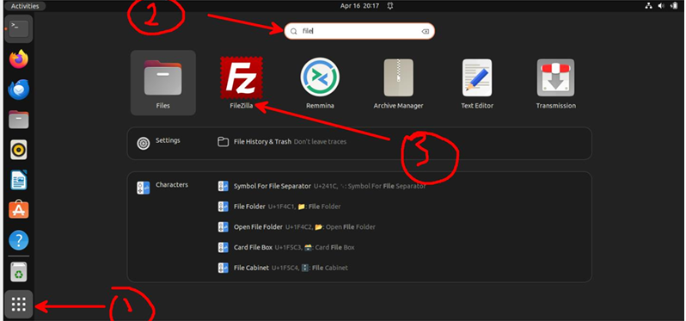 Figure 237

* Open FileZilla

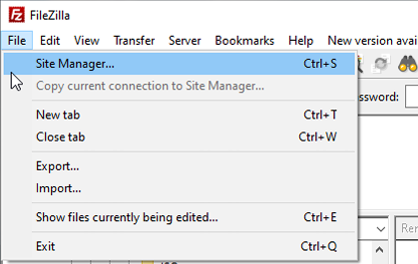  
Figure 238

* After we open FileZilla, we go to Site Manager

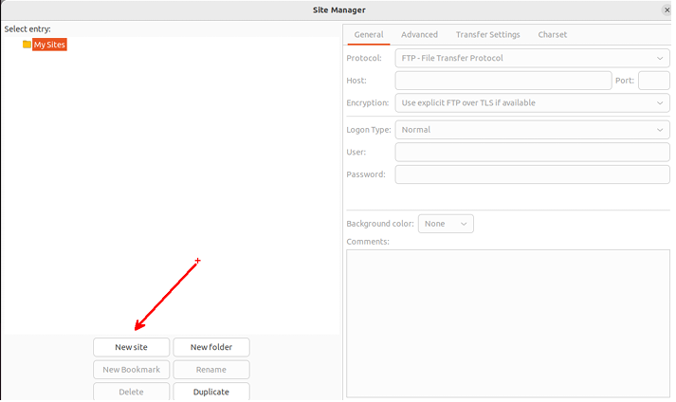 Figure 239

* Click New Site

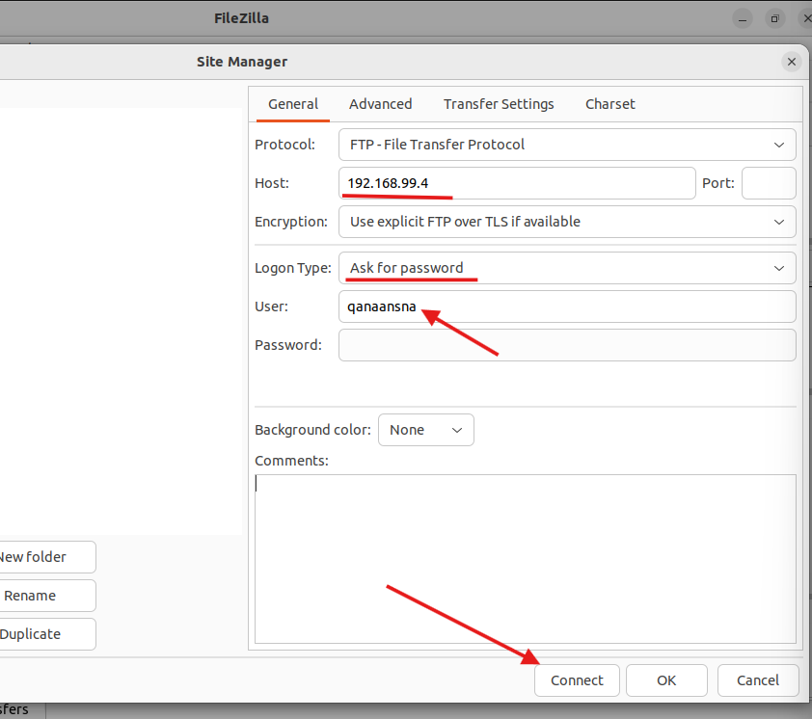 Figure 240

* We add Rocky Server information then click connect

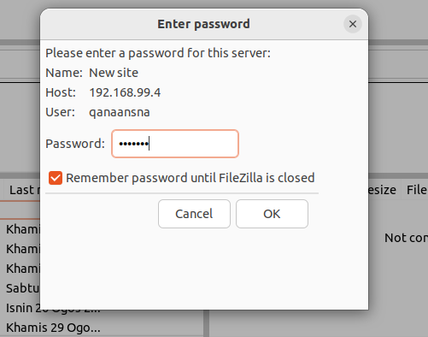  
Figure 241

* In the enter password window, we type our Rocky server password.

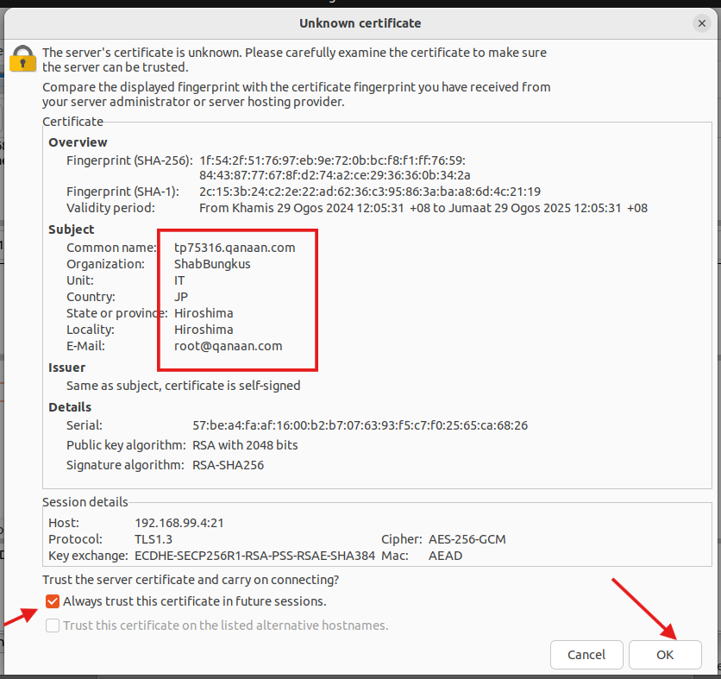  
Figure 242

* We can see the certificate details that we configured on the Rocky server during OpenSSL, which our Ubuntu client will now use for secure server-to-server communication.

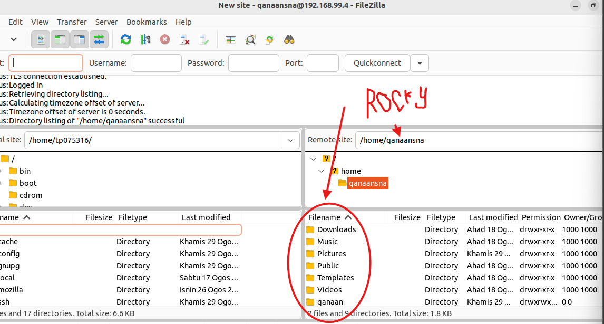  
Figure 243: Rocky server directories

* On the right side Rocky server directories.

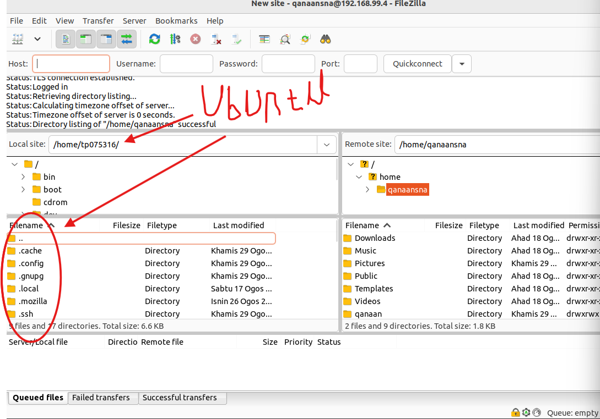 Figure 244: Ubuntu client directories

* On the left side Rocky server directories.

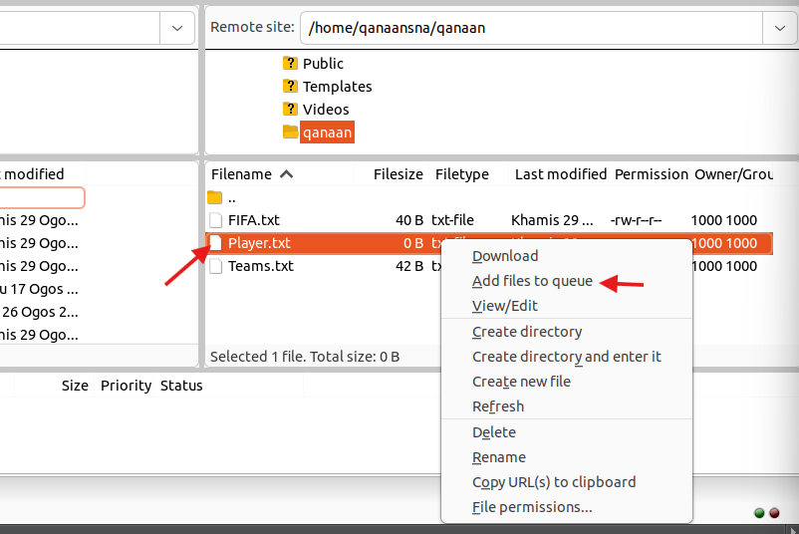 Figure 245: transfer file

This program offers a secure way to transfer files between a client and a server via SSL security.

Next, let’s test our FTP, we will transfer TestFile.txt from the Rocky Server to the Ubuntu client. Select Player.txt file then select add files to queue.

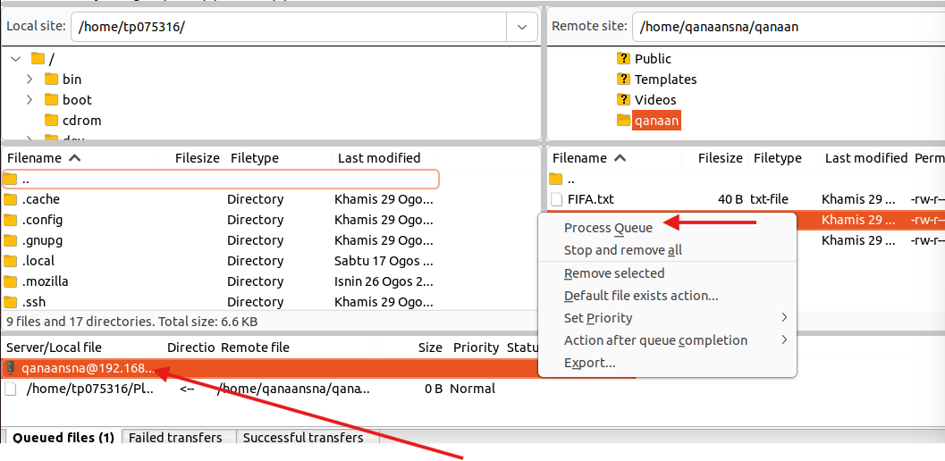 Figure 246: transfer file



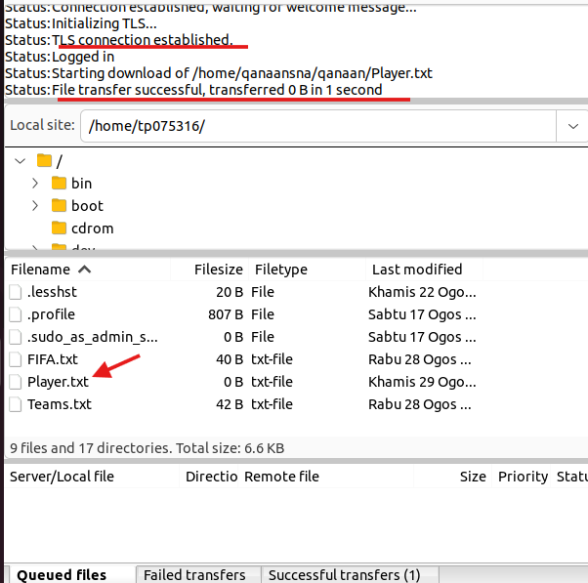  
Figure 247: file transferred

As we can see from the status at the top left corner, the connection was established, and the Player.txt was transferred successfully. Now, we have the file in our Ubuntu.

# 14.0 **Troubleshooting**

## 14.1 DHCP troubleshooting

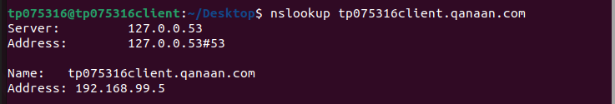  
Figure 248

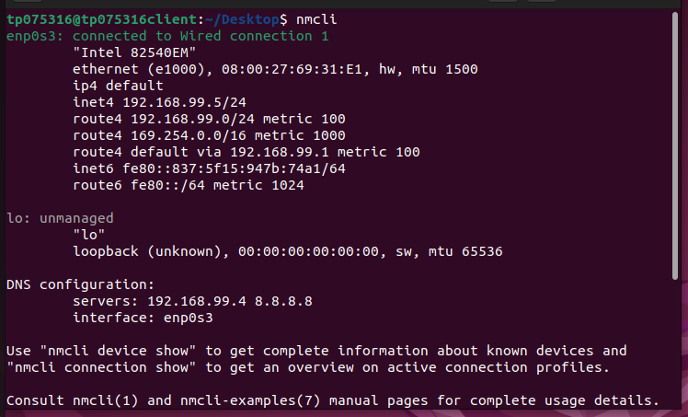  
Figure 249



The 2 figures above illustrate that the Ubuntu client is not receiving an IP address within the range I set in the Rocky server. The Ubuntu client is supposed to receive an IP address from 192.168.99.70 to 192.168.99.90.

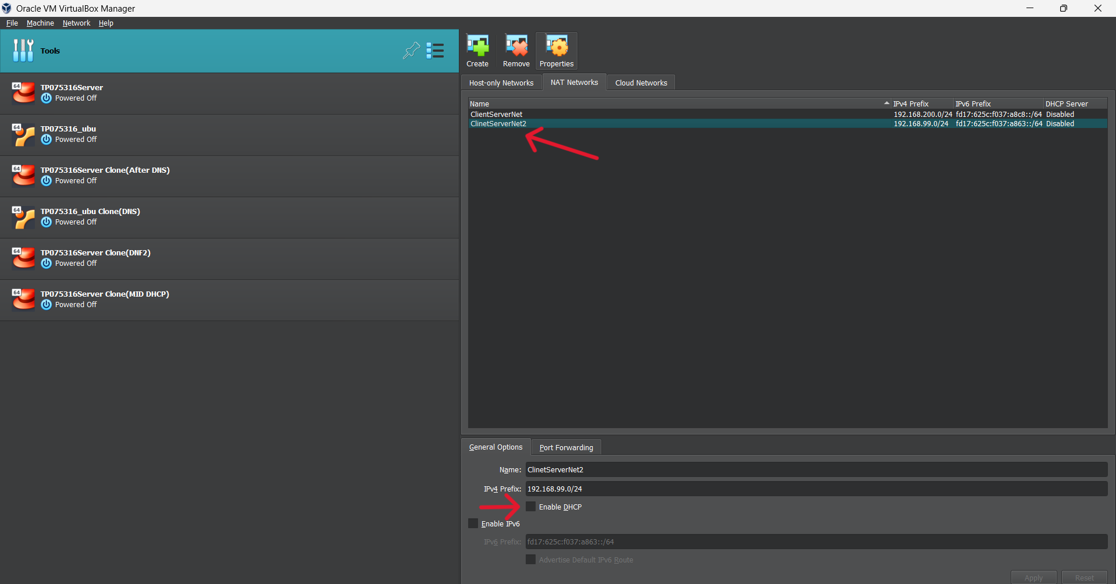  
Figure 250

The problem was solved by disabling the DHCP from the Virtual Machine and allowing the Rocky server to give DHCP to the Ubuntu client.

## 14.2 Apache web server troubleshooting

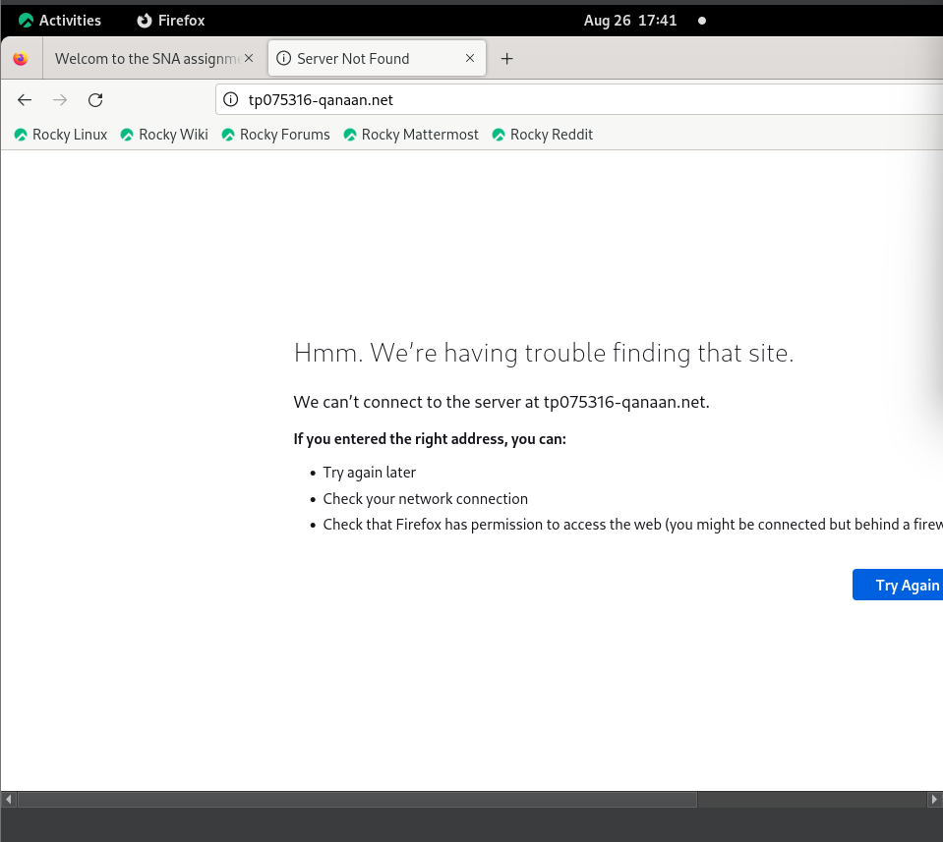  
Figure 251

The problem is that Firefox cannot connect to the Apache web server under the name tp075316-qanaan.net.

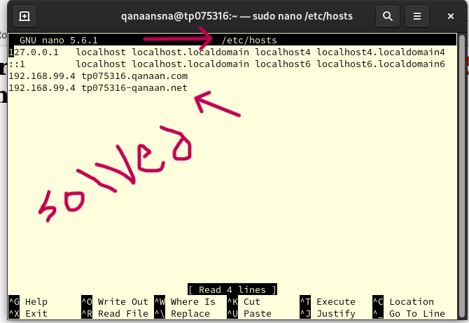  
Figure 252

To solve the problem, we just need to add the website name (tp075316-qanaan.net) with the IP address of the website inside (“sudo nano /etc/hosts”) file.

  
Figure 253

Now the Apache server works fine as it is shown in the figure above.

## 14.3 SSL/TLS for Apache web server troubleshooting

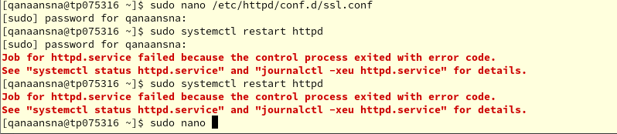  
Figure 254

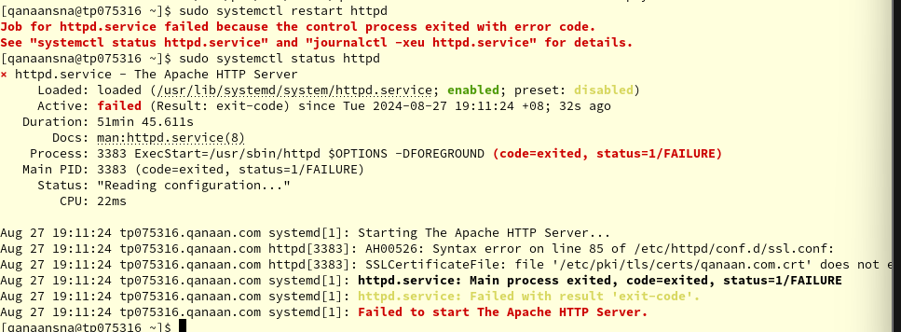

Figure 255:

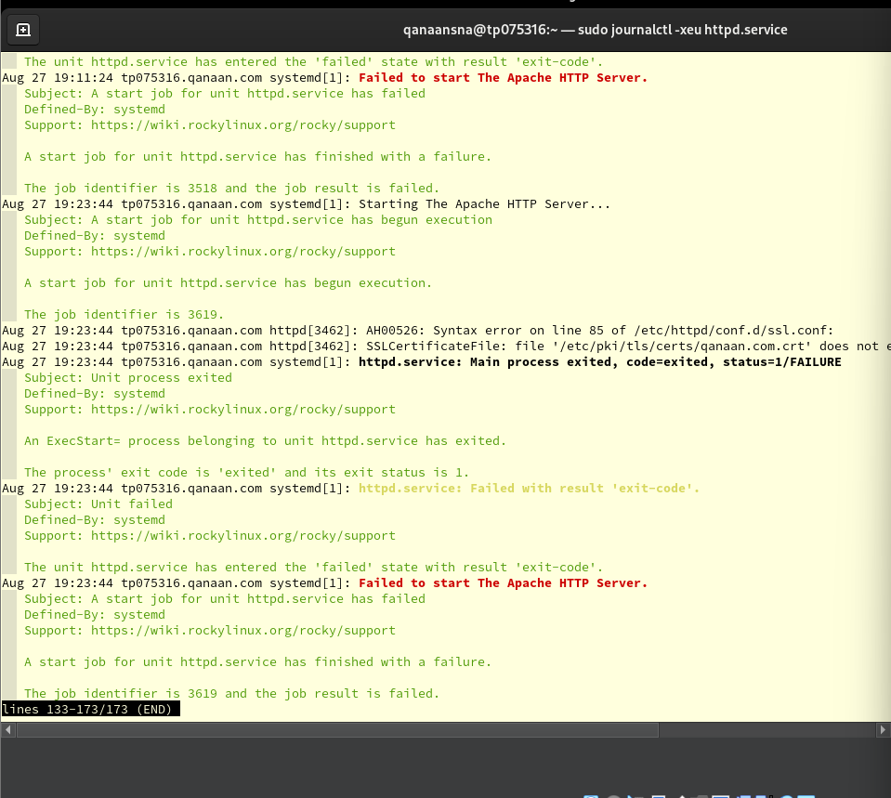  
Figure 256

The problem is that the Apache HTTP server (httpd) cannot be restarted or be activated.

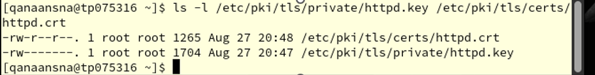  
Figure 257

The issue was resolved after deleting the following files and reconfiguring Apache HTTP server:

* (“sudo rm -r /etc/pki/tls/certs/httpd.crt”)
* (“sudo rm -r /etc/pki/tls/private/httpd.key”)

## 14.4 Email server troubleshooting

  
Figure 258

In the email server, I faced a problem when I tried to send an email with the command (mail) to send an email between two users, an error message that it says command not found. To fix this problem, we must install (s-nail) package, which provides the mail command functionality. The following image illustrates the installation process.

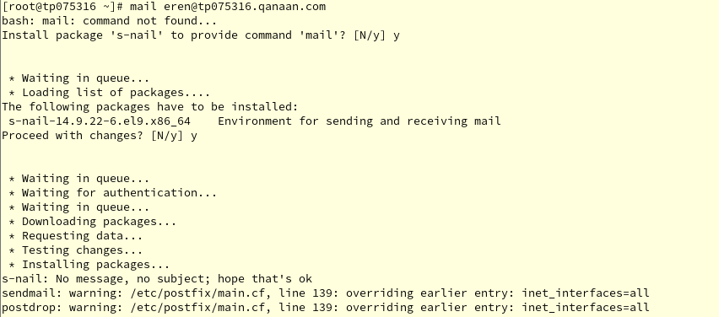  
Figure 259

## 14.5 Thunderbird mail troubleshooting

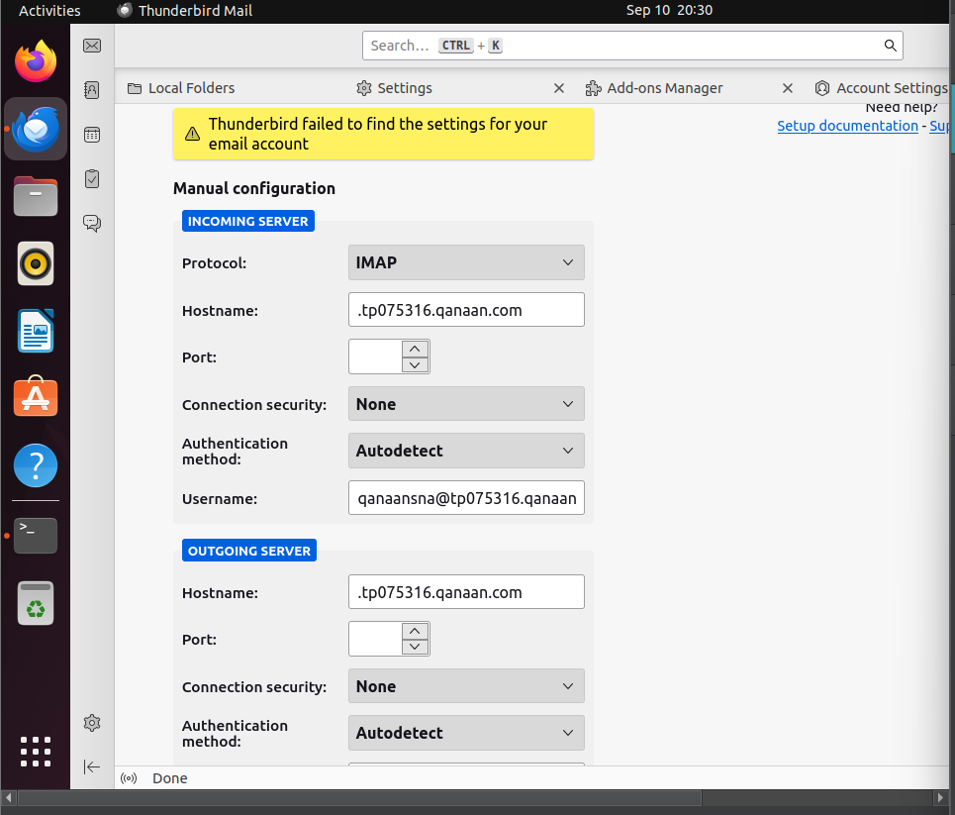Figure 260

Thunderbird shows here an error message in the figure above that "Thunderbird failed to find the settings for your email account”. To solve this problem I followed the next steps:

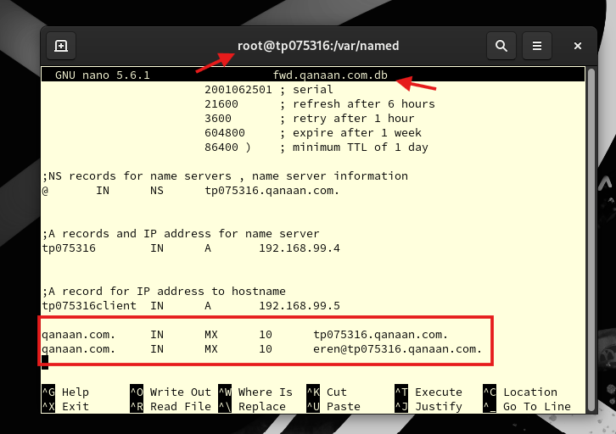 Figure 261

Step 1:

In this step, we go to the nano text editer for the file (“fwd.qanaan.com.db”) and add my domain name to the MX records for both users.

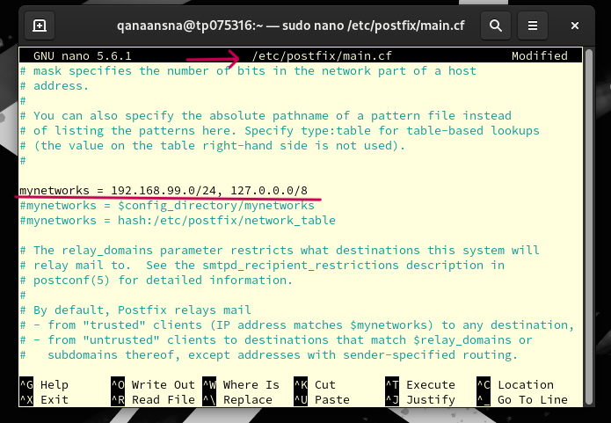 Figure 262

Step 2:

The image shows the configuration file (sudo nano /etc/postfix/main.cf) and make sure (mynetworks = 192.168.99.0/24, 127.0.0.0/8) is configured correctly

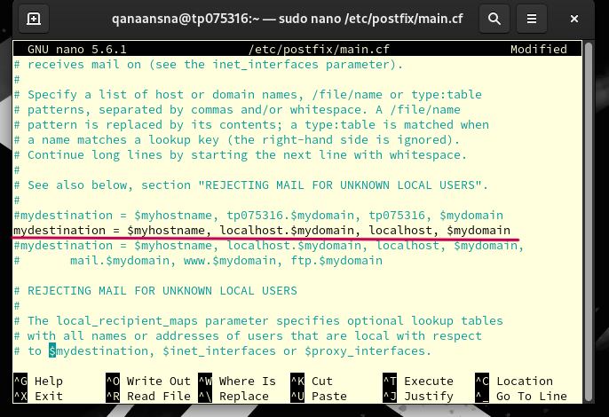 Figure 263

Step 3:

Make sure (mydestination = $myhostname, localhost.$mydomain, localhost, $mydomain) is configured correctly.

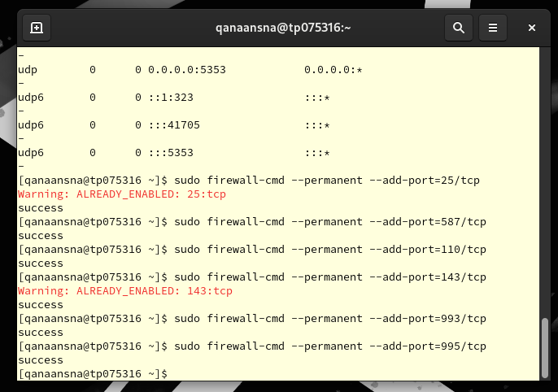 Figure 264

Step 4:

Here I added the ports above to the firewall.

 Figure 265

Now, Thunderbird is working and ready to use.

# References

Gillis, A. S. (2023, January 4). *DHCP (Dynamic Host Configuration Protocol)*. Networking. <https://www.techtarget.com/searchnetworking/definition/DHCP>

*What is an email server? Definition, how it works, why you need one? | Axigen*. (n.d.). <https://www.axigen.com/articles/what-is-an-email-server_107.html>

*What is Dovecot? Hosting Wikipedia*. (2021, April 12). Plesk. <https://www.plesk.com/wiki/dovecot/>  
Codex, A. C. (2024, February 16). *Installing and Configuring Dovecot on Rocky Linux 9*. Reintech. <https://reintech.io/blog/installing-configuring-dovecot-rocky-linux-9>

Anand K. (2020, September 21). *Postfix Mail Server Configuration on RHEL8 - Anand K* [Video]. YouTube. <https://www.youtube.com/watch?v=NHJyYzvwlzA>

Hernandez, J. (2019, May 8). What is Apache? In-Depth Overview of Apache Web Server. *Sumo Logic*. <https://www.sumologic.com/blog/apache-web-server-introduction/>

Gomez, J. (2023, March 17). How to install Apache on Rocky Linux 9 | LinuxTeck. *LinuxTeck*. <https://www.linuxteck.com/how-to-install-apache-on-rocky-linux/>

Garthus. (n.d.). *Apache With “mod_ssl” - Documentation*. <https://docs.rockylinux.org/guides/web/mod_SSL_apache/#generate-ssltls-certificate>

*What is FTP Server? - IT Glossary | SolarWinds*. (n.d.). <https://www.solarwinds.com/resources/it-glossary/ftp-server>

Gomez, J. (2023b, April 3). How to secure Apache with SSL in Rocky Linux | LinuxTeck. *LinuxTeck*. <https://www.linuxteck.com/secure-apache-with-ssl-in-rocky-linux/>